|  |  |
| --- | --- |
|  | Project Specification |
|  |  |
| 5/6/2015 | PKStateFilings |
|  |  |

Contents

Use Cases 3

PKStateFilings 3

State Filing Manager 3

UC-1-1 - SFM Dashboard View 3

UC-1-4 - SFM List View 10

UC-1-5 - SFM Project Details 13

UC-1-6 - SFM Change Project Owner 18

UC-1-7 - SFM Search Project 19

UC-1-8 - SFM Search Project Result 24

UC-1-9 - SFM Add Project 26

UC-1-10 - SFM Edit Project 31

UC-1-11 - SFM Filing Details 36

UC-1-12 - SFM Add Filing 44

UC-1-13 - SFM Edit Filing 50

UC-1-19 - SFM Filing Activity Details 55

UC-1-20 - SFM Filing Fee 57

UC-1-22 - SFM Filing Task Details 59

UC-1-23 - SFM Filing Bureau Adoption 61

UC-1-24 - SFM Filing Company Forms 64

UC-1-29 - SFM Filing Rules 68

UC-1-25 - SFM Filing Related Filings 70

UC-1-26 - SFM Change Filing Owner 71

UC-1-27 - SFM Search Filings 72

UC-1-28 - SFM Search Filing Results 77

Home Dashboard 78

UC-2-1 - Home Dashboard 79

UC-2-7 - Home Dashboard With Welcome & My Apps widgets 86

Common 94

$ID - $Name 94

Tools 95

$ID - $Name 95

Reports 96

$ID - $Name 96

Profile 97

$ID - $Name 97

Admin 98

$ID - $Name 98

Accounts 99

$ID - $Name 100

Users 100

$ID - $Name 101

Special Topics 101

$ID - $Name 102

Bureau Adoption Matrix 103

$ID - $Name 103

Bureaus 104

$ID - $Name 104

User Role Management 105

$ID - $Name 105

Manual Site Update 106

$ID - $Name 106

Products 107

$ID - $Name 107

Product Planner 108

$ID - $Name 108

Filing Correspondence Manager 109

$ID - $Name 109

SFC Map Generator 110

$ID - $Name 111

Requirement 111

$ID - $Name 112

Bureau Adoption Manager 113

$ID - $Name 113

Bureau Circular Manager 114

$ID - $Name 114

Company Forms Library 115

$ID - $Name 115

Starter Dashboard 116

$ID - $Name 116

User Role & Data Access 117

$ID - $Name 117

Activity Manager 118

$ID - $Name 118

Actors 120

Requirements 121

Glossary 122

Open Issues 123

# Use Cases

## PKStateFilings

## State Filing Manager

State Filing Manager app manages State Filing Projects, Individual State Filings and SERFF Submission process.

### UC-1-1 - SFM Dashboard View

The use case encompasses functionality of State Filing Manager Dashboard View for logged in users.

|  |  |
| --- | --- |
| Preconditions Admin, Authenticated Client, Authenticated Client Admin, Authenticated User should be logged in and have subscription for State Filing Manager App. | Success Guarantee System will display State Filing Manager Dashboard View to the Admin, Authenticated Client, Authenticated Client Admin, Authenticated User with their preferences set. |

#### Main Success Scenario

1. Admin, Authenticated Client, Authenticated Client Admin, Authenticated User will click on Apps->State Filing Manager.
2. System checks if Admin, Authenticated Client, Authenticated Client Admin, Authenticated User have subscription for "StateFilings.com Software" or "Perr&Knight State Filings Services" and redirects them to the Dashboard View of State Filing Manager. else System show informative page of State Filing Manager
3. When System redirects user on State Filing Manager Dashboard for the first time, it will display State Filing Manager Starter Dashboard. [Refer Use Case - Starter Dashboards (UC-23-1)].
4. State Filing Dashboard will have a "Dashboard Name" Dropdown list which will have all the dashboards created by the user and also the public dashboards of other users of the same account. If Admin, Authenticated Client, Authenticated Client Admin, Authenticated User selects a Name from the list of Dashboard Names, System will display the Dashboard for selected name and all the preferences set under that selected dashboard.
5. System will display Last Refreshed Date for the selected dashboard.
6. State Filing Manager Dashboard View will display all the preferences set by the user.
   1. General Widgets Functionality
      1. User can only add widgets with data specific to the filters selected while creating the dashboard.
      2. Add Widget - User can add widgets to current State Filing Manager Dashboard by clicking "Edit Dashboard" button, System will redirect user to "Edit Dashboard" screen and user can add the widgets on the current dashboard.
         1. Refer Use Case - Add Widget (UC-2-5) which will describe the general functionality of adding the widget.
         2. User cannot add a widget on public dashboard created by other users of same account as the widget will be displayed to all users.
         3. User can add maximum 10 widgets.
      3. Reorder Widgets - Admin, Authenticated Client, Authenticated Client Admin, Authenticated User can reorder the widgets added to the dashboard.
         1. User can reorder a widget placed on public dashboard created by other users of same account as it will not affect the view of same dashboard for other users.
      4. Remove Widgets - Admin, Authenticated Client, Authenticated Client Admin, Authenticated User can delete the widgets added to the dashboard and it will no longer be displayed on that dashboard.
         1. User cannot remove a widget placed on public dashboard created by other users of same account as it will affect the view of dashboard for other users
         2. System will confirm from the users if they want to delete the selected widget.
         3. If Admin, Authenticated Client, Authenticated Client Admin, Authenticated User click 'yes', System will remove the selected widget and it will not be available for user to view it on the dashboard.
      5. Edit Widget - Admin, Authenticated Client, Authenticated Client Admin, Authenticated User can edit the widgets added to the dashboard. If user clicks on Edit Widget icon in the header section of the widget, System will redirect users to Edit Widget Screen.
         1. Refer Use Case - Edit Widget (UC-2-6) which will describe the general functionality of editing the widget.
         2. User cannot edit a widget placed on public dashboard created by other users of same account.
   2. State Filing Manager specific Widgets [Please Refer Requirement - REQ-SF-8 (REQ-12-8)]
      1. Metric & Filters/Dimensions
         1. Metric
            1. Average Time To Filing Approval
            2. Average Time To Project Completion
            3. Count of Activities
            4. Count of Filings
            5. Count of Projects
            6. Count of Tasks
            7. Percent Project Complete
            8. Sum of Filing Fees
         2. Filters/Dimensions. User can create a dashboard without any filter
            1. Activity Type
            2. Affiliate
            3. Company Tracking Number
            4. Filing Fee Type
            5. Filing Fee Amount
            6. Filing Owner
            7. Filing Type
            8. Forms Contact
            9. Insurance Company
            10. Insurance Group
            11. New/Revised
            12. Product
            13. Product Type
            14. Project Name
            15. Project Owner
            16. Project Status
            17. Rate/Rule Contact
            18. SERFF Tracking Number
            19. State
            20. State Status
            21. State Tracking Number
            22. Sub-TOI
            23. Task Type
            24. Task Status
            25. Third Party Filer
            26. TOI
      2. State Filing Manager Widget Examples by Widget Types
         1. Metric
            1. Example 1 - If user selects filters as Product = 'Commercial Auto' (Only Show) & State = "New York" (Only Show) along with the metric "Count of Projects", System will display the Metric Widget with State Filing Projects Count (%) which belongs to product 'Commercial Auto' and state 'New York' & Total Projects Count (%).
            2. Example 2 - If user selects filters as Project = '2013 Comm Auto Revised' (Only Show), Task Type = 'Status Check' (Don't Show) & State = "New York" (Only Show) along with the metric "Count of Filings", System will display the Metric Widget with State Filings Count (%) which are associated with project '2013 Comm Auto Revision', belongs to state New York and has task types other than 'Status Check' & Total Filings Count (%).
         2. Timeline
            1. Example - If user selects filters as Product = "Commercial Auto" (Only Show) & Insurance Group = "Allstate Insurance Group" (Only Show) along with the metric "Count of Tasks", System will display the Timeline Widget with Tasks Count which are created for filings belonging to Group "Allstate Insurance Group" and product "Commercial Auto".
            2. If user selects 'All Time' in the date range field on the widget sub header section, System will display count of the Tasks added till date.
            3. If user selects 'This Week' in the date range field on the widget sub header section, System will display count of the Tasks added in the current week.
            4. If user selects 'This Month' in the date range field on the widget sub header section, System will display count of the Task added in the current month.
            5. If user selects 'This Year' in the date range field on the widget sub header section, System will display count of the Tasks added in the current year.
            6. The x-axis value for timeline widget will be always months.
         3. Geomap
            1. It will display selected metric with selected filters applied.
            2. Example - If user selects filters as Filing Type = 'Rates' (Don't Show), Project = '2013 Commercial Auto Revision' (Only Show) along with the metric "Count of Activities", System will display the Geomap Widget with Activities Count across different states which are associated with project '2013 Commercial Auto Revision' and has Filing type other than 'Rate'.
         4. Table
            1. It will display count of selected metric by the dimensions selected.
            2. User can select any metric from given list for Table Widget and user can select upto two dimensions.
            3. Example 1 (Single Dimension) - If user selects Filing Type = 'Rate' (Only Show), Filing Type = 'Rule' (Only Show) along with the metric "Count of Filings", System will display the Table Widget with two columns as "Rate" & "Rule" and table row (only single row will be displayed) will have Filing Counts with respect to the column values.
            4. Example 2 (Two Dimensions) - If user selects Filing Type = 'Rate' (Only Show), Filing Type = 'Rule' (Only Show) & Filing Status = 'Pending' (Only Show), Filing Status = 'Approved' (Only Show) along with the metric "Count of Filings", System will display the Table Widget with two columns as "Pending" & "Approved" and two table rows "Rate" & "Rule". First row with Filing type "Rate" will display Filing count for pending & approved statuses respectively. Second row with Filing type "Rule" will display Filing count for pending & approved statuses respectively.
         5. Pie
            1. It will display count of selected metric by grouping it with another specified field in Grouped By drop down.
            2. If user select Pie widget type, System will display a "Grouped By" option from where user can select value with which "Selected Metric" will be grouped and a "Apply Data Filter" option to select filters.
            3. "Grouped By" will be mandatory for users to select.
            4. Example - If user selects Grouped By = 'Filing Type' along with the metric "Count of Activities", System will display the Pie Widget with Activities Count grouped across Rate, Rule, Forms & Loss Cost Filing Types. That means Pie widget will have four slices, one slice will have Activities Count for 'Rate', second slice will have Activities Count for 'Rule', third slice will have Activities Count for 'Forms' & fourth slice will have Activities Count for 'Loss Cost', all slices with different colors.
         6. Bar
            1. It will display count of selected metric by grouping it with another specified field in Grouped By drop down.
            2. If user select Bar widget type, System will display a "Grouped By" option from where user can select value with which "Selected Metric" will be grouped and a "Apply Data Filter" option to select filters.
            3. "Grouped By" will be mandatory for users to select.
            4. Example - If user selects Grouped By = 'Task Type' along with the metric "Count of Task", System will display the Bar Widget with Tasks Count grouped across their associated task types. That means Bar widget will have bars equal to the no of task types and the no. of task per task type.
7. State Filing Project Quick Search
   1. **Search By Project Name** - Admin, Authenticated Client, Authenticated Client Admin, Authenticated User can have a quick search for projects by entering any project name and System will display the details related to the project if the project name is exists.
      1. User can enter multiple Project Name's with separators like "OR", "AND" & ",".
   2. If Admin, Authenticated Client, Authenticated Client Admin, Authenticated User click on "Search" button, System will display a State Filing Projects result screen for project name entered by user.
   3. If Admin, Authenticated Client, Authenticated Client Admin, Authenticated User click on "Reset" button, System will clear the project name value entered by user.
   4. **Advanced Search for Project** -If the Admin, Authenticated Client, Authenticated Client Admin, Authenticated User clicks on "Run an Advanced Search for Projects" link, System redirects user to the Project Search screen. [Refer Use Case - SFM Search Project (UC-1-7)]
   5. Admin, Authenticated Client, Authenticated Client Admin, Authenticated User can move "State Filing Project Quick Search" widget but can not edit or delete this widget.
8. State Filing Quick Search
   1. **Search By Company Filing Number** - Admin, Authenticated Client, Authenticated Client Admin, Authenticated User can enter a Company Filing Number and System will display filings with that Company Filing Number. Company Filing Number is same as Company Tracking Number
      1. User can enter multiple Company Filing Number with separators like "OR", "AND" & ",".
   2. **Search By SERFF Filing Number** - Admin, Authenticated Client, Authenticated Client Admin, Authenticated User can enter a SERFF Filing Number and System will display filings with that SERFF Filing Number. SERFF Filing Number is same as SERFF Tracking Number.
      1. User can enter multiple SERFF Filing Number with separators like "OR", "AND" & ",".
   3. **Search By DOI Filing Number** - Admin, Authenticated Client, Authenticated Client Admin, Authenticated User can enter a DOI Filing Number and System will display filings with that DOI Filing Number.
      1. User can enter multiple DOI Filing Number with separators like "OR", "AND" & ",".
   4. If Admin, Authenticated Client, Authenticated Client Admin, Authenticated User click on "Search" button, System will display a State Filings result screen for criteria mentioned in above fields.
   5. If Admin, Authenticated Client, Authenticated Client Admin, Authenticated User click on "Reset" button, System will clear all the value entered in the above fields.
   6. **Advanced Search for Filings** -If the Admin, Authenticated Client, Authenticated Client Admin, Authenticated User clicks on "Run an Advanced Search for Filings" link, System redirects user to the Filing Search screen. [Refer Use Case - SFM Search Filings (UC-1-27)]
   7. Admin, Authenticated Client, Authenticated Client Admin, Authenticated User can move State Filing Quick Search widget but can not edit or delete this widget.
9. Add Dashboard - System will redirect user to "Add Dashboard" screen. Once the Admin, Authenticated Client, Authenticated Client Admin, Authenticated User adds new dashboard it will be available in "Dashboard Name" dropdown list and user can view newly added dashboard by clicking the name of the dashboard.
   1. Refer Use Case - Home Dashboard - Add (UC-2-2)] for general functionality of Adding a Dashboard.
   2. State Filing Manager Dashboard will have following filters
      1. Filing Owner
      2. Insurance Company
      3. Insurance Group
      4. Project
      5. Project Owner
      6. State
      7. Third Party Filer
      8. TOI
      9. Sub-TOI
   3. If a user select Project = "2013 Comm Auto Revision" then the user can only add widgets with data specific to the above selected project name.
10. Edit Dashboard - System will redirect user to "Edit Dashboard" screen. Once the Admin, Authenticated Client, Authenticated Client Admin, Authenticated User edits the existing dashboard, user can view changes applied to dashboard by clicking the name of the dashboard.
    1. Admin, Authenticated Client, Authenticated Client Admin, Authenticated User cannot edit public dashboards created by other users of same account.
    2. Refer Use Case - Home Dashboard - Edit (UC-2-3) for general functionality of Editing a Dashboard.
11. Clone Dashboard - System will create a copy of selected dashboard with additional changes made by Admin, Authenticated Client, Authenticated Client Admin, Authenticated User (if they make changes to selected dashboard). A new record will be created by the System when user clones existing dashboard.
    1. Refer Use Case - Home Dashboard - Clone (UC-2-4) for general functionality of Cloning a Dashboard.
12. Delete Dashboard - System will confirm from Admin, Authenticated Client, Authenticated Client Admin, Authenticated User if they want to delete the selected dashboard. If Admin, Authenticated Client, Authenticated Client Admin, Authenticated User click 'yes', System will remove the selected dashboard and it will not be available for user to view the dashboard
    1. Admin, Authenticated Client, Authenticated Client Admin, Authenticated User cannot delete public dashboards created by other users.
13. Refresh Dashboard - If Admin, Authenticated Client, Authenticated Client Admin, Authenticated User clicks on Refresh Dashboard button, all the record counts under widgets on dashboard will be updated as of today.
14. Email Dashboard - System will email the selected dashboard to the logged in user. [Refer Point 3.1 from Use Case - E-Mail Notification Manager (UC-4-5)]
    1. Admin, Authenticated Client, Authenticated Client Admin, Authenticated User click on "Email Dashboard" button, System will display a list of frequencies.
       1. Daily - If user selects "Daily", System will add the selected dashboard to "Scheduled Dashboards" section of tool "Email Notification Manager" with "Daily" & "Active" options selected.
          1. System will send the email to the logged in user from Monday through Friday between 12 am and 4 am PST.
          2. System will send the dashboard in PDF Format.
       2. Weekly - If user selects "Weekly", System will add the selected report to "Scheduled Dashboards" section of tool "Email Notification Manager" with "Weekly" & "Active" options selected.
          1. System will send the email to the logged in user on every Monday between 12 am and 4 am PST.
          2. System will send the dashboard in PDF Format.
       3. Monthly - If user selects "Monthly", System will add the selected report to "Scheduled Dashboards" section of tool "Email Notification Manager" with "Monthly" & "Active" options selected.
          1. System will send the email to the logged in user on the first day of every month between 12 am and 4 am PST.
          2. System will send the dashboard in PDF Format.
    2. User can email both private as well as public dashboards.
    3. System stop sending mails for dashboards when user un-checks the active option for dashboards from Email Notification Manager - Scheduled Dashboards.
15. Search - System will provide user with two options
    1. Search Projects - System will redirect user to "Project Search" screen.
    2. Search Filings - System will redirect user to "Filing Search" screen.
16. Printable View - System will display a view of the dashboard selected and a "Print" button. When Admin, Authenticated Client, Authenticated Client Admin, Authenticated User click on "Print", a Print dialog box will be opened and user can print the dashboard.
17. Project List View - System will redirect Admin, Authenticated Client, Authenticated Client Admin, Authenticated User to a list view screen where projects created for logged in user are listed. [Refer Use Case - SFM List View (UC-1-4)]

#### Extensions

2.a If Admin, Authenticated Client, Authenticated Client Admin, Authenticated User does not have subscription for State Filing Manager App, System redirect user to the informative page of State Filing Manager.

2.b If Admin, Authenticated Client, Authenticated Client Admin, Authenticated User has set "Open this app in list view" option for State Filing Manager Dashboards from "SFC Dashboard Manager Tool", System will redirect user to the State Filing Manager List view screen.

6.1.2.3.a If Admin, Authenticated Client, Authenticated Client Admin, Authenticated User clicks on Add Widget with current count of widgets in the dashboard being 10.

1. System will display an error "Maximum 10 widgets can be added to the dashboard".

6.1.4.3.a If Admin, Authenticated Client, Authenticated Client Admin, Authenticated User click 'no', system will do nothing and remain on the State Filing Manager Dashboard screen.

6.2.2.5.3.a If user doesn't select "Grouped By"

1. System will display an error "Please select a data group."

6.2.2.6.3.a If user doesn't select "Grouped By"

1. System will display an error "Please select a data group."

12.a If Admin, Authenticated Client, Authenticated Client Admin, Authenticated User click 'no', system will do nothing.

14.a If no frequency is set for selected dashboard, System will not email the dashboard to the logged in user.

14.b If System doesn't have logged in user's email id

1. System will display an error "Please add a valid e-mail address to your user profile."

|  |  |  |
| --- | --- | --- |
| Related Requirements |  |  |
| REQ-12-8 | REQ-SF-8 | Non-functional |

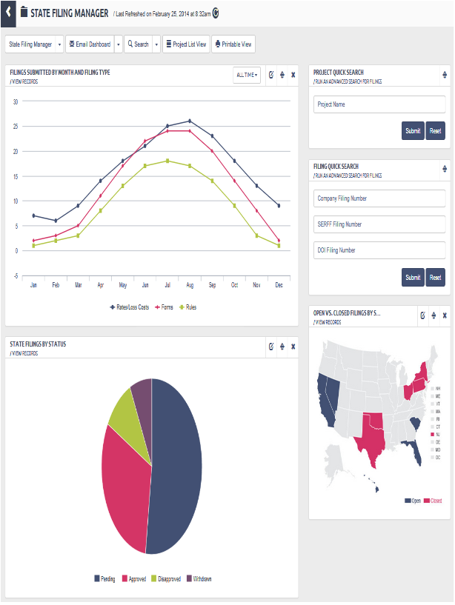

##### SFM Dashboard

### UC-1-4 - SFM List View

The use case encompasses functionality of State Filing Project List View for logged in users.

|  |  |
| --- | --- |
| Preconditions Admin, Authenticated Client, Authenticated Client Admin, Authenticated User should be logged in and have subscription for State Filing Manager App. | Success Guarantee System will display State Filing Manager Project List View to the Admin, Authenticated Client, Authenticated Client Admin, Authenticated User. |

#### Main Success Scenario

1. Admin, Authenticated Client, Authenticated Client Admin, Authenticated User will click on Apps->State Filing Manager->Project List View.
2. if Admin, Authenticated Client, Authenticated Client Admin, Authenticated User select List view as Default View in SFA Dashboard Manager then System directly show the List View other than dashboard.
3. System checks if Admin, Authenticated Client, Authenticated Client Admin, Authenticated User have subscription for "StateFilings.com Software" or "Perr&Knight State Filings Services" and redirects them to the List View of State Filing Manager. else System show informative page of State Filing Manager.
4. System will redirect Admin, Authenticated Client, Authenticated Client Admin, Authenticated User to the "Default View" of State Filing Project List View screen.
   1. System will retain the Current Selected view (Custom or Default), when the user is redirected to the same screen (i.e State Filing Project List View) by performing below mentioned actions within State Filing Manager App.
      1. If the user clicks on "View" link against a project record, system will redirect user to project detail screen and again user clicks on "Back to Project List" button on details screen.
      2. If the user click on "Dashboard View" and again from Dashboard view comes back to State Filing Project List View.
      3. If user click on "Printable View" button on State Filing Project List View screen.
      4. If user click on "Export Details" button on State Filing Project List View screen.
      5. If user performs pagination on State Filing Project List View.
      6. If user adds a new project by clicking "Add a Project".
   2. Once the user leaves the app and comes to State Filing Project List View, System will always display Default View.
5. "Default View" will display all the default columns set for list of projects. Users cannot modify or delete a Default View.
6. "Custom View" - Admin, Authenticated Client, Authenticated Client Admin, Authenticated User can add custom views where in they can select the columns, column sort order etc. to be displayed in project list.
   1. To add a custom a view, the available columns will include default view columns plus custom fields added for State Filing Manager and the account of logged in user.
   2. **Add View** - System will add a new Custom View for State Filing Project.
      1. If the user is adding a custom view from State Filing Manager List View, Add Custom View screen will have all the columns related to the State Filing Project. All the other things will be same as general add custom view functionality [Refer - Add Custom View (UC-3-1)]
   3. **Edit Current View** - System will save changes made to the selected custom view for State Filing Project [Refer Use Case - Edit Custom View (UC-3-2)]
   4. **Delete Current View** - System will confirm from user if they want to delete the selected custom view. If Admin, Authenticated Client, Authenticated Client Admin, Authenticated User click 'yes', System will remove the view and it will not be available for user on State Filing Project List.
   5. **Custom View List** - Admin, Authenticated Client, Authenticated Client Admin, Authenticated User can select the view to be displayed from the list of Custom View shown on State Filing Project List View.
7. System will display a list of all account level projects with columns set in the view selected by user.
   1. If Insurance Group Level user is logged in, System will show projects for that parent group and its associated companies for that user.
   2. If Insurance Child Company Level user is logged in, System will show projects for that company and not the projects belonging to its parent group.
   3. If Insurance Company Level user is logged in, System will show projects belonging to the company itself.
   4. If Third Party Level user is logged in, System will show projects for that Third Party Filer account and projects for Groups and Companies with whom the Third Party Filer is associated with.
   5. If Affiliate Level user is logged in, System will show projects for Groups and Companies with whom the Affiliate is associated with.
   6. If Admin Account user is logged in, System will show projects for all Groups and Companies in the available in system.
8. System will display following columns under Default View. The default sort order for the list will be descending order on Project Created Date.
   1. Project Name - provided by user while creating the project or after editing a project.
      1. User can click on the sort icon besides "Project Name". If the "Project Name" is in Ascending Order it will change to Descending Order and If the "Project Name" is in Descending Order it will change to Ascending Order
      2. Admin, Authenticated Client, Authenticated Client Admin, Authenticated User clicks on values corresponding to "Project Name".
         1. System will redirect user to particular Project's detail screen.
   2. Description - provided by user while creating the project or after editing a project.
   3. Company Name - provided by user while creating the project or after editing a project.
      1. User can click on the sort icon besides "Company Name". If the "Company Name" is in Ascending Order it will change to Descending Order and If the "Company Name" is in Descending Order it will change to Ascending Order
   4. Status - If the user changes the status to "Closed" while editing the project, System will display the Status as closed else the status will be "Open".
      1. User can click on the sort icon besides column "Status". If the "Status" is in Ascending Order it will change to Descending Order and If the "Status" is in Descending Order it will change to Ascending Order
   5. % Complete - System will calculate the "% Complete" for each project by calculating [(No. of Approved Filings / Total No. of Filings) * 100]
      1. User can click on the sort icon besides column "% Complete". If the "% Complete" is in Ascending Order it will change to Descending Order and If the "% Complete" is in Descending Order it will change to Ascending Order
   6. Start Date - provided by user while creating the project or after editing a project.
      1. User can click on the sort icon besides column "Start Date". If the "Start Date" is in Ascending Order it will change to Descending Order and If the "Start Date" is in Descending Order it will change to Ascending Order.
      2. Start Date format would be MM/dd/yyyy.
9. Project List Count
   1. All - User can click on "All" link to get all list of project where status 'Open' and 'Closed'.
   2. Open - User can click on "Open" link to get list of project where status is 'Open'.
   3. Closed - User can click on "Closed" link to get list of project where status is 'Closed'.
10. System will have sorting for the columns selected while creating custom view.
11. System will have paging. Admin, Authenticated Client, Authenticated Client Admin, Authenticated User can select number of records to be displayed per page.
    1. User can click on "<<" button to view the first page.
    2. User can click on ">>" button to view the last page.
12. Add Project - System will redirect user to Add Project screen.
    1. This button will not be available to Read-Only users
13. Search - System will provide user with two options
    1. Search Projects - System will redirect user to "Project Search" screen.
    2. Search Filings - System will redirect user to "Filing Search" screen.
14. Dashboard View - System will redirect user to default State Filing Manager Dashboard View screen of that particular user. If user has not select any dashboard as default then user will display State Filing Manager Starter Dashboard.
15. Printable View - System will display a view of the project list and a "Print" button. When Admin, Authenticated Client, Authenticated Client Admin, Authenticated User click on "Print", a Print dialog box will be opened and user can print the project list.
16. Export Details - System will export all the project list with columns selected in the custom view or default view columns to excel file.

#### Extensions

6.4.a If Admin, Authenticated Client, Authenticated Client Admin, Authenticated User click 'no', system will do nothing and remains on screen State Filing Project List View.

8.4.a System will not analyze the status of the project based on "% Complete". User can manually close a project from Edit Project screen

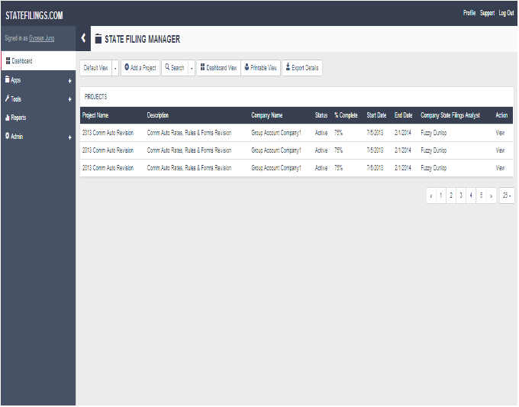

##### SFM Project List View

### UC-1-5 - SFM Project Details

The use case encompasses functionality of State Filing Project Details for logged in users.

|  |  |
| --- | --- |
| Preconditions Admin, Authenticated Client, Authenticated Client Admin, Authenticated User should be logged in and have subscription for State Filing Manager App. | Success Guarantee System will display State Filing Manager Project Details to the Admin, Authenticated Client, Authenticated Client Admin, Authenticated User. |

#### Main Success Scenario

1. Admin, Authenticated Client, Authenticated Client Admin, Authenticated User will click on Apps->State Filing Manager->Project List View and click on "View" link of any of the projects listed.
2. System will redirect user to State Filing project details screen.
3. Collapse/Expand All - User can collapse/expand both "Project Details" & "Filings" panels by clicking "Collapse All" / "Expand All" buttons.
4. "Project Details"
   1. System will display all the details related to the project selected. Following are the details
      1. Project Name
      2. Company State Filings Analyst
      3. Company Rate/Rule Contact
      4. Company Forms Contact
      5. Third Party Filer State Filings Analyst
      6. Third Party Filer Rate/Rule Contact
      7. Third Party Filer Forms Contact
      8. Percentage Complete
      9. Product
      10. Group Name
      11. Company Name
      12. Affiliates
      13. TOI
      14. Sub-TOI
      15. Filing Type(s)
      16. States - System will display number of states
          1. When user hover over state number, System will display the list of state codes.
      17. Description
      18. Date Ended - Date Ended will be the date when the last filing of project is marked as approved. i.e when all the filings in a particular project are approved System will update the end of the project.
      19. Created By
      20. Create Date
      21. Last Edited By
      22. Last Edit Date
      23. Project Requesting Department
      24. Project Requesting Employee
   2. User can collpase/expand "Project Details" panel by clicking down/up arrow icon placed before project details text.
5. Filings
   1. System displays all the filings belonging to the selected project.
      1. At first Filings are listed as per the Default View. Admin, Authenticated Client, Authenticated Client Admin, Authenticated User can not edit or delete the Default View for Filings. In Default View Filings will be listed as per descending order on Created Date.
         1. Select - System will display check boxes to select filings for download. The check box will be disabled for filings with status other than 'Approved/Filed' & 'Desk Filing'
         2. Company Tracking Number - Entered by user while adding filing
            1. System will display Company Tracking Number as link if the filing status is 'Approved/Filed' or 'Desk Filing' else it will be a normal text.

When Admin, Authenticated Client, Authenticated Client Admin, Authenticated User clicks on Company Tracking Number link then System will redirect user to filing details screen.

* + - * 1. User can click on the sort icon besides "Company Tracking Number". If the "Company Tracking Number" is in Ascending Order it will change to Descending Order and If the "Company Tracking Number" is in Descending Order it will change to Ascending Order.
      1. State - Selected by user while adding filing
         1. User can click on the sort icon besides "State". If the "State" is in Ascending Order it will change to Descending Order and If the "State" is in Descending Order it will change to Ascending Order.
      2. Filing Type - Selected by user while adding filing
         1. User can click on the sort icon besides "Filing Type". If the "Filing Type" is in Ascending Order it will change to Descending Order and If the "Filing Type" is in Descending Order it will change to Ascending Order.
      3. Status - Set by user while working on filing
         1. User can click on the sort icon besides "Status". If the "Status" is in Ascending Order it will change to Descending Order and If the "Status" is in Descending Order it will change to Ascending Order.
      4. Effective Date (New) - Selected by user while adding filing
         1. User can click on the sort icon besides "Effective Date (New)". If the "Effective Date (New)" is in Ascending Order it will change to Descending Order and If the "Effective Date (New)" is in Descending Order it will change to Ascending Order.
         2. Effective Date (New) format would be MM/dd/yyyy.
      5. Effective Date(Renewals) - Selected by user while adding filing
         1. User can click on the sort icon besides "Effective Date(Renewals)". If the "Effective Date(Renewals)" is in Ascending Order it will change to Descending Order and If the "Effective Date(Renewals)" is in Descending Order it will change to Ascending Order.
         2. Effective Date(Renewals) format would be MM/dd/yyyy.
    1. "Select All" - When user clicks on 'Select All' button, System will select all the filings whose status is 'Approved/Filed' and not other filings
    2. "Download Selected Filings" - When user clicks on 'Download Selected Filings' button, System will download a zip file which will contain all the attachments related to the particular filing and is of Filing Attachment Type "Complete Approved Filing".
    3. Admin, Authenticated Client, Authenticated Client Admin, Authenticated User can add custom views for filings by clicking "Add View" link on Project details screen and the view will be available for user on Project Details screen. User can click on the view name and System will display the preferences set in the view. [Refer Use Case - Add Custom View (UC-3-1)]
       1. The columns user can add from a custom view are
          1. State
          2. Filing Type
          3. Status
          4. Effective Date(New)
          5. Effective Date(Renewal)
          6. Company Tracking Number
    4. Admin, Authenticated Client, Authenticated Client Admin, Authenticated User can edit existing custom view created for filings by click "Edit Current View" on Project details screen. [Refer Use Case - Edit Custom View (UC-3-2)]
    5. Admin, Authenticated Client, Authenticated Client Admin, Authenticated User can delete existing custom view by clicking "Delete Current View" on Project details screen. System will confirm from user if they want to delete the selected custom view. If Admin, Authenticated Client, Authenticated Client Admin, Authenticated User click 'yes', System will remove the view and it will not be available for the users.
  1. User can collpase/expand "Filings" panel by clicking down/up arrow icon placed before filings text.

1. Filing List Count
   1. All - User can see all list of Filing for Selected Project.
2. Edit Project - Admin, Authenticated Client, Authenticated Client Admin, Authenticated User can edit the selected project by clicking "Edit" link. System will enable fields in edit mode on same screen where user can save the changes, cancel and delete the current "Project Details".
   1. User can cancel current "Project Details" and disable the edit mode and remains on same screen.
   2. User clicks on 'Delete' button on "Project Details" screen in Edit mode.
      1. System opens confirmation pop up
      2. On subsequent confirmation by the user for project deletion
         1. System should opens a pop with fields :
            1. Reason (Text Field, Mandatory)
            2. Delete (Button)

Admin, Authenticated Client, Authenticated Client Admin, Authenticated User clicks 'Confirm' button

System will delete the particular project and redirect user to 'Project Listing' screen.

1. Add Filings - Admin, Authenticated Client, Authenticated Client Admin, Authenticated User can add new filings to the project by clicking "Add Filings" button. System will redirect user to Add Filings screen.
   1. This button will not be available to Read-Only users
2. Search - System will provide user with two options
   1. Search Projects - System will redirect user to "Project Search" screen.
   2. Search Filings - System will redirect user to "Filing Search" screen.
3. Back to Project List - If Admin, Authenticated Client, Authenticated Client Admin, Authenticated User clicks on "Back to Project List" button, System will redirect user to the State Filing Project List View.
   1. If user redirected from search result to Project Details screen , System will redirect user to Search Project Result Screen.
4. Dashboard View - If Admin, Authenticated Client, Authenticated Client Admin, Authenticated User clicks on "Dashboard View" button, System will redirect user to State Filing Manager Dashboard View screen.
5. Printable View - System will display a details of project selected, filings belonging to the project and a "Print" button. When Admin, Authenticated Client, Authenticated Client Admin, Authenticated User clicks on "Print", a Print dialog box will be opened and user can print the project details.
6. Export Details - System will export all the project details and filings belonging to the project with columns selected in the custom view or default view columns on two different sheets of excel file.

#### Extensions

5.1.6.a If Admin, Authenticated Client, Authenticated Client Admin, Authenticated User click 'no', system will do nothing and remains on screen State Filing Project Details screen.

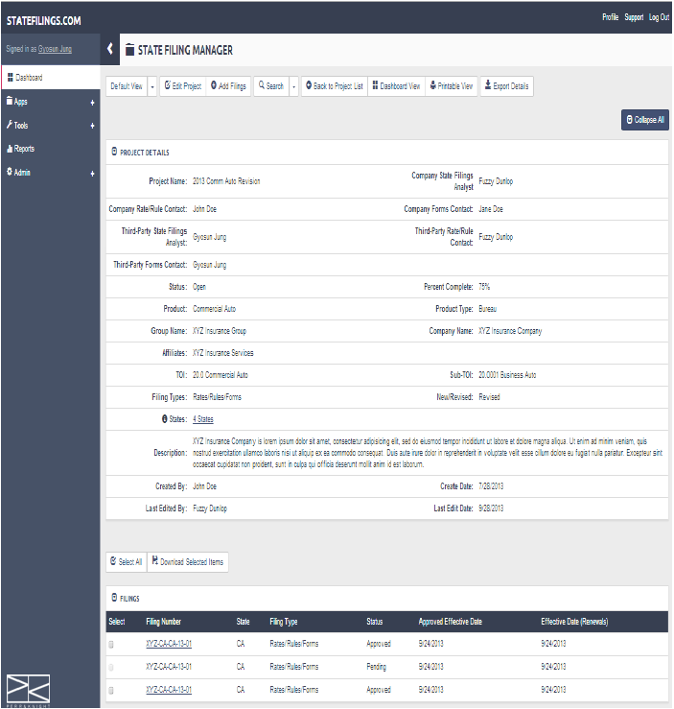

##### SFM Project Details

### UC-1-6 - SFM Change Project Owner

The use case encompasses functionality of changing Owner for a project

|  |  |
| --- | --- |
| Preconditions Admin, Authenticated Client, Authenticated Client Admin, Authenticated User should have subscription for State Filing Manager App. | Success Guarantee System will display changed Owner Name on State Filing Manager Project Details and notify user about the same. |

#### Main Success Scenario

1. Admin, Authenticated Client Admin will click on Apps->State Filing Manager->Project List View->Project Details and click on "[Change]" link.
2. System will redirect user to Change Project Owner screen.
3. Project Owner(Mandatory) - System will display existing project owner name into the Project Owner dropdown list.
   1. Admin, Authenticated Client Admin can change the project owner from the given list of owner names in the dropdown list.
   2. List of users will be those users who belongs to the same account and has access to the project.
4. Change Ownership for All Filings - Admin, Authenticated Client Admin can select this option if they want to change the owner of all the filings belonging to the selected projected.
5. Send Notification Email - If Admin, Authenticated Client Admin selects this option, System will notify Authenticated Client Admin about the change of Project Owner via e-mail.
6. If Admin, Authenticated Client Admin clicks on "Save", System will save the Project Owner name against the project selected and user can view it on the State Filing Project Details screen.
7. If Admin, Authenticated Client Admin clicks on "Cancel", System will discard the changes and redirect user to State Filing Project Details screen.

#### Extensions

1.a System will not show "[Change]" link for Authenticated Client, Authenticated User.

3.1.a If Admin, Authenticated Client Admin doesn't select any project owner name, System will display an error message "Project Owner Name is required."

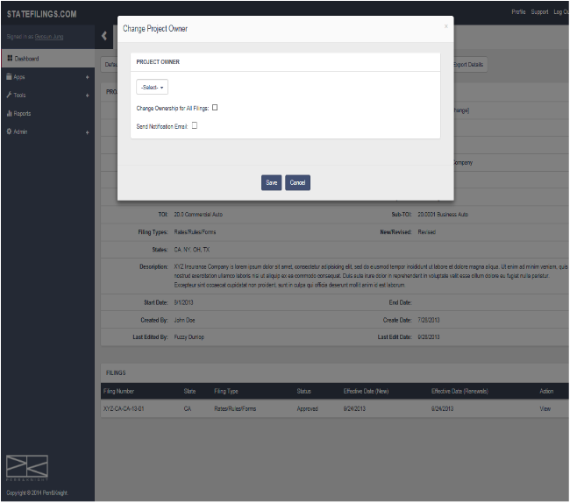

##### SFM Change Project Owner

### UC-1-7 - SFM Search Project

The use case encompasses functionality of Searching State Filing Projects.

|  |  |
| --- | --- |
| Preconditions Admin, Authenticated Client, Authenticated Client Admin, Authenticated User should be logged in and have subscription for State Filing Manager App. | Success Guarantee System will displays list of projects as a result of criteria selected on Project Search screen. |

#### Main Success Scenario

1. Admin, Authenticated Client, Authenticated Client Admin, Authenticated User can go to Search Project screen from State Filing Manger Dashboard by clicking 'Run an Advanced Search for Projects' and from State Filing Manager Project List View, State Filing Manager Project Details View or State Filing Details screens by clicking "Search Projects" button.
2. System will redirect user to State Filings Search Project screen.
3. System will allow user to search for particular project(s) and its details.
4. System will allow Authenticated Client & Authenticated User to search only projects created by themselves respectively.
5. System will allow users to search only filings created for its company account.
6. System will allow Admin to search all the projects for all accounts.
7. System provides different search criteria grouped under following sections based on which projects can be searched
   1. Project Name (Not Mandatory)
      1. Multiple Project names can be entered by using separator comma.
   2. Company Name (Not Mandatory)
      1. User can search projects by entering company name into a text box.
   3. Product Name (Not Mandatory)
      1. User can search projects by entering product name into a text box.
   4. Status (Not Mandatory)
      1. User can search projects by selecting status from a dropdown list.
         1. Open- If user selects 'Open', System will return list of all the active projects belonging to company of logged in user.
         2. Closed - If user selects 'Closed', System will return list of all the closed projects belonging to company of logged in user.
   5. Group Name List - User can select projects by Group Names
      1. If Logged in User is Group Level, System show Account Name in Group Name List
      2. If Logged in User is Company Level, System show Group Name List disable
      3. If Logged in User is Third Party Filer Level, System show Associated Group Name of Third Party Filer in Group Name List
      4. If Logged in User is Affiliate Level, System show Associated Group Name of Affiliate in Group Name List
      5. Admin, Authenticated Client, Authenticated Client Admin, Authenticated User can select multiple Group Names from the available list and click on ">>" button to add the Group Names to the selected list of Group Names.
      6. Admin, Authenticated Client, Authenticated Client Admin, Authenticated User can select multiple Group Names from the selected Group Name list and click on "<<" button to add the Group Names back to the available list of Group Names.
   6. Billing Contact - This option is shown only to 'Super Users'.
      1. User can search projects by selecting a Billing Contact from a Billing Contact combo box.
      2. User can search Billing Contact by entering Billing Contact name into a text box
      3. Admin, Authenticated Client, Authenticated Client Admin, Authenticated User can select multiple Billing Contact Name from the available list and click on ">>" button to add the Billing Contact to the selected list of Billing Contact Names.
      4. Admin, Authenticated Client, Authenticated Client Admin, Authenticated User can select multiple Billing Contact Names from the selected Billing Contact list and click on "<<" button to add the Billing Contact Names back to the available list of Billing Contact Names.
   7. Affiliate Name List - User can select projects by Affiliate Names
      1. Admin, Authenticated Client, Authenticated Client Admin, Authenticated User can select multiple Affiliate Names from the available list and click on ">>" button to add the Affiliate Names to the selected list of Affiliate Names.
      2. Admin, Authenticated Client, Authenticated Client Admin, Authenticated User can select multiple Affiliate Names from the selected Affiliate Name list and click on "<<" button to add the Affiliate Names back to the available list of Company Names.
   8. Dates
      1. From & To Dates - User can provide a date range in From & To date fields in order to retrieve projects which is "Date Created/Date Ended/Last Date Edited " between the date range specified.
         1. Today - If user clicks on "Today" link, System will set the date range fields with "From" date & "To" date as current date. For Example:- From - 02/11/2014 & To - 02/11/2014
         2. This Week - If user clicks on "This Week" link, System will set the date range fields with "From" date as start date of current week & "To" date as end date of current week. For Example:- From - 02/10/2014 & To - 02/16/2014
         3. This Month - If user clicks on "This Month" link, System will set the date range fields with "From" date as start date of the current month & "To" date as end date of current month. For Example:- From - 02/01/2014 & To - 02/28/2014
         4. This Year - If user clicks on "This Year" link, System will set the date range fields with "From" date as start date of the current year & "To" date as end date of current year. For Example:- From - 01/01/2014 & To - 12/31/2014
   9. DOI Analyst (Not Mandatory) (Multiple)
      1. User can search Project by selecting DOI Analyst from Available List to Selected List
      2. If "Group Level" user is logged in, System will display users of that group.
      3. If "Company Level" user is logged in, System will display users of that company.
      4. If a "Third Party" user is logged in, System will display users of that account to whom third party filer is associated.
      5. If a "Affiliate" user is logged in, System will display users of that account to whom affiliate is associated.
   10. TOI List - If Admin, Authenticated Client, Authenticated Client Admin, Authenticated User select TOI in Search by field, System will display a list of available TOIs.
       1. Admin, Authenticated Client, Authenticated Client Admin, Authenticated User can select multiple TOIs from the available list and click on ">>" button to add the TOIs to the selected list of TOIs
       2. Admin, Authenticated Client, Authenticated Client Admin, Authenticated User can select multiple TOIs from the selected TOI list and click on "<<" button to add the TOIs back to the available list of TOIs
   11. Sub-TOI List - If Admin, Authenticated Client, Authenticated Client Admin, Authenticated User select Sub-TOI in Search by field, System will display a list of available Sub-TOIs.
       1. Admin, Authenticated Client, Authenticated Client Admin, Authenticated User can select multiple Sub-TOIs from the available list and click on ">>" button to add the Sub-TOIs to the selected list of Sub-TOIs
       2. Admin, Authenticated Client, Authenticated Client Admin, Authenticated User can select multiple Sub-TOIs from the selected Sub-TOI list and click on "<<" button to add the Sub-TOIs back to the available list of Sub-TOIs.
   12. Filing Contact (Not Mandatory)
       1. Admin, Authenticated Client, Authenticated Client Admin, Authenticated User can select multiple Filing Contact from the available list and click on ">>" button to add the Filing Contact to the selected list of Filing Contact.
       2. Admin, Authenticated Client, Authenticated Client Admin, Authenticated User can select multiple Filing Contact from the selected Filing Contact list and click on "<<" button to add the Filing Contact back to the available list of Filing Contact.
   13. Filing Types (Not Mandatory)
       1. User can search projects by selecting filing types from given buttons.
   14. States
       1. Admin, Authenticated Client, Authenticated Client Admin, Authenticated User can select states for which they want to search a project.
       2. User can select "All State" in order to select all the states at one go.
   15. Keyword
       1. User can search projects by entering keyword into a text box.
8. Search - If Admin, Authenticated Client, Authenticated Client Admin, Authenticated User click on "Search" button, System will process the different criteria selected/entered by user and return a list of projects based on those criteria.
9. Save & Initiate Search - If Admin, Authenticated Client, Authenticated Client Admin, Authenticated User click on "Save & Initiate Search" button, System will save the criteria and process the same to return a list of projects based on those criteria.
   1. System will open a popup asking user to enter the Name(Mandatory) for the search to be saved and its Description(Not Mandatory).
   2. If user clicks on "Save", System will save the criteria and proceed with the result.
   3. If user clicks on "Cancel", System will close the popup without saving the report.
10. View Saved Searches - If Admin, Authenticated Client, Authenticated Client Admin, Authenticated User click on "View Saved Searched" button, System will redirect user to saved searches screen where user can see all the saved searches for type "State Filing Manger(Projects)" and run them without selecting the criteria again.
    1. The project saved searches can be seen with type "State Filing Manager (Projects)".
11. Reset - If Admin, Authenticated Client, Authenticated Client Admin, Authenticated User click on "Reset" button, System will reset all the changes made to the criteria.

#### Extensions

7.4.1.a If user does not select any Status from the drop down, system will display results with both Open& Closed status.

7.8.1.a From & To Dates should be valid Date value else system will display an error message "Invalid Date"

1. Use Case continues from pt 7.8.1

9.a Admin, Authenticated Client, Authenticated Client Admin, Authenticated User can view the saved search under Tools->Saved Search Manager and run the search.

9.1.a If user doesn't enter Search Name, System will display an error message "Name is required"

1. Use case continues from pt 9.1

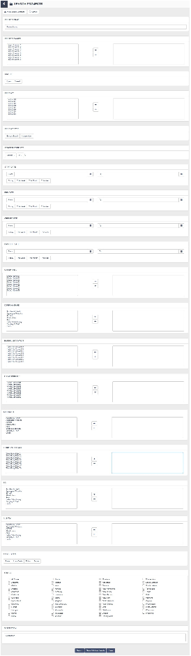

##### SFM Search Project

### UC-1-8 - SFM Search Project Result

The use case encompasses functionality of displaying the result for State Filing Project Search.

|  |  |
| --- | --- |
| Preconditions Admin, Authenticated Client, Authenticated Client Admin, Authenticated User should be logged in and have subscription for State Filing Manager App. | Success Guarantee System will displays list of projects as a result of criteria selected on Project Search screen. |

#### Main Success Scenario

1. Admin, Authenticated Client, Authenticated Client Admin, Authenticated User can view Search Project Result by selecting criteria on Search Project screen and clicking "Initiate Search" or "Save & Initiate Search". [Refer Use Case - SFM Search Project (UC-1-7)]
2. System will display the result with following columns
   1. Project Name - provided by user while creating the project or after editing a project.
      1. User can click on the sort icon besides "Project Name". If the "Project Name" is in Ascending Order it will change to Descending Order and If the "Project Name" is in Descending Order it will change to Ascending Order
   2. Description - provided by user while creating the project or after editing a project.
   3. Status - If the user changes the status to "Closed" while editing the project, System will display the Status as closed else the status will be "Acive".
      1. User can click on the sort icon besides column "Status". If the "Status" is in Ascending Order it will change to Descending Order and If the "Status" is in Descending Order it will change to Ascending Order
   4. % Complete - System will calculate the "% Complete" for each project by calculating [(No. of Approved Filings / Total No. of Filings) * 100]
      1. User can click on the sort icon besides column "% Complete". If the "% Complete" is in Ascending Order it will change to Descending Order and If the "% Complete" is in Descending Order it will change to Ascending Order
   5. Start Date - provided by user while creating the project or after editing a project.
      1. User can click on the sort icon besides column "Start Date". If the "Start Date" is in Ascending Order it will change to Descending Order and If the "Start Date" is in Descending Order it will change to Ascending Order
   6. End Date - provided by user while creating the project or after editing a project.
      1. User can click on the sort icon besides column "End Date". If the "End Date" is in Ascending Order it will change to Descending Order and If the "End Date" is in Descending Order it will change to Ascending Order
   7. Company State Filings Analyst - provided by user while creating the project or after editing a project.
      1. User can click on the sort icon besides column "Company State Filings Analyst". If the "Company State Filings Analyst" is in Ascending Order it will change to Descending Order and If the "Company State Filings Analyst" is in Descending Order it will change to Ascending Order
   8. Action - System will display following links under action column
      1. System will display "View" link under Action column by clicking on which user can see the project details. System will redirect user to State Filing Project details screen. [Refer Use Case - SFM Project Details (UC-1-5)]
3. Search Result will have paging. Admin, Authenticated Client, Authenticated Client Admin, Authenticated User can select number of records to be displayed per page.
4. Search Again - When Admin, Authenticated Client, Authenticated Client Admin, Authenticated User clicks on "Search Again ' button, System will redirect user to Project Search screen where user can select a new criteria for searching projects.
5. Refine Search - When Admin, Authenticated Client, Authenticated Client Admin, Authenticated User clicks on "Refine Search" button, System will redirect user to Project Search screen where all the criteria for search will be retained by the system.
6. Printable View - When Admin, Authenticated Client, Authenticated Client Admin, Authenticated User clicks on "Printable View", System will display a view of the project search result and a "Print" button. When Admin, Authenticated Client, Authenticated Client Admin, Authenticated User click on "Print", a Print dialog box will be opened and user can print the result.
7. Export Details - System will export project results to excel file.
8. Project List Count
   1. All - User can click on "All" link to get all list of project where status is 'Open' and 'Closed'.
   2. Open - User can click on "Open" link to get list of project where status is 'Open'.
   3. Closed - User can click on "Closed" link to get list of project where status is 'Closed'.

#### Extensions

2.3.a System will not analyze the status of the project based on "% Complete". User can manually close a project from Edit Project screen

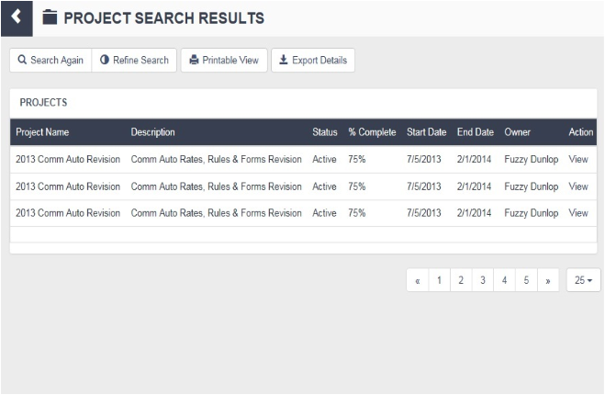

##### Search Project Result

### UC-1-9 - SFM Add Project

The use case encompasses functionality of Adding State Filing Projects.

|  |  |
| --- | --- |
| Preconditions Admin, Authenticated Client, Authenticated Client Admin, Authenticated User should be logged in and have subscription for State Filing Manager App. | Success Guarantee System will create a project for user. |

#### Main Success Scenario

1. System checks if Admin, Authenticated Client, Authenticated Client Admin, Authenticated User have subscription for "StateFilings.com Software" or "Perr&Knight State Filings Services"
2. System checks,
3. If logged In User's Account having Subscription of only "StateFilings.com Software", then Admin, Authenticated Client Admin, Authenticated Client of Insurance Group and Insurance Company can Add Project.
4. If logged In User's Account having Subscription of only "Perr&Knight State Filings Services" , then Admin, Authenticated Client Admin ,Authenticated Client of Third Party Filer can Add Project.
5. Admin, Authenticated Client Admin can go to Add Project screen from State Filing Manager Project List View -> Add a Project.
6. System will redirect user to the "Add Project" screen.
7. System will require following inputs from user in order to create a project
   1. Project Name (Mandatory)
      1. Admin, Authenticated Client Admin, Authenticated Client can enter a project name which will be unique across the account of the user who is creating the project
   2. Group Name (Mandatory) - Single Selection
      1. Admin, Authenticated Client Admin, Authenticated Client can select a group name for which the project is to be created.
      2. If logged in user is a parent Group/Company level user, System will display Account name of that user.
      3. If logged in user is a child Company level user, System will display the Parent group Account name of that user.
      4. If logged in user is a Third Party Filer user, System will display the Group Account name selected by Third party filer user after login.
      5. If logged in user is Admin account user, System will display list of all the parent group/company account names available in the System.
   3. Company Name (Mandatory) - Multiple Selection
      1. System will display blank list box for Available Company.
      2. When Admin, Authenticated Client Admin, Authenticated Client select the group in step 7.2 , System will display a list of companies belonging to group selected by user and user can select the companies from available company list
   4. Third Party Filer - Single Selection
      1. Third Party Filer dropdown will have following values
         1. No (By default selected)
            1. If the logged in user selects 'No', the System will consider that the project is not assigned to Third Party Filer even if the group/company for which the project is to be added has "Perr&Knight State Filings Services" subscription and Third Party Filer account associated with it.
            2. Also the project will not be displayed on the project list view when a third party filer account user is logged in.
         2. Yes
            1. If the logged in user selects 'Yes', the System will consider that the project is assigned to Third Party Filer and the Third Party Filer account users can handle the project further
            2. The project will be displayed on the project list view when a third party filer account user is logged in.
      2. If a Group/Company does not have "Perr&Knight State Filings Services" subscription or "Perr&Knight State Filings Services" subscription has expired or Third Party Filer account is not associated with it, then System will display Third Party Filer dropdown as disabled and by default the value will be displayed 'No' as selected.
      3. Third Party Filer will have read-write access to the projects. They can make any changes to projects.
   5. Company State Filings Analyst (Mandatory) - Single Selection
      1. System will display "Company State Filings Analyst" dropdown as disabled until the user selects a Group Name.
      2. Admin, Authenticated Client Admin, Authenticated Client can select a "Company State Filings Analyst" from a dropdown list who will manage the project further.
      3. If logged in user is a parent Group level user, "Company State Filings Analyst" dropdown will have users belonging to the account of logged in user.
      4. If logged in user is a parent or child Company level user, "Company State Filings Analyst" dropdown will have users belonging to the account of logged in user.
      5. If logged in user is a Third Party Filer user or Admin account user, "Company State Filings Analyst" dropdown will have users belonging to the account of selected Group in step 7.2.
   6. Third-Party Filer State Filings Analyst (Mandatory) - Single Selection
      1. System will display "Third-Party Filer State Filings Analyst" dropdown once user selects value 'Yes' from third party filer dropdown in step 7.4.
      2. Admin, Authenticated Client Admin, Authenticated Client can select "Third-Party Filer State Filings Analyst" from a dropdown list which will have list of all the users from the Third Party Filer account associated with the selected group/company.
   7. Company Rate/Rule Contact (Not Mandatory) - Single Selection
      1. System will display Company Rate/Rule Contact dropdown as disabled until the user selects a Group Name.
      2. If logged in user is a parent Group/Company level user, Company Rate/Rule Contact dropdown will have users belonging to the account of logged in user.
      3. If logged in user is a child Company level user, Company Rate/Rule Contact dropdown will have users belonging to the parent account of logged in user.
      4. If logged in user is a Third Party Filer user or Admin account user, Company Rate/Rule Contact dropdown will have users belonging to the account of selected Group in step 7.2.
      5. Admin , Authenticated Client Admin, Authenticated Client select Company Rate/Rule Contact from dropdown.
   8. Third-Party Filer Rate/Rule Contact (Not Mandatory) - Single Selection
      1. System will display "Third-Party Filer Rate/Rule Contact" dropdown once user selects value 'Yes' from third party filer dropdown in step 7.4.
      2. Admin, Authenticated Client Admin, Authenticated Client can select "Third-Party Filer Rate/Rule Contact" from a dropdown list which will have list of all the users from the Third Party Filer account associated with the selected group/company.
   9. Company Forms Contact (Not Mandatory) - Single Selection
      1. System will display Company Forms Contact dropdown as disabled until the user selects a Group Name.
      2. If logged in user is a parent Group/Company level user, Company Forms Contact dropdown will have users belonging to the account of logged in user.
      3. If logged in user is a child Company level user, Company Forms Contact dropdown will have users belonging to the account of logged in user.
      4. If logged in user is a Third Party Filer user or Admin account user, Company Forms Contact dropdown will have users belonging to the account of selected Group in step 7.3.
      5. Admin , Authenticated Client Admin, Authenticated Client select Forms Contact from drop down
   10. Third-Party Filer Forms Contact (Not Mandatory) - Single Selection
       1. System will display "Third-Party Filer Forms Contact" dropdown once user selects value 'Yes' from third party filer dropdown in step 7.4.
       2. Admin, Authenticated Client Admin, Authenticated Client can select "Third-Party Filer Forms Contact" from a dropdown list which will have list of all the users from the Third Party Filer account associated with the selected group/company.
   11. Product (Not Mandatory) - Single Selection
       1. System will display Product dropdown as disabled until the user selects a Companies in step 7.3.
       2. Product dropdown will have products belonging to the Companies selected in step 7.3.
       3. Admin, Authenticated Client Admin, Authenticated Client can select a product for the project to be created from drop down.
   12. Affiliates (Not Mandatory) - Multiple Selection
       1. System will display blank list box for Available Affiliates.
       2. When Admin, Authenticated Client Admin, Authenticated Client select the group in step 7.2 , System will display a list of affiliates belonging to group selected by user and user can select the affiliates from available affiliates list
       3. Admin, Authenticated Client Admin, Authenticated Client can select Affiliates from a list box who will be associated with the project.
       4. Affiliates only have read-only access to the projects. They cannot make any changes to projects.
   13. TOIs (Mandatory) - Multiple Selection
       1. Admin, Authenticated Client Admin, Authenticated Client can select TOIs from a list box for which the project will be created.
   14. Sub-TOI (Mandatory) - Multiple Selection
       1. Sub-TOI will be disabled at first. Once the user selects TOIs in Step 7.13, the Sub-TOIs list will be enabled and displays Sub-TOIs based on TOIs selected.
       2. Admin, Authenticated Client Admin, Authenticated Client can select Sub-TOIs from a list box for which the project will be created.
   15. Filing Types (Mandatory) - Multiple Selection
       1. Admin, Authenticated Client Admin, Authenticated Client can multiple filing types for a project from a checkbox list.
       2. The filing types given are
          1. Rate
          2. Rule
          3. Forms
          4. Loss Cost
   16. States (Mandatory) - Multiple Selection
       1. Admin, Authenticated Client Admin, Authenticated Client can select States from a checkbox list for which the project will be created.
       2. Admin, Authenticated Client Admin, Authenticated Client can add only those filings to projects which belongs to the states selected in step 7.16.1.
   17. Description (Not Mandatory)
       1. Admin, Authenticated Client Admin can enter a description in the textbox.
   18. Project Requesting Department (Single Selection)
       1. This field will have following values :
          1. Actuarial
          2. Compalaince
          3. FMU
          4. Forms Working Group
          5. IT
          6. Product Management
          7. Special Risk
          8. UCS
          9. Other
   19. Project Requesting Employee (Single Selection)
8. Add Project - When Admin, Authenticated Client Admin clicks on "Add Project", System will check for all the validations and if its valid then System will create the project for that Account. System will redirect user to State Filing Project List View screen.
   1. When System creates a project, it marks project's Start Date as the date when the project is created.
9. Cancel - When Admin, Authenticated Client Admin clicks on "Cancel" button, System will redirect user back to State Filing Project List View screen.

#### Extensions

7.1.a If user doesn't enter Project Name, System will display an error "Project Name is required".

1. Use case will continue from pt 7.1

7.1.1.a If user enters a Project Name which is already used for other project under that account, System will display an error "Project Name is already used".

1. Use case will continue from pt 7.1.1

7.2.a If user doesn't select Group Name, System will display an error "A Group is required".

1. Use case will continue from pt 7.2

7.3.a If user doesn't select Company Names, System will display an error "One or more Companies are required".

1. Use case will continue from pt 7.3

7.5.a If user doesn't select Company State Filings Analyst , System will display an error "Company State Filings Analyst is required".

1. Use case will continue from pt 7.5

7.6.a If user doesn't select Third-Party Filer State Filings Analyst , System will display an error "Third-Party Filer State Filings Analyst is required".

1. Use case will continue from pt 7.6

7.11.a If user doesn't select Product, System will display an error "Product is required".

1. Use case will continue from pt 7.11

7.13.a If user doesn't select TOIs, System will display an error "One or more TOIs are required".

1. Use case will continue from pt 7.13

7.14.a If user doesn't select Sub-TOIs, System will display an error "One or more Sub-TOIs are required".

1. Use case will continue from pt 7.14

7.15.a If user doesn't select Filing Types, System will display an error "One or more Filing Types are required".

1. Use case will continue from pt 7.15

7.16.a If user doesn't select States, System will display an error "One or more States are required".

1. Use case will continue from pt 7.16

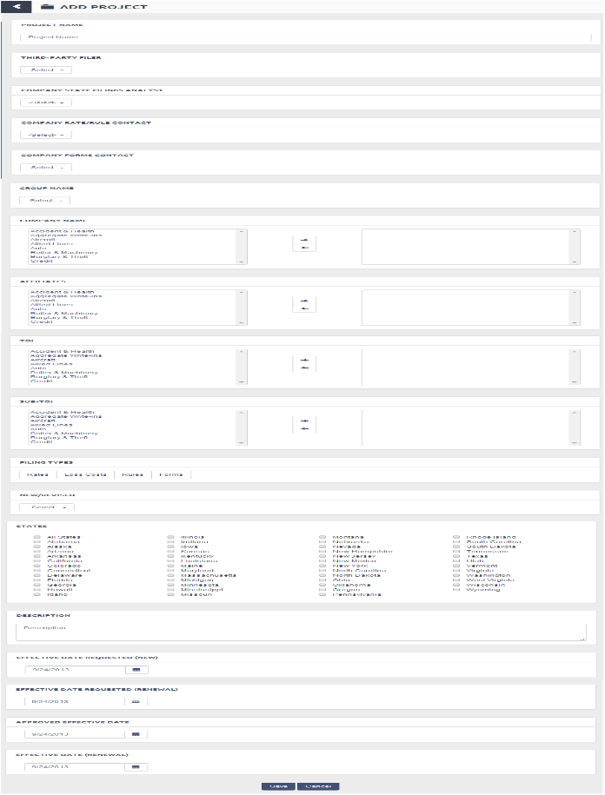

##### AddProject

### UC-1-10 - SFM Edit Project

The use case encompasses functionality of Editing State Filing Projects.

|  |  |
| --- | --- |
| Preconditions Admin, Authenticated Client, Authenticated Client Admin, Authenticated User should be logged in and have subscription for State Filing Manager App. | Success Guarantee System will make all the changes requested by user to a project. |

#### Main Success Scenario

1. System checks if Admin, Authenticated Client, Authenticated Client Admin, Authenticated User have subscription for "StateFilings.com Software" or "Perr&Knight State Filings Services"
2. System checks,
3. If logged In User's Account having Subscription of only "StateFilings.com Software", then Admin, Authenticated Client Admin, Authenticated Client of Insurance Group and Insurance Company can Add Project.
4. If logged In User's Account having Subscription of only "Perr&Knight State Filings Services" , then Admin, Authenticated Client Admin ,Authenticated Client of Third Party Filer can Add Project.
5. Admin, Authenticated Client Admin can go to Edit Project screen from State Filing Manager Project List View then view a project to be edited and click on Edit Project button.
6. System will redirect user to the "Edit Project" screen.
7. System will populate the following fields with values selected while creating the project and Admin, Authenticated Client Admin can change any of the below mentioned fields which are allowed to be edited in order to make changes to a particular project.
   1. Project Name (Mandatory)
      1. Admin, Authenticated Client Admin, Authenticated Client can enter a project name which will be unique across the account of the user who is creating the project
   2. Group Name (Mandatory) - Single Selection
      1. Admin, Authenticated Client Admin, Authenticated Client can select a group name for which the project is to be created.
   3. Company Name (Mandatory) - Multiple Selection
      1. System will display a list of companies belonging to the group selected by user in step 7.2 and user can select the companies from available company list
   4. Third Party Filer - Single Selection
      1. Third Party Filer dropdown will have following values
         1. No (By default selected)
            1. If the logged in user selects 'No', the System will consider that the project is not assigned to Third Party Filer even if the group/company for which the project is to be added has "Perr&Knight State Filings Services" subscription and Third Party Filer account associated with it.
            2. Also the project will not be displayed on the project list view when a third party filer account user is logged in.
         2. Yes
            1. If the logged in user selects 'Yes', the System will consider that the project is assigned to Third Party Filer and the Third Party Filer account users can handle the project further
            2. The project will be displayed on the project list view when a third party filer account user is logged in.
      2. If a Group/Company does not have "Perr&Knight State Filings Services" subscription or "Perr&Knight State Filings Services" subscription has expired or Third Party Filer account is not associated with it, then System will display Third Party Filer dropdown as disabled and by default the value will be displayed 'No' as selected.
      3. If logged in user changes value from 'No' to 'Yes' then system will display third party related contacts (Third Party Filer State Filing Analyst, Third Party Filer Rate/Rule Contact & Third Party Filer Forms Contact)
      4. If logged in user changes value from 'Yes' to 'No' then system will hide third party related contacts (Third Party Filer State Filing Analyst, Third Party Filer Rate/Rule Contact & Third Party Filer Forms Contact)
   5. Company State Filings Analyst (Mandatory) - Single Selection
      1. System will display "Company State Filings Analyst" selected while adding project
      2. Admin, Authenticated Client Admin, Authenticated Client can change the "Company State Filings Analyst" from a dropdown list.
      3. If logged in user is a parent Group level user, "Company State Filings Analyst" dropdown will have users belonging to the account of logged in user.
      4. If logged in user is a parent or child Company level user, "Company State Filings Analyst" dropdown will have users belonging to the account of logged in user.
      5. If logged in user is a Third Party Filer user or Admin account user, "Company State Filings Analyst" dropdown will have users belonging to the account of selected Group in step 7.2.
   6. Third-Party Filer State Filings Analyst (Mandatory) - Single Selection
      1. System will display "Third-Party Filer State Filings Analyst" selected while adding project
      2. Admin, Authenticated Client Admin, Authenticated Client can change "Third-Party Filer State Filings Analyst" from a dropdown list which will have list of all the users from the Third Party Filer account associated with the selected group/company.
   7. Company Rate/Rule Contact (Not Mandatory) - Single Selection
      1. System will display "Company Rate/Rule Contact " selected while adding project
      2. If logged in user is a parent Group/Company level user, Company Rate/Rule Contact dropdown will have users belonging to the account of logged in user.
      3. If logged in user is a child Company level user, Company Rate/Rule Contact dropdown will have users belonging to the parent account of logged in user.
      4. If logged in user is a Third Party Filer user or Admin account user, Company Rate/Rule Contact dropdown will have users belonging to the account of selected Group in step 7.2.
      5. Admin , Authenticated Client Admin, Authenticated Client select Company Rate/Rule Contact from dropdown.
   8. Third-Party Filer Rate/Rule Contact (Not Mandatory) - Single Selection
      1. System will display "Third-Party Filer Rate/Rule Contact" selected while adding project
      2. Admin, Authenticated Client Admin, Authenticated Client can change "Third-Party Filer Rate/Rule Contact" from a dropdown list which will have list of all the users from the Third Party Filer account associated with the selected group/company.
   9. Company Forms Contact (Not Mandatory) - Single Selection
      1. System will display "Company Forms Contact " selected while adding project
      2. If logged in user is a parent Group/Company level user, Company Forms Contact dropdown will have users belonging to the account of logged in user.
      3. If logged in user is a child Company level user, Company Forms Contact dropdown will have users belonging to the account of logged in user.
      4. If logged in user is a Third Party Filer user or Admin account user, Company Forms Contact dropdown will have users belonging to the account of selected Group in step 7.3.
      5. Admin , Authenticated Client Admin, Authenticated Client select Forms Contact from drop down
   10. Third-Party Filer Forms Contact (Not Mandatory) - Single Selection
       1. System will display "Third-Party Filer Forms Contact" selected while adding project
       2. Admin, Authenticated Client Admin, Authenticated Client can change "Third-Party Filer Forms Contact" from a dropdown list which will have list of all the users from the Third Party Filer account associated with the selected group/company.
   11. Product (Not Mandatory) - Single Selection
       1. Admin, Authenticated Client Admin, Authenticated Client can change a product for the project to be created from a list box.
   12. Affiliates (Not Mandatory) - Multiple Selection
       1. System shows Affiliates Names in Available List who are associate with that Account.
       2. Admin, Authenticated Client Admin, Authenticated Client can select Affiliates from a list box who will be associated with the project.
       3. Affiliates only have read-only access to the projects. They cannot make any changes to projects.
   13. TOIs (Mandatory) - Multiple Selection
       1. Admin, Authenticated Client Admin, Authenticated Client can select TOIs from a list box for which the project will be created.
   14. Sub-TOI (Mandatory) - Multiple Selection
       1. Admin, Authenticated Client Admin, Authenticated Client can select Sub-TOIs from a list box for which the project will be created.
   15. Filing Types (Mandatory) - Multiple Selection
       1. Admin, Authenticated Client Admin, Authenticated Client can multiple filing types for a project from a checkbox list.
       2. The filing types given are
          1. Rate
          2. Rule
          3. Forms
          4. Loss Cost
   16. States (Mandatory) - Multiple Selection
       1. Admin, Authenticated Client Admin, Authenticated Client can select States from a checkbox list for which the project will be created.
       2. Admin, Authenticated Client Admin, Authenticated Client can add only those filings to projects which belongs to the states selected in step 3.16.1.
   17. Description (Mandatory)
       1. Admin, Authenticated Client Admin can change a description in the textbox.
   18. Project Requesting Department (Single Selection)
       1. This field will have following values :
          1. Actuarial
          2. Compalaince
          3. FMU
          4. Forms Working Group
          5. IT
          6. Product Management
          7. Special Risk
          8. UCS
          9. Other
   19. Project Requesting Employee (Single Selection)
8. Admin, Authenticated Client Admin can only edit projects whose status is "Open". System will not allowed user to edit "Closed" projects.
9. Save Project - When Admin, Authenticated Client Admin clicks on "Save Project", System will check for all the validations and if its valid then System will save the changes to project for that Account. System will redirect user to State Filing Project Details screen.
10. Cancel - When Admin, Authenticated Client Admin clicks on "Cancel" button, System will discard any changes and redirect user back to State Filing Project Details screen.

#### Extensions

7.1.a If user doesn't enter Project Name, System will display an error "Project Name is required".

1. Use case will continue from pt 7.1

7.1.1.a If user enters a Project Name which is already used for other project under that account, System will display an error "Project Name is already used".

1. Use case will continue from pt 7.1.1

7.2.a If user doesn't select Group Name, System will display an error "A Group is required".

1. Use case will continue from pt 7.2

7.3.a If user doesn't select Company Names, System will display an error "One or more Companies are required".

1. Use case will continue from pt 7.3

7.5.a If user doesn't select Company State Filings Analyst , System will display an error "Company State Filings Analyst is required".

1. Use case will continue from pt 7.5

7.6.a If user doesn't select Third-Party Filer State Filings Analyst , System will display an error "Third-Party Filer State Filings Analyst is required".

1. Use case will continue from pt 7.6

7.11.a If user doesn't select Product, System will display an error "Product is required".

1. Use case will continue from pt 7.5

7.13.a If user doesn't select TOIs, System will display an error "One or more TOIs are required".

1. Use case will continue from pt 7.8

7.14.a If user doesn't select Sub-TOIs, System will display an error "One or more Sub-TOIs are required".

1. Use case will continue from pt 7.9

7.15.a If user doesn't select Filing Types, System will display an error "One or more Filing Types are required".

1. Use case will continue from pt 7.10

7.16.a If user doesn't select States, System will display an error "One or more States are required".

1. Use case will continue from pt 7.11

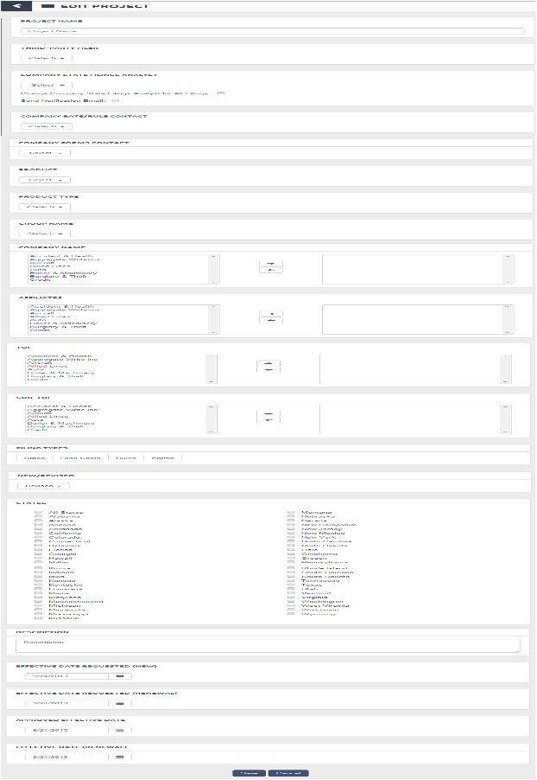

##### EditProject

### UC-1-11 - SFM Filing Details

The use case encompasses functionality of State Filing Details for logged in users.

|  |  |
| --- | --- |
| Preconditions Admin, Authenticated Client, Authenticated Client Admin, Authenticated User should be logged in and have subscription for State Filing Manager App. | Success Guarantee System will display State Filing Manager - Filing Details to the Admin, Authenticated Client, Authenticated Client Admin, Authenticated User. |

#### Main Success Scenario

1. Admin, Authenticated Client, Authenticated Client Admin, Authenticated User will go to Apps->State Filing Manager->Project List View -> click on "View" -> Project Details-> click on "View" link to view any of the filings belonging to the project selected.
2. System opens up a new window showcasing State Filing Details screen.
3. Collapse/Expand All - User can collapse/expand all the panels on filing details screen by clicking "Collapse All" / "Expand All" buttons.
4. System will display all the details related to the filing selected. Following are the details. User can collpase/expand "Filing Details" panel by clicking down/up arrow icon placed before filing details text.
   1. Company Tracking Number
   2. State Tracking Number
   3. SERFF Tracking Number
   4. State
   5. Filing Types
   6. Filing Law
   7. Filing Status
   8. DOI Analyst
   9. Company Name
   10. Project Name
   11. TOI
   12. Sub-TOI
   13. Effective Date(New)
   14. Effective Date (Renewal)
5. System will also display other panels related to the Filing. Panels are listed below
   1. Filing Fees - It will list all the fees incurred for the selected filing
      1. The contents of the table will be rows for each fee type which are namely DOI Filing Fees, Shipping fees, SASE Fees, Returned Fees, Other Fees. The content of each rows are :
         1. Button labelled "Add"
            1. When Admin, Authenticated Client, Authenticated Client Admin, Authenticated User clicks this particular button System adds a new row with Fee Type corresponding to the particular button.
         2. Remittance Date (Mandatory)
            1. Remittance Date is the date when filing fee is submitted to DOI
         3. Fee Type(Pre populated label)
         4. Note
         5. Amount (Mandatory)
            1. Admin, Authenticated Client Admin can enter the amount of filing fee submitted.
      2. Last row will display Total value based on fees entered by the user.
      3. User can collpase/expand "Filing Fees" panel by clicking down/up arrow icon placed before 'Filing Fees' text.
   2. Activities - It will list all the activities related to the filing.
      1. The details include
         1. Activity Date
         2. Activity Type
         3. Note
         4. Attachment
         5. Follow Up Date
         6. Due Date
         7. Close Date
         8. Email
            1. Email - If Admin, Authenticated Client, Authenticated Client Admin, Authenticated User click on "Email" button, System will send email to users regarding selected activities.

System will open a popup asking user to enter following details :

Email To(Mandatory) - Suggestive Text Box

Admin, Authenticated Client Admin can enter the email address to be send in this field

Subject(Mandatory)

Admin, Authenticated Client Admin can enter the subject of the email to be send in this field

Body(Mandatory)

Admin, Authenticated Client Admin can enter the content of the email to be send in this field.

If user clicks on "Send", System will send the email to email address as mentioned in "Email To" field

The content of the email will the content of "Body" field and a link, on the click of which Admin, Authenticated Client will redirected to the filing details page, scrolled down to the task and activity section

If user clicks on "Cancel", System will close the popup without sending the email and remains on the same screen.

* + - 1. Entered By
      2. Activity ID
         1. System will display link labelled based on Activity ID value by clicking on which user can edit a particular activity. System will redirect user to Edit Activity screen. [Refer Use Case -TAM Edit Filing Activity (UC-25-8)]
    1. Log Filing Activity - When Admin, Authenticated Client Admin click on "Log Filing Activity" button, System will open pop up for Log Filing Activity. [Refer Use Case - TAM Log Filing Activity (UC-25-2)]
    2. If no Activities log for filings, System shows message "No Activities added yet".
    3. User can collpase/expand "Activities" panel by clicking down/up arrow icon placed before 'Activities' text.
  1. Forms Schedule - It will list all the details of Company Forms related to selected filing.
     1. The details include
        1. Form Name
           1. User can click on the sort icon besides "Form Name". If the "Form Name" is in Ascending Order it will change to Descending Order and If the "Form Name" is in Descending Order it will change to Ascending Order.
        2. Form Number
           1. User can click on the sort icon besides "Form Number". If the "Form Number" is in Ascending Order it will change to Descending Order and If the "Form Number" is in Descending Order it will change to Ascending Order.
           2. User can click on this link to view company form details. System will redirect user to Company Form Details screen.
        3. Form Type
           1. User can click on the sort icon besides "Form Type". If the "Form Type" is in Ascending Order it will change to Descending Order and If the "Form Type" is in Descending Order it will change to Ascending Order.
        4. New/Revised
           1. User can click on the sort icon besides "New/Revised". If the "New/Revised" is in Ascending Order it will change to Descending Order and If the "New/Revised" is in Descending Order it will change to Ascending Order.
        5. Status
     2. Add Company Forms - When Admin, Authenticated Client Admin click on "Add Company Forms" button, System will open pop up for Company Forms Search where user can search for the forms to be added for a particular filing. [Refer Use Case - SFM Filing Company Forms (UC-1-24)]
     3. If no Company Forms Added for filings, System shows message "No Company Forms added yet".
     4. User can collpase/expand "Forms Schedule" panel by clicking down/up arrow icon placed before 'Forms Schedule' text.
  2. Rules Schedule - It will list all the Rules related to selected filing. Only Product Management Review User can access this section. For all users it will not be visible
     1. The details include
        1. Rule Name
           1. User can click on the sort icon besides "Rule Name". If the "Rule Name" is in Ascending Order it will change to Descending Order and If the "Rule Name" is in Descending Order it will change to Ascending Order.
        2. Rule Number
           1. User can click on the sort icon besides "Rule Number". If the "Rule Number" is in Ascending Order it will change to Descending Order and If the "Rule Number" is in Descending Order it will change to Ascending Order.
           2. User can click on this link to view rule details. System will redirect user to Rule Details screen.
        3. Rule Edition Date
           1. User can click on the sort icon besides "Rule Edition Date". If the "Rule Edition Date" is in Ascending Order it will change to Descending Order and If the "Rule Edition Date" is in Descending Order it will change to Ascending Order.
     2. Add Rule - When Product Management Review User click on "Add Rule" button, System will open pop up for rules where user can add rule for a particular filing. [Refer Use Case - SFM Filing Rules (UC-1-29)]
     3. If no Rules Added for filings, System shows message "No Rules added yet".
     4. User can collpase/expand "Forms Schedule" panel by clicking down/up arrow icon placed before 'Forms Schedule' text.
  3. Attachments - It will list all the attachments related to the selected filing
     1. The details include
        1. Document Name
           1. User can click on the sort icon besides "Document Name". If the "Document Name" is in Ascending Order it will change to Descending Order and If the "Document Name" is in Descending Order it will change to Ascending Order.
           2. User can click link to download the attachment.

When Admin, Authenticated Client Admin clicks on this particular link, System will open the respective uploaded document.

* + - 1. Attachment Types
         1. Attachment Types will have one of the below mentioned values

Complete Approved Filing

Desk Filing

Regulations

Other

* + - * 1. User can click on the sort icon besides "Filing Attachment Type". If the "Filing Attachment Type" is in Ascending Order it will change to Descending Order and If the "Filing Attachment Type" is in Descending Order it will change to Ascending Order.
      1. Description
         1. User can click on the sort icon besides "Description". If the "Description" is in Ascending Order it will change to Descending Order and If the "Description" is in Descending Order it will change to Ascending Order.
      2. Action
         1. User can delete the attachment by clicking Delete link.
    1. Add Attachment - When Admin, Authenticated Client Admin click on "Add Attachment" button, System will open pop up for Add Attachment screen.
       1. System will add the attachment against the current filing.
       2. Refer Use Case - Add Attachment (UC-3-6) which will describe a general functionality of adding an attachment.
    2. If no Attachment Added for filings, System shows message "No Attachment added yet".
    3. User can collpase/expand "Attachments" panel by clicking down/up arrow icon placed before 'Attachments' text.
  1. Bureau Adoption Information - It will list all the details of Bureau Adoption related to selected filing.
     1. The details include
        1. Circular
           1. User can click on the sort icon besides "Circular". If the "Circular" is in Ascending Order it will change to Descending Order and If the "Circular" is in Descending Order it will change to Ascending Order.
           2. System will display link labelled based on Circular value by clicking on which user can edit a particular circular. System will redirect user to Edit Circular screen. [Refer Use Case -BMC Edit Circular (UC-13-10)]
        2. Bureau
           1. User can click on the sort icon besides "Bureau". If the "Bureau" is in Ascending Order it will change to Descending Order and If the "Bureau" is in Descending Order it will change to Ascending Order.
        3. Title
           1. User can click on the sort icon besides "Title". If the "Title" is in Ascending Order it will change to Descending Order and If the "Title" is in Descending Order it will change to Ascending Order.
        4. Publication Number
           1. User can click on the sort icon besides "Publication Number". If the "Publication Number" is in Ascending Order it will change to Descending Order and If the "Publication Number" is in Descending Order it will change to Ascending Order.
        5. Reference Filing Number
           1. User can click on the sort icon besides "Reference Filing Number". If the "Reference Filing Number" is in Ascending Order it will change to Descending Order and If the "Reference Filing Number" is in Descending Order it will change to Ascending Order.
     2. Add Bureau Circular - When Admin, Authenticated Client Admin click on "Add Bureau Circular" button, System will open pop up for Company Forms Search where user can search for the forms to be added for a particular filing. [Refer Use Case - BMC Edit Circular (UC-13-11)]
     3. If no Bureau Adoption Information Added for filings, System shows message "No Bureau Adoption Information added yet".
     4. User can collpase/expand "Bureau Adoption Information" panel by clicking down/up arrow icon placed before 'Bureau Adoption Information' text.
  2. Product Management Review - Only Product Management Review User can access the data elements mentioned below.
     1. UCS Trigger (One) - System will display a UCS Trigger dropdown where user can select any one of the following values
        1. Fill-in Form
        2. New Coverage
        3. Significant Change to Existing Form
        4. Significant Change to Existing Rule
        5. Significant Impact to Rating Mechanics
        6. Regulatory Mandate
        7. Bureau Overhaul
        8. FYI
        9. Other
        10. Not Applicable
     2. IT Trigger - (One) - System will display a IT Trigger dropdown where user can select any one of the following values
        1. Fill-in Form
        2. New Coverage
        3. Significant Change to Existing Form
        4. Significant Change to Existing Rule
        5. Significant Impact to Rating Mechanics
        6. Regulatory Mandate
        7. Bureau Overhaul
        8. FYI
        9. Other
        10. Not Applicable
     3. Actuarial Trigger (One) - System will display a IT Trigger dropdown where user can select any one of the following values
        1. Fill-in Form
        2. New Coverage
        3. Significant Change to Existing Form
        4. Significant Change to Existing Rule
        5. Significant Impact to Rating Mechanics
        6. Regulatory Mandate
        7. Bureau Overhaul
        8. FYI
        9. Other
        10. Not Applicable
     4. Other Stakeholders (One or Many)
        1. System will display a listbox with amerisure user list. User can select multiple stakeholders from the list.
     5. Mandated by State? (One or Many)
        1. System will provide user with two options -
           1. Yes
           2. No.
        2. The default value will be 'No', but user will be able to change it to 'Yes'.
     6. Summary
        1. System will provide text area to add summary.
     7. Significant Provisions
        1. System will provide text box to add significant provisions.
     8. Proposed Actions (One)
        1. System will provide user with two options -
           1. Adopt
           2. Programs
     9. Target Effective Date
        1. System will allow user to enter Target Effective Date.
     10. USC Question/Feedback
         1. System will provide text area to add USC Question/Feedback.
     11. IT Question/Feedback
         1. System will provide text area to add IT Question/Feedback.
     12. Actuarial Question/Feedback
         1. System will provide text area to add Actuarial Question/Feedback.
     13. Other Stakeholders Feedback
         1. System will provide text area to add Other Stakeholders Feedback.
     14. Reminder Note
         1. The Reminder Notes field only be visible if the filing is created based on some adoptions whose source is 'Amerisure'
         2. System will check for the state and TOI for filing have special request as mentioned in Table H of the data elements sheet.

1. Edit Filing Admin, Authenticated Client, Authenticated Client Admin, Authenticated User can edit the selected project by clicking "Edit" link. System will enable fields in edit mode on same screen where user can save the changes, cancel and delete the current "Filing Details".
   1. User can cancel current "Filing Details" and disable the edit mode and remains on same screen.
   2. User can delete current "Filing Details". If "Project Details" is deleted and System will redirect user to "Project List View".
2. Search - System will provide user with two options
   1. Search Projects - System will redirect user to "Project Search" screen. [Refer Use Case - SFM Search Project (UC-1-7)]
   2. Search Filings - System will redirect user to "Filing Search" screen. [Refer Use Case - SFM Search Filings (UC-1-27)]
3. Back to Project Details - System will redirect user back to project details screen from where the user selected current filing.
   1. If user redirected from Search Result of Filing, System will change the caption of the button as "Back to Filings" and redirected user to Search Result of Filings.
4. Dashboard View - System will redirect user to the State Filing Manager Dashboard screen.
5. Printable View - System will display a view of the Filing Details with all its related panels and a "Print" button. When Admin, Authenticated Client, Authenticated Client Admin, Authenticated User click on "Print", a Print dialog box will be opened and user can print the filing details.
6. Export Details - System will export all the filing details with its related panels, each on different excel sheets of spreadsheet file.
7. Actuarial Review Function
   1. Only Actuarial review function role Admin, Authenticated Client, Authenticated Client Admin, Authenticated User can enter Target Effective Date.
8. Quality Review Function
   1. Only Quality Review Function role Admin, Authenticated Client, Authenticated Client Admin, Authenticated User can enter Quality Review Date.

#### Extensions

5.1.1.2.a If User doesn't enter Remittance Date

1. System will display an error "Remittance Date is required".

2. Use Case will continue from pt 3.1.1.1

5.1.1.3.a If User doesn't select Fee Type

1. System will display an error "Fee Type is required".

2. Use Case will continue from pt 3.1.1.2

5.1.1.5.a If User doesn't enter Amount

1. System will display an error "Filing Fee Amount is required".

2. Use Case will continue from pt 3.1.1.3

5.2.1.8.1.a Admin, Authenticated Client, Authenticated Client Admin, Authenticated User can view the saved search under Tools->Saved Search Manager and run the search.

5.2.1.8.1.1.a If user doesn't enter Search Name, System will display an error message "Name is required"

1. Use case continues from pt 4.3

8.a If the user is redirected to State Filing Details screen by click "View" link of the related filing of the current selected filing, when click on the "Back to Project Details" screen, System will redirect user to the parent project details screen of current selected filing.

1. For Example -

1.1. Scenario 1 - IF 'A' is a project which contains 'B' filing. Filing 'B' will have 'C' as its related filing. When user clicks on view link, System will redirect user to State Filing Details screen displaying details of Filing 'C'. If user clicks on "Back to Project screen" button System will redirect user to State Filing Project Details Screen displaying details of project 'A' as its a parent project of Filing 'B'.

1.2. Scenario 2 - IF 'A' is a project which contains 'B' filing. Filing 'B' will have 'C' as its related filing. Filing 'C' will again have a related filing 'D'. When user clicks on view link , System will redirect user to State Filing Details screen displaying details of Filing 'D'. If user clicks on "Back to Project screen" button System will redirect user to State Filing Project Details Screen displaying details of project 'A' as its a parent project of Filing 'B' from where the viewing related filing chain started.

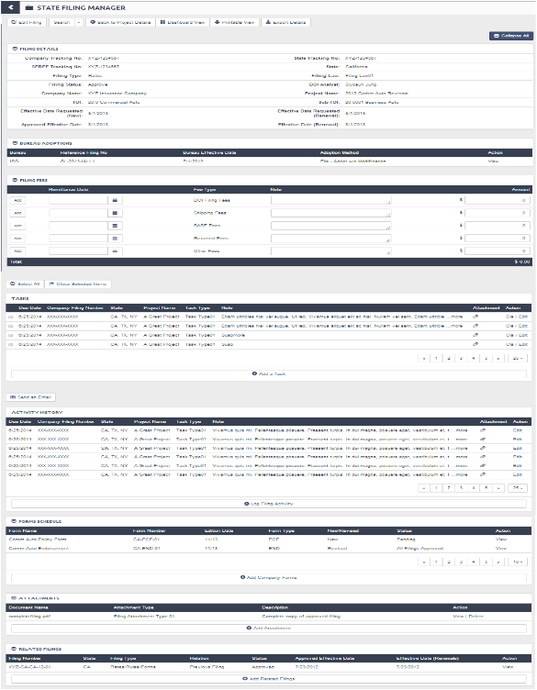

##### SFM Filing Details

### UC-1-12 - SFM Add Filing

The use case encompasses functionality of Adding a State Filing to selected project.

|  |  |
| --- | --- |
| Preconditions Admin, Authenticated Client, Authenticated Client Admin, Authenticated User should be logged in and have subscription for State Filing Manager App. | Success Guarantee System will add a filing under selected project |

#### Main Success Scenario

1. System checks if Admin, Authenticated Client, Authenticated Client Admin, Authenticated User have subscription for "StateFilings.com Software" or "Perr&Knight State Filings Services"
2. System checks,
3. If logged In User's Account having Subscription of only "StateFilings.com Software", then Admin, Authenticated Client Admin, Authenticated Client of Insurance Group and Insurance Company can Add Filings.
4. If logged In User's Account having Subscription of only "Perr&Knight State Filings Services" , then Admin, Authenticated Client Admin ,Authenticated Client of Third Party Filer can Add Filings.
5. Admin, Authenticated Client Admin, Authenticated Client will go to Apps->State Filing Manager->Project List View -> click on "View" -> Project Details-> Add Filing
6. System will redirect user to Add Filing screen.
7. System will redirect user to Add Filing screen will have two tabs.
   1. Filing Upload
      1. Filing Upload screen will be used to upload filings in bulk.
      2. The Filing Upload process will be executed in the background through a batch job.
      3. User will browse folder library and select up to 100 filings at once.
      4. System will check if the filing is initial filings or approved filings.
         1. Initial Filing Upload
            1. System will open filings one by one and create filing records.
            2. System opens first filing and create a new record of the filing by parsing the data from the SERFF transmittal form in StateFilings.
            3. System will then log an activity 'Sent Filing to DOI' and a follow up task 30 days after the activity to follow up
            4. System will upload the 'SERFF transmittal form' which was opened to add the filing record will be uploaded against the 'Sent Filing to DOI' activity created.
         2. Final Approved Filings Upload
            1. System will open filings one by one and check if the SERFF no exists in StateFilings.com.
            2. If the record exists System will overwrite the existing values else create a new record for the approved filing
            3. System opens first filing and creates/updates a record of the filing by parsing the data from the SERFF transmittal form in StateFilings.
            4. System will then log an activity 'Received DOI Approval'.
            5. System will upload the 'SERFF transmittal form' which was opened to create/update the filing record will be uploaded against the 'Received DOI Approval' activity created.
   2. Add Filing
      1. Add Filing screen will be used to manually add a single filing at a time.
      2. System will require all the below fields.
         1. Company Tracking Number (Mandatory)
            1. Admin, Authenticated Client Admin, Authenticated Client can enter Company Tracking Number into a textbox
         2. State Tracking Number(Not Mandatory)
            1. Admin, Authenticated Client Admin, Authenticated Client can enter State Tracking Number into a textbox
         3. SERFF Tracking Number(Not Mandatory)
            1. Admin, Authenticated Client Admin, Authenticated Client can enter SERFF Tracking Number into a textbox
         4. DOI Analyst
            1. Admin, Authenticated Client Admin, Authenticated Client can enter DOI Analyst into a textbox.
         5. Company Name
            1. Admin, Authenticated Client Admin, Authenticated Client can select Company from a list box.
            2. The list of companies will include company names which were selected for creating parent project.
            3. The company list will be shown in selected list box and user can remove any of the companies from the selected list box.
            4. Admin, Authenticated Client Admin, Authenticated Client can select multiple companies from the available list and click on ">>" button to add the companies to the selected list of companies
            5. Admin, Authenticated Client Admin, Authenticated Client can select multiple companies from the selected companies list and click on "<<" button to add the companies back to the available list of companies
         6. Project Name
            1. System will display Project Name of the project for which the filing is to be added into a disabled textbox.
         7. Affiliates
            1. Admin, Authenticated Client Admin, Authenticated Client can select Affiliates from a list box.
            2. The list of affiliates will include affiliate names which were selected for creating parent project.
            3. The affiliates list will be shown in selected list box and user can remove any of the affiliate from the selected list box.
            4. Admin, Authenticated Client Admin, Authenticated Client can select multiple affiliates from the available list and click on ">>" button to add the affiliates to the selected list of affiliates
            5. Admin, Authenticated Client Admin, Authenticated Client can select multiple affiliates from the selected affiliates list and click on "<<" button to add the affiliates back to the available list of affiliates.
         8. Third Party Filer - Single Selection
            1. Third Party Filer dropdown will be pre populated with value selected at project level
            2. Third Party Filer dropdown will have following values

No

Yes

* + - * 1. If a Group/Company for which the project is added does not have "Perr&Knight State Filings Services" subscription or "Perr&Knight State Filings Services" subscription has expired or Third Party Filer account is not associated with it, then System will display Third Party Filer dropdown as disabled and by default the value will be displayed 'No' as selected.
      1. TOI (Mandatory)
         1. System will display the NAIC list of TOIs which were selected for the parent project of the filing into selected list box.
         2. Admin, Authenticated Client Admin, Authenticated Client can select multiple TOIs from the available list and click on ">>" button to add the TOIs to the selected list of TOIs
         3. Admin, Authenticated Client Admin, Authenticated Client can select multiple TOIs from the selected TOI list and click on "<<" button to add the TOIs back to the available list of TOIs
      2. Sub-TOI (Mandatory)
         1. System will display the NAIC list of Sub-TOIs which were selected for parent project of the filing into selected list box.
         2. Admin, Authenticated Client Admin, Authenticated Client can select multiple Sub-TOIs from the available list and click on ">>" button to add the Sub-TOIs to the selected list of Sub-TOIs
         3. Admin, Authenticated Client Admin, Authenticated Client can select multiple Sub-TOIs from the selected Sub-TOI list and click on "<<" button to add the Sub-TOIs back to the available list of Sub-TOIs.
      3. Filing Types
         1. Admin, Authenticated Client Admin, Authenticated Client select Filing Types from following

Rates

Loss Costs

Rules

Forms

* + - 1. States (Mandatory)
         1. System will display a list of States which were selected for parent project of the filing
         2. Admin, Authenticated Client Admin, Authenticated Client can select Multiple States by selecting Check boxes.
      2. Filing Law (Mandatory) (Single Selection)
         1. Admin, Authenticated Client Admin, Authenticated Client can select the filing law from the following :

File & Use

Use & File

Prior Approval

* + - 1. Filing Status
         1. This field will not be present in the UI.
         2. Initially when a filing is added filing status will be null and later on the filing status values mentioned below will be filled by an activity associated with filing
         3. Filing Status Values :

Pending

Desk Filing

Filed/Approved

Withdrawn

Disapproved

* + - * 1. Submission Date
        2. Admin, Authenticated Client Admin, Authenticated Client can select Submission Date for particular filing.
      1. 1.2. Disposition Date
         1. Admin, Authenticated Client Admin, Authenticated Client can select Disposition Date for particular filing.
      2. Effective Date Requested (New)
         1. Effective Date Requested (New) will be pre populated with the value selected at project level
         2. Admin, Authenticated Client Admin, Authenticated Client can change the Effective Date Requested (New) for particular filing
      3. Effective Date Requested (Renewal)
         1. Effective Date Requested (Renewal) will be pre populated with the value selected at project level
         2. Admin, Authenticated Client Admin, Authenticated Client can change Effective Date Requested (Renewal) for particular filing
      4. Approved Effective Date
         1. Approved Effective Date will be pre populated with the value selected at project level
         2. Admin, Authenticated Client Admin, Authenticated Client can change the Approved Effective Date for particular filing
      5. Effective Date (Renewal)
         1. Effective Date(Renewal) will be pre populated with the value selected at project level
         2. Admin, Authenticated Client Admin, Authenticated Client can change Effective Date (Renewal) for particular filing
      6. Description
         1. Description will be pre populated with value at the project level.
         2. Admin, Authenticated Client Admin can change the description .
    1. Add Filing - When Admin, Authenticated Client Admin , Authenticated Client clicks on "Add Filing", System will check for all the validations and if its valid then System will create the filing under its parent project for that Account. System will redirect user to State Filing Project Details screen and user can view the newly added filing under "Filings" panel.
    2. Cancel - When Admin, Authenticated Client Admin, Authenticated Client clicks on "Cancel" button, System will redirect user back to State Filing Project Details screen without adding the filing.

#### Extensions

7.2.2.1.a If user doesn't enter Company Tracking Number

1. System will display error "Company Tracking Number is required".

2. Use case continues from pt 7.2.2.1

7.2.2.5.a If user doesn't select Company

1. System will display error "One or more Companies are required".

2. Use case continues from pt 7.2.2.5

7.2.2.9.a If user doesn't select TOIs

1. System will display error "One or more TOIs are required".

2. Use case continues from pt 7.2.2.9

7.2.2.10.a If user doesn't select Sub-TOIs

1. System will display error "One or more Sub-TOIs are required".

2. Use case continues from pt 7.2.2.10

7.2.2.12.a If user doesn't select State

1. System will display error "State is required".

2. Use case continues from pt 7.2.2.12

7.2.2.17.a If user enters some extreme dates like 1/1/2114

1. System will display error "Please enter valid date"

2. Use case continues from pt 7.2.2.17

7.2.2.18.a If user enters some extreme dates like 1/1/2114

1. System will display error "Please enter valid date"

2. Use case continues from pt 7.2.2.18

7.2.2.19.a If user enters some extreme dates like 1/1/2114

1. System will display error "Please enter valid date"

2. Use case continues from pt 7.2.2.18

7.2.2.20.a If user enters some extreme dates like 1/1/2114

1. System will display error "Please enter valid date"

2. Use case continues from pt 7.2.2.19

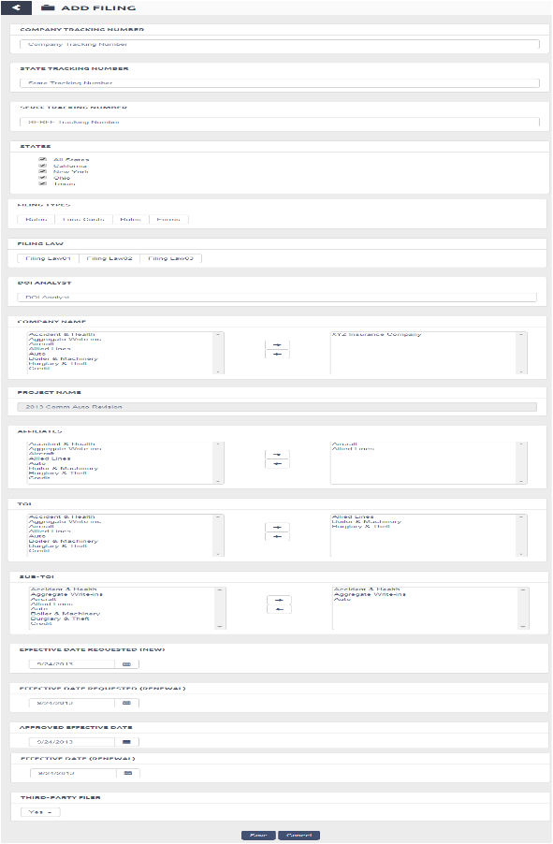

##### AddFiling

### UC-1-13 - SFM Edit Filing

The use case encompasses functionality of Editing a State Filing under selected project.

|  |  |
| --- | --- |
| Preconditions Admin, Authenticated Client, Authenticated Client Admin, Authenticated User should be logged in and have subscription for State Filing Manager App. | Success Guarantee System will update a filing under selected project |

#### Main Success Scenario

1. Admin, Authenticated Client Admin will go to Apps->State Filing Manager->Project List View -> click on "View" -> Project Details-> View Filing Details-> Edit Filing
2. System will redirect user to Edit Filing screen.
3. System will populate all the filing detail fields and Admin, Authenticated Client Admin can edit the filing detail fields which are mentioned below
   1. Company Tracking Number (Mandatory)
      1. Admin, Authenticated Client Admin, Authenticated Client can change Company Tracking Number into a textbox
   2. State Tracking Number (Not Mandatory)
      1. Admin, Authenticated Client Admin, Authenticated Client can change State Tracking Number into a textbox
   3. SERFF Tracking Number (Not Mandatory)
      1. Admin, Authenticated Client Admin, Authenticated Client can change SERFF Tracking Number into a textbox
   4. DOI Analyst
      1. Admin, Authenticated Client Admin, Authenticated Client can enter DOI Analyst into a text box.
   5. Company Name
      1. Admin, Authenticated Client Admin, Authenticated Client can select Company from a list box. The selected list of companies will include company names which were selected for creating filings and available list of companies will have company names which were selected while adding project but not selected while adding a filing.
      2. Admin, Authenticated Client Admin, Authenticated Client can select multiple companies from the available list and click on ">>" button to add the companies to the selected list of companies
      3. Admin, Authenticated Client Admin, Authenticated Client can select multiple companies from the selected companies list and click on "<<" button to add the companies back to the available list of companies
   6. Project Name
      1. System will display Project Name of the project for which the filing was added into a disabled textbox.
   7. Affiliates
      1. Admin, Authenticated Client Admin, Authenticated Client can select affiliates from a list box. The selected list of affiliates will include affiliate names which were selected for creating filing and available list of affiliates will have affiliate names which were selected while adding project but not selected while adding a filing.
      2. Admin, Authenticated Client Admin, Authenticated Client can select multiple affiliates from the available list and click on ">>" button to add the affiliates to the selected list of affiliates
      3. Admin, Authenticated Client Admin, Authenticated Client can select multiple affiliates from the selected affiliates list and click on "<<" button to add the affiliates back to the available list of affiliates.
   8. Third Party Filer - Single Selection
      1. Third Party Filer dropdown will be pre populated with value selected while adding the filing
   9. TOI (Mandatory)
      1. System will display the NAIC list of TOIs into a list box.
      2. Available list of TOIs will have NAIC list of TOIs which were selected while adding project but not selected while adding a filing.
      3. Selected list of TOIs will have NAIC list of TOIs which were selected while adding filing.
      4. Admin, Authenticated Client Admin, Authenticated Client can select multiple TOIs from the available list and click on ">>" button to add the TOIs to the selected list of TOIs
      5. Admin, Authenticated Client Admin, Authenticated Client can select multiple TOIs from the selected TOI list and click on "<<" button to add the TOIs back to the available list of TOIs
   10. Sub-TOI (Mandatory)
       1. System will display the NAIC list of Sub-TOIs into a list box.
       2. Available list of Sub-TOI will have NAIC list of Sub-TOIs which were selected while adding project but not selected while adding a filing.
       3. Selected list of Sub-TOI will have NAIC list of Sub-TOIs which were selected while adding filing.
       4. Admin, Authenticated Client Admin, Authenticated Client can select multiple Sub-TOIs from the available list and click on ">>" button to add the Sub-TOIs to the selected list of Sub-TOIs
       5. Admin, Authenticated Client Admin, Authenticated Client can select multiple Sub-TOIs from the selected Sub-TOI list and click on "<<" button to add the Sub-TOIs back to the available list of Sub-TOIs.
   11. Filing Types
       1. Admin, Authenticated Client Admin, Authenticated Client select Filing Types from following
          1. Rates
          2. Loss Costs
          3. Rules
          4. Forms
   12. States (Mandatory)
       1. System will display a list of States which were selected for parent project of the filing
       2. Admin, Authenticated Client Admin, Authenticated Client can select a Multiple States by selecting Check boxes.
   13. Filing Law (Mandatory) (Single Selection)
       1. Admin, Authenticated Client Admin, Authenticated Client can change the filing law from the given list
   14. Filing Status
       1. This field will not be present in the UI.
       2. Filing status values mentioned below will be filled by an activity associated with filing
       3. Filing Status Values :
          1. Pending
          2. Desk Filing
          3. Filed/Approved
          4. Withdrawn
          5. Disapproved
       4. Submission Date
       5. Admin, Authenticated Client Admin, Authenticated Client can select Submission Date for particular filing.
   15. 1.2. Disposition Date
       1. Admin, Authenticated Client Admin, Authenticated Client can select Disposition Date for particular filing.
   16. Effective Date Requested (New)
       1. Admin, Authenticated Client Admin, Authenticated Client can change the Effective Date Requested (New) for particular filing
   17. Effective Date Requested (Renewal)
       1. Admin, Authenticated Client Admin, Authenticated Client can change Effective Date Requested (Renewal) for particular filing
   18. Approved Effective Date
       1. Admin, Authenticated Client Admin, Authenticated Client can change Approved Effective Date
   19. Effective Date (Renewal)
       1. Admin, Authenticated Client Admin, Authenticated Client can change Effective Date (Renewal)
   20. Description
       1. Admin, Authenticated Client Admin can change the description .
4. Save Filing - When Admin, Authenticated Client Admin clicks on "Save Filing", System will check for all the validations and if its valid then System will save the filing details. System will redirect user to State Filing Project Details screen and user can view the updated filing under "Filings" panel.
5. Cancel - When Admin, Authenticated Client Admin clicks on "Cancel" button, System will discard all the changes and redirect user back to State Filing Project Details screen.
6. Delete - When Admin, Authenticated Client Admin clicks on "Delete" button
   1. System Popup message for conformation.
      1. Admin, Authenticated Client Admin click on "Yes" button.
         1. System closes the Popup.
         2. System deletes the Filing

#### Extensions

3.1.a If user doesn't enter Company Tracking Number

1. System will display error "Company Tracking Number is required".

2. Use case continues from pt 3.1

3.5.a If user doesn't select Company

1. System will display error "One or more Companies are required".

2. Use case continues from pt 3.5

3.9.a If user doesn't select TOIs

1. System will display error "One or more TOIs are required".

2. Use case continues from pt 3.9

3.10.a If user doesn't select Sub-TOIs

1. System will display error "One or more Sub-TOIs are required".

2. Use case continues from pt 3.10

3.12.a If user doesn't select State

1. System will display error "State is required".

2. Use case continues from pt 3.12

3.17.a If user enters some extreme dates like 1/1/2114

1. System will display error "Please enter valid date"

2. Use case continues from pt 7.2.2.16

3.18.a If user enters some extreme dates like 1/1/2114

1. System will display error "Please enter valid date"

2. Use case continues from pt 7.2.2.17

3.19.a If user enters some extreme dates like 1/1/2114

1. System will display error "Please enter valid date"

2. Use case continues from pt 7.2.2.16

3.20.a If user enters some extreme dates like 1/1/2114

1. System will display error "Please enter valid date"

2. Use case continues from pt 7.2.2.17

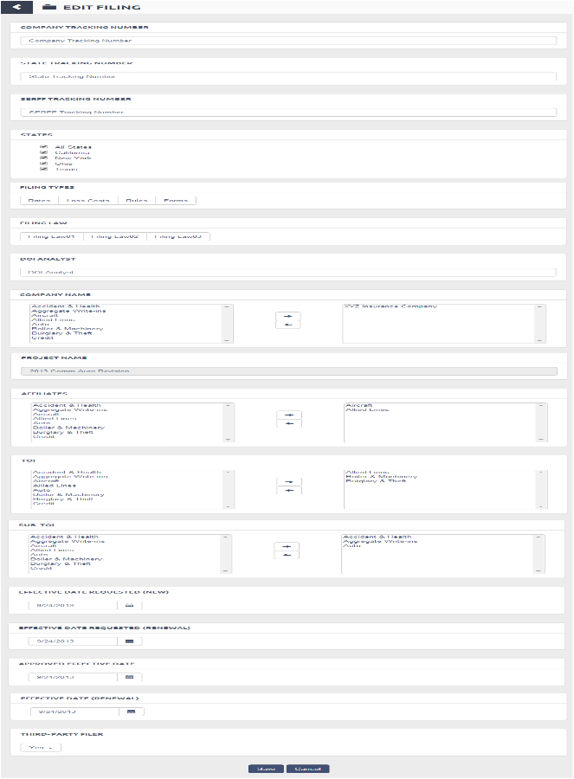

##### EditFiling

### UC-1-19 - SFM Filing Activity Details

The use case encompasses functionality of viewing a Filing Activity details.

|  |  |
| --- | --- |
| Preconditions Admin, Authenticated Client Admin, Authenticated Client, Authenticated User should be logged in and have subscription for State Filing Manager App. | Success Guarantee System will display Filing Task Details. |

#### Main Success Scenario

1. Admin, Authenticated Client Admin, Authenticated Client, Authenticated User will click on Apps->State Filing Manager-> Project List View->View Project Details -> View Filing Details -> "View" a particular Activity.
2. System will redirect user to Filing Activity Details screen.
   1. System will display following details to user
      1. Activity Details
         1. System will display following details under Activity Details Section
            1. Due Date

Due Date entered by Admin, Authenticated Client Admin while logging the activity.

* + - * 1. Activity Type

Activity type selected by Admin, Authenticated Client Admin while logging the activity.

* + - * 1. Description

Description entered by Admin, Authenticated Client Admin while logging the activity

* + 1. Attachments
       1. System will display following details under Activity Details Section
          1. Document Name

Document Name entered by Admin, Authenticated Client Admin while logging the activity.

* + - * 1. Description

Document Description entered by Admin, Authenticated Client Admin while logging the activity.

* + - * 1. Action- will have "View" link to view the attachment.
    1. Related Correspondence
       1. System will display following details under Activity Details Section
          1. Correspondence Date

Correspondence Date entered by Admin, Authenticated Client Admin.

* + - * 1. Correspondence Type

Correspondence Type entered by Admin, Authenticated Client Admin .

* + - * 1. Author

Author entered by Admin, Authenticated Client Admin .

* + - * 1. Due Date

Due Date entered by Admin, Authenticated Client Admin .

* + - * 1. Action - will have "View" link to view the attachment.

1. Back to Filing Details - When Admin, Authenticated Client Admin clicks on "Back to Filing Details" button , System will redirect user back to the State Filing Details screen.
2. Edit Filings - When Admin, Authenticated Client Admin clicks on "Edit Filings" button , System will redirect user to Edit Filings screen [Refer Use Case: SFM Edit Filing (UC-1-13)].
3. Printable View - System will display a view of the Filing Details with all its related panels and a "Print" button. When Admin, Authenticated Client Admin click on "Print", a Print dialog box will be opened and user can print the filing details.
4. Export Details - System will export all the filing activity details with its related panels, each on different excel sheets of spreadsheet file.

#### Extensions

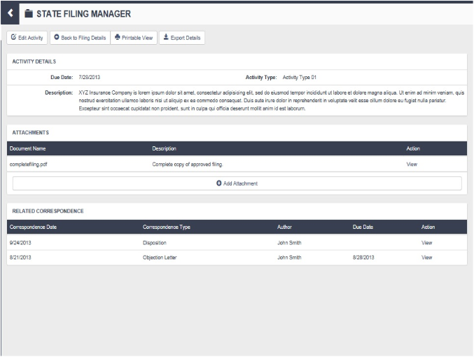

##### FilingActivityDetails

### UC-1-20 - SFM Filing Fee

The use case encompasses functionality of logging a Filing Fee against a particular filing and its state.

|  |  |
| --- | --- |
| Preconditions Admin, Authenticated Client Admin should be logged in and have subscription for State Filing Manager App. | Success Guarantee System will log the Fee entered against the selected filing and its state. |

#### Main Success Scenario

1. Admin, Authenticated Client Admin will click on Apps->State Filing Manager-> Project List View->View Project Details -> View Filing Details -> Log Fee.
2. Admin, Authenticated Client Admin can log fee per filing not per activity.
3. system displays 5 rows of Filling Fees which are having fee types "DOI Filing Fees", "Shipping Fees", "SASE Fees" and "Returned Fees", "Other Fees" respectively.
   1. Admin, Authenticated Client Admin can click on "Add" button of any row to add new row of the particular fee type.
      1. System will add new row with the respective fee type.
   2. Admin, Authenticated Client Admin can click on "Remove" button of newly added row.
      1. System will remove that particular row.
4. Admin, Authenticated Client Admin can either log fee or edit already logged fee for the selected filing.
   1. **Log Fee** - System will redirect user to "Log Fee" screen.
      1. System will require following details
         1. Remittance Date (Mandatory)
            1. Remittance Date is the date when filing fee is submitted to DOI
         2. Fee Type (Mandatory)
            1. Admin, Authenticated Client Admin can select the type of the Fee submitted from given list of types in a drop down.
         3. Notes
            1. Admin, Authenticated Client Admin can enter notes related to filing fees being entered.
         4. Amount (Mandatory)
            1. Admin, Authenticated Client Admin can enter the amount of filing fee submitted.
      2. Log Filling Fee- When Admin, Authenticated Client Admin clicks on "Log Filling Fee" button , System will validate inputs and if valid, add the Filing Fee against the selected filing & its state and redirect user back to the State Filing Details screen.
   2. **Edit Fee** - System will redirect user to "Edit Filing Fee" screen.
      1. System will populate following details for filing fee to be edited
         1. Remittance Date (Mandatory)
            1. Admin, Authenticated Client Admin can change the Remittance Date previously logged for the filing fee.
         2. Fee Type (Mandatory)
            1. Admin, Authenticated Client Admin can change the type of the Fee submitted from given list of types in a drop down.
         3. Notes
            1. Admin, Authenticated Client Admin can change the notes related to filing fees being edited.
         4. Amount (Mandatory)
            1. Admin, Authenticated Client Admin can change the amount of filing fee to be edited.
      2. Log Filling Fee- When Admin, Authenticated Client Admin clicks on "Log Filling Fee" button , System will validate inputs and if valid, save the Filing Fee against the selected filing & its state and redirect user back to the State Filing Details screen with updated Filing Fee record.

#### Extensions

4.1.1.1.a If User doesn't enter Remittance Date

1. System will display an error "Remittance Date is required".

2. Use Case will continue from pt 4.1.1.1

4.1.1.4.a If User doesn't enter Amount

1. System will display an error "Filing Fee Amount is required".

2. Use Case will continue from pt 4.1.1.4

4.2.1.1.a If User removes already entered date and doesn't enter a new Remittance Date

1. System will display an error "Remittance Date is required".

2. Use Case will continue from pt 4.2.1.1

4.2.1.4.a If User removes already entered amount and doesn't enter a new Fee Amount

1. System will display an error "Filing Fee Amount is required".

2. Use Case will continue from pt 4.2.1.4

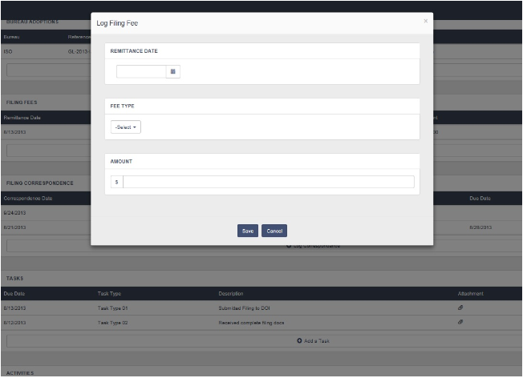

##### AddFilingFee

### UC-1-22 - SFM Filing Task Details

The use case encompasses functionality of viewing a Filing Task details.

|  |  |
| --- | --- |
| Preconditions Admin, Authenticated Client Admin, Authenticated Client, Authenticated User should be logged in and have subscription for State Filing Manager App. | Success Guarantee System will log display Filing Activity Details. |

#### Main Success Scenario

1. Admin, Authenticated Client Admin, Authenticated Client, Authenticated User will click on Apps->State Filing Manager-> Project List View->View Project Details -> View Filing Details -> "View" a particular Task.
2. System will redirect user to Filing Task Details screen.
   1. System will display following details to user
      1. Task Details
         1. System shows following under Task Details
            1. Due Date

System will display Task Due Date which was entered while adding the task. It is the date by which user should complete the task.

* + - * 1. Task Type

System will display Task Type selected by user while adding the task.

* + - * 1. Description

System will display Description entered by user while adding the task.

* + - * 1. Status (Mandatory)

System will display current Status of the task .

* + 1. Related Correspondences
       1. System show related Correspondences for the particular task with following details
          1. Correspondences Date
          2. Correspondences Type
          3. Author
          4. Due Date
          5. Action - System shows view link to View Correspondences details

1. Back to Filing Details - When Admin, Authenticated Client Admin clicks on "Back to Filing Details" button , System will redirect user back to the State Filing Details screen.
2. Edit Task - System will redirect user to Edit Task screen(User can edit a task irrespective of its "Status" i.e either "open" or "closed").
   1. System will populate following details for filing task to be edited
      1. Due Date (Mandatory)
         1. Admin, Authenticated Client Admin can change the existing Task Due Date from date picker into a textbox.
      2. Task Type (Mandatory)
         1. Admin, Authenticated Client Admin can change the existing type of task from the given list of Task Types.
      3. Description
         1. Admin, Authenticated Client Admin can change the existing description of the task to be edited.
      4. Related To
         1. System will display a list of correspondences logged against the parent filing in suggestive texbox
         2. Admin, Authenticated Client Admin can select the correspondences to which the task is to be related.
         3. System will display a list of correspondences which are already related to Task
            1. System shows correspondences list with following details

Correspondences Date

Correspondences Type

Author

Due Date

Action

System can remove Correspondences by clicking remove icon.

* + 1. Status (Mandatory)
       1. Admin, Authenticated Client Admin can change the existing status of the task from a dropdown list. It has two values
          1. If the user selects "Closed", system will mark the task as completed and the task will be "Converted to Activity" by the System. It will no longer be available in the list of Tasks.
  1. Save- When Admin, Authenticated Client Admin clicks on "Save" button , System will save all the change made to the task against the selected filing & its state and redirect user back to the State Filing Details screen.
  2. Cancel - When Admin, Authenticated Client Admin clicks on "Cancel" button , System will discard all the changes made to the task and will redirect user back to the State Filing Details screen.

1. Export Details - System will export all the filing task details with its related panels, each on different excel sheets of spreadsheet file.

#### Extensions

4.1.1.a Extension same as 2.1.1.1.a

1. Use Case will continue from pt 2.2.1.1

4.1.2.a Extension same as 2.1.1.2.a

1. Use Case will continue from pt 2.2.1.2

4.1.5.a Extension same as 2.1.1.4.a

1. Use Case will continue from pt 2.2.1.5

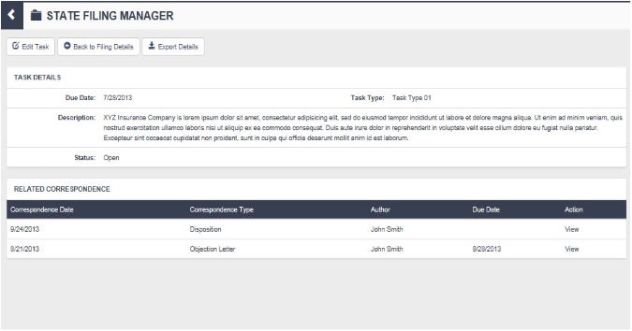

##### FilingTaskDetails

### UC-1-23 - SFM Filing Bureau Adoption

The use case encompasses functionality of adding Bureau Adoptions against a particular filing and its state.

|  |  |
| --- | --- |
| Preconditions Admin, Authenticated Client, Authenticated Client Admin, Authenticated User should be logged in and have subscription for State Filing Manager App. | Success Guarantee System will add Bureau Adoptions against the selected filing and its state. |

#### Main Success Scenario

1. Admin, Authenticated Client, Authenticated Client Admin, Authenticated User will click on Apps->State Filing Manager-> Project List View->View Project Details -> View Filing Details -> Add Bureau Adoptions.
2. System will redirect user to Add Bureau Adoption screen.
3. System will display following fields. User can enter/select values in any of the given fields in order to get the desired bureau adoptions as search result.
   1. Bureau (Single)
      1. System will populate the bureaus in the dropdown
      2. Admin, Authenticated Client, Authenticated Client Admin, Authenticated User can select a Bureau from dropdown.
   2. Bureau LOB (Single)
      1. Bureau LOB drop down will be disable until user selects a Bureau in step 3.1
      2. System will populate Bureau LOBs based on the Bureau selected in step 3.1
      3. Admin, Authenticated Client, Authenticated Client Admin, Authenticated User can select a Bureau LOB from dropdown
   3. State (Single)
      1. State dropdown will be disabled until user select Bureau & Bureau LOB
      2. System will populate States based on Bureau & Bureau LOB selected in step 3.1 & 3.2 respectively.
      3. Admin, Authenticated Client, Authenticated Client Admin, Authenticated User can select a State from dropdown.
   4. Filing Type (Single)
      1. System will populate the Filing Types in the dropdown
      2. Admin, Authenticated Client, Authenticated Client Admin, Authenticated User can select a Filing Type from dropdown
   5. Company Name (Single)
      1. System will populate the names of the companies selected for which the filing has been created.
      2. Admin, Authenticated Client, Authenticated Client Admin, Authenticated User can select a Company Name from dropdown
   6. Bureau Effective Date
      1. Admin, Authenticated Client, Authenticated Client Admin, Authenticated User can select a date from date picker
   7. Reference Filing Number (Single)
      1. System will populate the Reference Filing Number based on all the values selected above.
      2. Admin, Authenticated Client, Authenticated Client Admin, Authenticated User can select the reference filing number from dropdown.
4. Save
   1. System will fetch a unique adoption record for above selected values (i.e Bureau, Bureau LOB, State, Filing Type, Company, Bureau Effective Date & Reference Filing Number)
   2. System will add this adoption record against the selected filing when user clicks on "Save" button and redirect user to State Filing Details screen.
5. Cancel - System will redirect user to back to State Filing Details screen without adding any bureau adoption to the selected filing.

#### Extensions

3.1.a If user doesn't select Bureau

1. System will display error message "Please select Bureau".

3.2.a If user doesn't select Bureau LOB

1. System will display error message "Please select Bureau LOB".

3.3.a If user doesn't select State

1. System will display error message "Please select State".

3.4.a If user doesn't select Filing Type

1. System will display error message "Please select Filing Type".

3.5.a If user doesn't select Company Name

1. System will display error message "Please select Company Name".

3.6.a If user doesn't enter Bureau Effective Date

1. System will display error message "Please enter Bureau Effective Date".

3.7.a If user doesn't select Reference Filing Number

1. System will display error message "Please select Reference Filing Number".

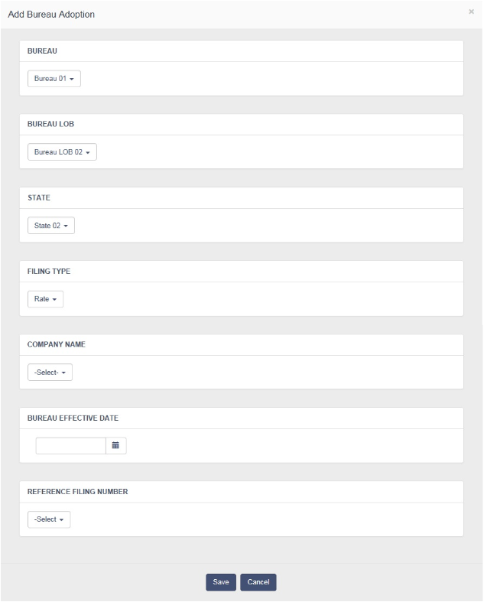

##### AddFilingBureauAdoption

### UC-1-24 - SFM Filing Company Forms

The use case encompasses functionality of adding Company Forms against a particular filing and its state.

|  |  |
| --- | --- |
| Preconditions Admin, Authenticated Client, Authenticated Client Admin, Authenticated User should be logged in and have subscription for State Filing Manager App. | Success Guarantee System will add Company Forms against the selected filing and its state. |

#### Main Success Scenario

1. Admin, Authenticated Client, Authenticated Client Admin will click on Apps->State Filing Manager-> Project List View->View Project Details -> View Filing Details -> Add Company Forms.
2. System will redirect user to the Add Company Form screen. System will require following details
   1. Form Name
      1. Admin , Authenticated Client Admin, Authenticated Client can enter Form Name
   2. Form Number
      1. Admin , Authenticated Client Admin, Authenticated Client can enter Form Number
   3. State Tracking Number
      1. System will display State Tracking Number of the parent filing against which the form is to be added into a disabled text box.
   4. SERFF Tracking Number
      1. System will display SERFF Tracking Number of the parent filing against which the form is to be added into a disabled text box.
   5. States (Mandatory)
      1. System will display a list of States which were selected for parent filing of the form
      2. Admin, Authenticated Client Admin, Authenticated Client can select Multiple States by selecting Check boxes.
   6. TOI (Mandatory)
      1. System will display the NAIC list of TOIs which were selected for the parent filing of the form into selected list box.
      2. Admin, Authenticated Client Admin, Authenticated Client can select multiple TOIs from the available list and click on ">>" button to add the TOIs to the selected list of TOIs
      3. Admin, Authenticated Client Admin, Authenticated Client can select multiple TOIs from the selected TOI list and click on "<<" button to add the TOIs back to the available list of TOIs
   7. Sub-TOI (Mandatory)
      1. System will display the NAIC list of Sub-TOIs which were selected for parent filing of the form into selected list box.
      2. Admin, Authenticated Client Admin, Authenticated Client can select multiple Sub-TOIs from the available list and click on ">>" button to add the Sub-TOIs to the selected list of Sub-TOIs
      3. Admin, Authenticated Client Admin, Authenticated Client can select multiple Sub-TOIs from the selected Sub-TOI list and click on "<<" button to add the Sub-TOIs back to the available list of Sub-TOIs.
   8. Product
      1. System will display Product of the parent filing against which the form is to be added into a disabled text box.
   9. Edition Date
      1. Admin, Authenticated Client Admin, Authenticated Client can enter or select Edition Date
   10. Form Type
       1. Admin, Authenticated Client Admin, Authenticated Client can select Form Type from following
          1. Advertising
          2. Application / Binder / Enrollment
          3. Bond
          4. Canc / Non Ren Notice
          5. Cirtificate
          6. Declarations/ Schedule
          7. Disclosure / Notice
          8. Endorsement / Amendment / Conditions
          9. Election / Rejection / Supp Applications
          10. Other
          11. Policy / Coverage Form
   11. New / Revised
       1. Admin, Authenticated Client Admin, Authenticated Client can select New or Revised by clicking button
   12. Previous From Number
       1. Admin, Authenticated Client Admin, Authenticated Client can enter Previous Form Number
   13. Previous Edition Date
       1. Admin, Authenticated Client Admin, Authenticated Client can enter or select Previous Edition Date.
   14. Previous Filing Tracking Number
       1. Admin, Authenticated Client Admin, Authenticated Client can enter Previous Filing Tracking Number
   15. Form Purpouse
       1. Admin, Authenticated Client Admin, Authenticated Client can click on button and select Form Purpose from following
          1. Broadens
          2. Restricts
   16. Form Issuing Status
       1. Admin, Authenticated Client Admin, Authenticated Client can click on button and select Form Issuing Status from following
          1. Open
          2. Closed
   17. Effective Date Requested (New)
       1. Effective Date Requested (New) will be pre populated with the corresponding value associated with form's parent filing.
       2. Admin, Authenticated Client Admin, Authenticated Client can change the Effective Date Requested (New) for particular form.
   18. Effective Date Requested (Renewal)
       1. Effective Date Requested (Renewal) will be pre populated with the corresponding value associated with form's parent filing.
       2. Admin, Authenticated Client Admin, Authenticated Client can change Effective Date Requested (Renewal) for particular form.
   19. Approved Effective Date
       1. Approved Effective Date will be pre populated with the corresponding value associated with form's parent filing.
       2. Admin, Authenticated Client Admin, Authenticated Client can change the Approved Effective Date for particular form
   20. Effective Date (Renewal)
       1. Effective Date(Renewal) will be pre populated with the corresponding value associated with form's parent filing.
       2. Admin, Authenticated Client Admin, Authenticated Client can change Effective Date (Renewal) for particular form.
3. Save - Admin, Authenticated Client, Authenticated Client Admin clicks on "Save" button, System checks validation , add the selected forms against the selected filing and redirect user to Upload Forms List tab.
4. Cancel - Admin, Authenticated Client, Authenticated Client Admin User clicks on "Cancel", System will redirect user to Search Filing Details screen without adding forms to the selected filing.
5. **Upload Forms List tab**
   1. Choose file
      1. Admin, Authenticated Client, Authenticated Client Admin can click on brows button and select the file.
      2. The number of attachments that can be added per Company Forms is 100.
   2. Save
      1. Admin, Authenticated Client, Authenticated Client Admin click on save button, System add selected file to added Forms
   3. Cancel
      1. Admin, Authenticated Client, Authenticated Client Admin User clicks on "Cancel", System will redirect user to Search Filing Details screen without adding forms to the selected filing.

#### Extensions

2.5.a If user doesn't select State

1. System will display error "State is required".

2. Use case continues from pt 2.5

2.6.a If user doesn't select TOIs

1. System will display error "One or more TOIs are required".

2. Use case continues from pt 2.6

2.7.a If user doesn't select Sub-TOIs

1. System will display error "One or more Sub-TOIs are required".

2. Use case continues from pt 2.7

2.17.a If user enters some extreme dates like 1/1/2114

1. System will display error "Please enter valid date"

2. Use case continues from pt 2.17

2.18.a If user enters some extreme dates like 1/1/2114

1. System will display error "Please enter valid date"

2. Use case continues from pt 2.18

2.19.a If user enters some extreme dates like 1/1/2114

1. System will display error "Please enter valid date"

2. Use case continues from pt 2.19

2.20.a If user enters some extreme dates like 1/1/2114

1. System will display error "Please enter valid date"

2. Use case continues from pt 2.20

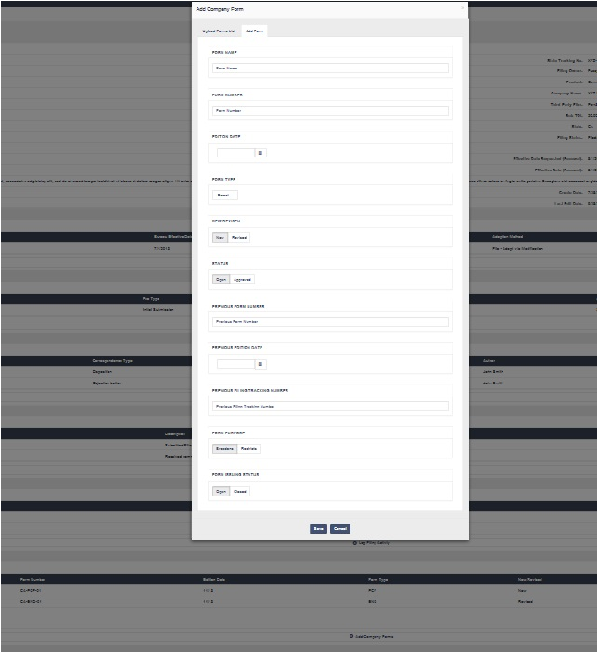

##### AddFilingCompanyForms-Step1

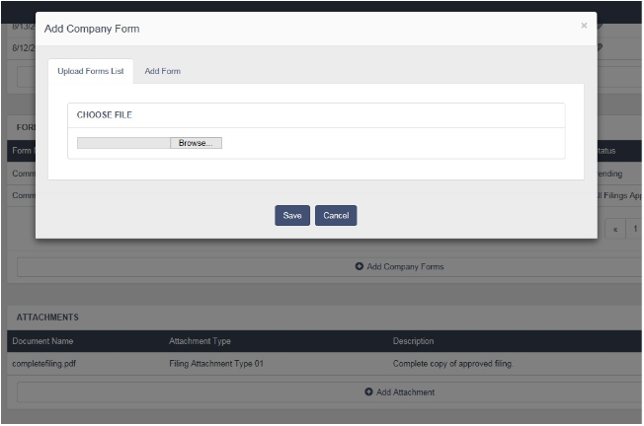

##### AddFilingCompanyForms-Step2

### UC-1-29 - SFM Filing Rules

The use case encompasses functionality of adding Rules against a particular filing and its state.

|  |  |
| --- | --- |
| Preconditions Product Management Review User should be logged in and have subscription for State Filing Manager App. | Success Guarantee System will add rules against the selected filing and its state. |

#### Main Success Scenario

1. Product Management Review User will click on Apps->State Filing Manager-> Project List View->View Project Details -> View Filing Details -> Add Rules.
2. System will redirect user to the add rule screen. System will require following details
   1. Rule Name (Required)
      1. Product Management Review User can enter Rule Name
   2. Rule Number (Required)
      1. Product Management Review User can enter Rule Number
   3. State Tracking Number
      1. System will display State Tracking Number of the parent filing against which the rule is to be added into label.
   4. SERFF Tracking Number
      1. System will display SERFF Tracking Number of the parent filing against which the rule is to be added into a label.
   5. States (Mandatory)
      1. System will display a list of States which were selected for parent filing of the rule
   6. Sub-TOI (Mandatory)
      1. System will display the NAIC list of Sub-TOIs which were selected for parent filing of the rule into label.
   7. Product
      1. System will display Product of the parent filing against which the rule is to be added into a dropdown.
   8. Rule Edition Date (Required)
      1. Product Management Review User can enter or select Edition Date from datepicker.
   9. Multistate or State Specific?
      1. Product Management Review User can select if the rule is multistate or not
         1. Yes
            1. If yes, system will ask user to select multiple states for it
         2. No
   10. Publication Code
       1. The Publication Code field will hold one of the following values
          1. Programmed (selected by default)
          2. Not Programmed
   11. Not Programmed Sub List
       1. If user selects 'Not Programmed' then system will display another list where user can select one of the following
          1. System limitation
          2. Underwriting decision
          3. Company product supercedes
          4. Other
   12. Company Action
       1. Product Management Review User can select one of the following values
3. Save - Product Management Review User clicks on "Save" button, System checks validation , add the rule against the selected filing and redirect user to filing details screen.
4. Cancel - Product Management Review User User clicks on "Cancel", System will redirect user to Filing Details screen without adding rule to the selected filing.

#### Extensions

2.1.a If user doesn't enter Rule Name

1. System displays validation message 'Rule Name is required'

2. Use case continues from Point 2.1

2.2.a If user doesn't enter Rule Number

1. System displays validation message 'Rule Number is required'

2. Use case continues from Point 2.2

2.8.a If user doesn't enter Rule Edition Date

1. System displays validation message 'Rule Edition Date is required'

2. Use case continues from Point 2.8

### UC-1-25 - SFM Filing Related Filings

The use case encompasses functionality of adding related filings against a particular filing and its state.

|  |  |
| --- | --- |
| Preconditions Admin, Authenticated Client, Authenticated Client Admin, Authenticated User should be logged in and have subscription for State Filing Manager App. | Success Guarantee System will add selected related filings against the selected filing and its state. |

#### Main Success Scenario

1. Admin, Authenticated Client, Authenticated Client Admin will click on Apps->State Filing Manager-> Project List View->View Project Details -> View Filing Details -> Add Related Filings.
2. System will redirect user to the Add Related Filing screen.
   1. System will require following fields to Add related Filings
      1. Filing Number
         1. Admin, Authenticated Client, Authenticated Client Admin can enter Filing Number or Select filing Number from Suggestions
         2. Filing number will be Suggestive Text box
         3. When user clicks on any of the suggestions, system will add the related filing against the Filing.
         4. Filing Number will be same as Company Tracking Number.
      2. Related Filing Type
         1. Admin, Authenticated Client, Authenticated Client Admin can select Related Filing Type from dropdown
3. Save- Admin, Authenticated Client, Authenticated Client Admin clicks on "Save" button, System checks validation , add related filing for Filing.
4. Cancel - When Admin, Authenticated Client, Authenticated Client Admin, Authenticated User clicks on "Cancel" button, System will redirect user to State Filing Details screen without adding any related filings.

#### Extensions

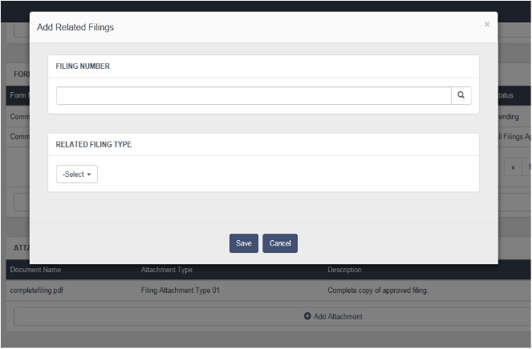

##### AddFilingRelatedFilings

### UC-1-26 - SFM Change Filing Owner

The use case encompasses functionality of changing Owner for a filing

|  |  |
| --- | --- |
| Preconditions Admin, Authenticated Client, Authenticated Client Admin, Authenticated User should have subscription for State Filing Manager App. | Success Guarantee System will display changed Owner Name on State Filing Manager Filing Details and notify user about the same. |

#### Main Success Scenario

1. Admin, Authenticated Client Admin will click on Apps->State Filing Manager->Project List View->Project Details-> View Filing Details -> and click on "[Change]" link on Filing Details screen.
2. System will redirect user to Change Filing Owner screen.
3. Filing Owner(Mandatory) - System will display name of the users who belongs to the same account and has access to the project with existing filing owner name selected into the Filing Owner drop down list.
   1. Admin, Authenticated Client Admin can change the filing owner from the given list of owner names in the dropdown list.
4. Send Notification Email - If Admin, Authenticated Client Admin selects this option, System will notify users(both old and new owner) about the change of Filing Owner via e-mail.
5. If Admin, Authenticated Client Admin clicks on "Save", System will save the Filing Owner name against the filing selected and user can view it on the State Filing Details screen.
6. If Admin, Authenticated Client Admin clicks on "Cancel", System will discard the changes and redirect user to State Filing Details screen.

#### Extensions

1.a System will not show "[Change]" link for Authenticated Client, Authenticated User.

3.1.a If Admin, Authenticated Client Admin doesn't select any filing owner name, System will display an error message "Filing Owner Name is required."

### UC-1-27 - SFM Search Filings

The use case encompasses functionality of Searching of State Filings.

|  |  |
| --- | --- |
| Preconditions Admin, Authenticated Client, Authenticated Client Admin, Authenticated User should be logged in and have subscription for State Filing Manager App. | Success Guarantee System will displays list of filings as a result of criteria selected on State Filing Search screen. |

#### Main Success Scenario

1. Admin, Authenticated Client, Authenticated Client Admin, Authenticated User can go to Search Filing screen from State Filing Manger Dashboard by clicking 'Run an Advanced Search for Filings' link and from State Filing Manager Project List View, State Filing Manager Project Details View or State Filing Details screens by clicking "Search Filing" button.
2. Admin, Authenticated Client, Authenticated Client Admin, Authenticated User will click on Apps->State Filing Manager-> Project List View->View Project Details ->Search Filings
3. Admin, Authenticated Client, Authenticated Client Admin, Authenticated User will click on Apps->State Filing Manager-> Project List View->View Project Details -> View Filing Details ->Search Filings.
4. System will redirect user to Search Filings screen.
5. System will allow Authenticated Client, Authenticated Client Admin, Authenticated User to search only filings created for its parent company /group account.
6. System will allow Admin to search all the filings for all accounts.
7. System will allow Third-Party Filer to search their own filings and there associate account Filings.
8. System provides different search criteria on which filings can be searched
   1. Company Tracking Number (Not Mandatory)
      1. User can enter multiple Company Tracking Numbers with specific separators and System will return the results for the same.
   2. Company Name (Not Mandatory)
      1. User can search filing by entering company name into a text box.
   3. Project Name (Not Mandatory)
      1. User can search filing by entering project name into a text box.
   4. Product Name (Not Mandatory)
      1. User can search filing by entering product name into a text box.
   5. DOI Analyst (Not Mandatory) (Multiple)
      1. User can search filings by selecting DOI Analyst from Available List to Selected List
      2. If "Group Level" user is logged in, System will display users of that group.
      3. If "Company Level" user is logged in, System will display users of that company.
      4. If a "Third Party" user is logged in, System will display users of that account to whom third party filer is associated.
      5. If a "Affiliate" user is logged in, System will display users of that account to whom affiliate is associated.
   6. Dates
      1. From & To Dates - User can provide a date range in From & To date fields in order to retrieve filing which is "Date Created/Date Ended/Last Date Edited " between the date range specified.
         1. Today - If user clicks on "Today" link, System will set the date range fields with "From" date & "To" date as current date. For Example:- From - 02/11/2014 & To - 02/11/2014
         2. This Week - If user clicks on "This Week" link, System will set the date range fields with "From" date as start date of current week & "To" date as end date of current week. For Example:- From - 02/10/2014 & To - 02/16/2014
         3. This Month - If user clicks on "This Month" link, System will set the date range fields with "From" date as start date of the current month & "To" date as end date of current month. For Example:- From - 02/01/2014 & To - 02/28/2014
         4. This Year - If user clicks on "This Year" link, System will set the date range fields with "From" date as start date of the current year & "To" date as end date of current year. For Example:- From - 01/01/2014 & To - 12/31/2014
   7. TOI List - If Admin, Authenticated Client, Authenticated Client Admin, Authenticated User select TOI in Search by field, System will display a list of available TOIs.
      1. Admin, Authenticated Client, Authenticated Client Admin, Authenticated User can select multiple TOIs from the available list and click on ">>" button to add the TOIs to the selected list of TOIs
      2. Admin, Authenticated Client, Authenticated Client Admin, Authenticated User can select multiple TOIs from the selected TOI list and click on "<<" button to add the TOIs back to the available list of TOIs
   8. Sub-TOI List - If Admin, Authenticated Client, Authenticated Client Admin, Authenticated User select Sub-TOI in Search by field, System will display a list of available Sub-TOIs.
      1. Admin, Authenticated Client, Authenticated Client Admin, Authenticated User can select multiple Sub-TOIs from the available list and click on ">>" button to add the Sub-TOIs to the selected list of Sub-TOIs
      2. Admin, Authenticated Client, Authenticated Client Admin, Authenticated User can select multiple Sub-TOIs from the selected Sub-TOI list and click on "<<" button to add the Sub-TOIs back to the available list of Sub-TOIs.
   9. Filing Types (Not Mandatory) (Multiple)
      1. User can search filings by selecting filing types from following.
         1. Rates
         2. Loss Costs
         3. Rules
         4. Forms
         5. Marketing
         6. New Program
         7. Statistical
         8. Symbol
   10. Billing Contact - This option is shown only to 'Super Users'.
       1. User can search filing by selecting a Billing Contact from a Billing Contact combo box.
       2. User can search Billing Contact by entering Billing Contact name into a text box
       3. Admin, Authenticated Client, Authenticated Client Admin, Authenticated User can select multiple Billing Contact Name from the available list and click on ">>" button to add the Billing Contact to the selected list of Billing Contact Names.
       4. Admin, Authenticated Client, Authenticated Client Admin, Authenticated User can select multiple Billing Contact Names from the selected Billing Contact list and click on "<<" button to add the Billing Contact Names back to the available list of Billing Contact Names.
   11. States (Not Mandatory)
       1. Admin, Authenticated Client, Authenticated Client Admin can select states for which they want to search filings.
       2. User can select "All State" in order to select all the states at one go.
       3. System will show 'All States' selected by default.
   12. Filing Law
       1. Admin, Authenticated Client, Authenticated Client Admin can search filings by selecting multiple filing laws from the given options
   13. Status (Not Mandatory)
       1. User can search filing by selecting status from a dropdown list.
          1. Open- If user selects 'Open', System will return list of all the active filing belonging to company of logged in user.
          2. Closed - If user selects 'Closed', System will return list of all the closed filing belonging to company of logged in user.
   14. Filing Contact (Not Mandatory)
       1. Admin, Authenticated Client, Authenticated Client Admin, Authenticated User can select multiple Filing Contact from the available list and click on ">>" button to add the Filing Contact to the selected list of Filing Contact.
       2. Admin, Authenticated Client, Authenticated Client Admin, Authenticated User can select multiple Filing Contact from the selected Filing Contact list and click on "<<" button to add the Filing Contact back to the available list of Filing Contact.
   15. Keyword
       1. Admin, Authenticated Client, Authenticated Client Admin, Authenticated User enter keyword to search in filing description, it will work as like search.
   16. Group Name - This option is shown only to 'Super Users'.
       1. User can search filing by selecting a Group Name from a Group Name combo box.
       2. User can search Group Name by entering Group Name into a text box
       3. Admin, Authenticated Client, Authenticated Client Admin, Authenticated User can select multiple Group Name from the available list and click on ">>" button to add the Group Name to the selected list of Group Name .
       4. Admin, Authenticated Client, Authenticated Client Admin, Authenticated User can select multiple Group Name Names from the selected Group Name list and click on "<<" button to add the Group Name back to the available list of Group Name .
9. Search - If Admin, Authenticated Client, Authenticated Client Admin, Authenticated User click on "Search" button, System will process the different criteria selected/entered by user and return a list of filings based on those criteria.
10. Save & Initiate Search - If Admin, Authenticated Client, Authenticated Client Admin, Authenticated User click on "Save & Initiate Search" button, System will save the criteria and process the same to return a list of filings based on those criteria.
    1. System will open a popup asking user to enter the Name(Mandatory) for the search to be saved and its Description(Not Mandatory).
    2. If user clicks on "Save", System will save the criteria and proceed with the result.
    3. If user clicks on "Cancel", System will close the popup without saving the report and remains on the same screen.
11. Reset - If Admin, Authenticated Client, Authenticated Client Admin, Authenticated User click on "Reset" button, System will reset all the changes made to the criteria.
12. View Saved Searches - If Admin, Authenticated Client, Authenticated Client Admin, Authenticated User click on "View Saved Searched" button, System will redirect user to saved searches screen where user can see all the saved searches related to type "State Filing Manager (Filings)" and run them without selecting the criteria again.
13. Cancel- If Admin, Authenticated Client, Authenticated Client Admin, Authenticated User click on "Cancel" button, System will redirect user to Project Details or Filing Details from where it comes from.

#### Extensions

8.1.a Company Tracking Number can have only ",", "OR", "AND" as separators.

1. If user enters any other separator, System will display error "Please enter valid Company Tracking Number list"

2. Use Case continues from pt 8.0.

8.2.a Company Tracking Number can have only ",", "OR", "AND" as separators.

1. If user enters any other separator, System will display error "Please enter valid Company Tracking Number list"

2. Use Case continues from pt 8.0.

8.6.1.a From & To Dates should be valid Date value else system will display an error message "Invalid Date"

1. Use Case continues from pt 7.8.1

8.13.1.a If user does not select any Status from the drop down, system will display results with both Open& Closed status.

11.a Admin, Authenticated Client, Authenticated Client Admin, Authenticated User can view the saved search under Tools->Saved Search Manager and run the search.

11.1.a If user doesn't enter Search Name, System will display an error message "Name is required"

1. Use case continues from pt 11.1

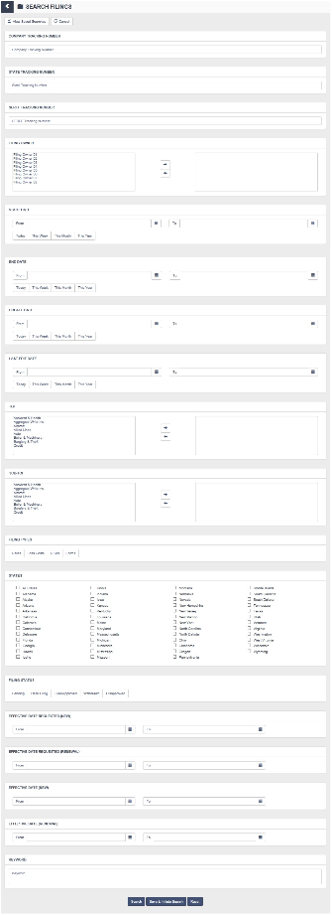

##### SearchFilings

### UC-1-28 - SFM Search Filing Results

The use case encompasses functionality of displaying the result for State Filing Search.

|  |  |
| --- | --- |
| Preconditions Admin, Authenticated Client, Authenticated Client Admin, Authenticated User should be logged in and have subscription for State Filing Manager App. | Success Guarantee System will displays list of filings as a result of criteria selected on State Filing Search screen. |

#### Main Success Scenario

1. Admin, Authenticated Client, Authenticated Client Admin, Authenticated User can view Filing Search Result by selecting criteria on Search Filing screen and clicking "Initiate Search" or "Save & Initiate Search". [Refer Use Case - SFM Search Filings (UC-1-27)]
2. System will display the result with following columns
   1. Company Tracking Number - System will display the alpha numeric number generated by the company.
      1. User can click on the sort icon besides "Filing Number". If the "Filing Number" is in Ascending Order it will change to Descending Order and If the "Filing Number" is in Descending Order it will change to Ascending Order.
   2. State- System will display the State to which the filing belongs.
      1. User can click on the sort icon besides "State". If the "State" is in Ascending Order it will change to Descending Order and If the "State" is in Descending Order it will change to Ascending Order.
   3. Filing Type- System will display the Filling Type to which the filing belongs.
      1. User can click on the sort icon besides "Filing Type". If the "Filing Type" is in Ascending Order it will change to Descending Order and If the "Filing Type" is in Descending Order it will change to Ascending Order.
   4. Status - System will display current status of the filing.
      1. User can click on the sort icon besides column "Status". If the "Status" is in Ascending Order it will change to Descending Order and If the "Status" is in Descending Order it will change to Ascending Order.
   5. Effective Date (New)- System will display Effective Date (New)of the filing.
      1. User can click on the sort icon besides column "Effective Date (New)". If the "Status" is in Ascending Order it will change to Descending Order and If the "Effective Date (New)" is in Descending Order it will change to Ascending Order.
   6. Effective Date (Renewal)- System will display Effective Date (Renewal)of the filing.
      1. User can click on the sort icon besides column "Effective Date (Renewal)". If the "Status" is in Ascending Order it will change to Descending Order and If the "Effective Date (Renewal)" is in Descending Order it will change to Ascending Order.
   7. Action - System will display following links under action column
      1. System will display "View" link under Action column by clicking on which user can see the filing details. System will redirect user to State Filing details screen. [Refer Use Case - SFM Filing Details (UC-1-11)]
3. Search Result will have paging. Admin, Authenticated Client, Authenticated Client Admin, Authenticated User can select number of records to be displayed per page.
4. Search Again - When Admin, Authenticated Client, Authenticated Client Admin, Authenticated User clicks on "Search Again" button, System will redirect user to Filing Search screen where user can select a new criteria for searching filings.
5. Refine Search - When Admin, Authenticated Client, Authenticated Client Admin, Authenticated User clicks on "Refine Search" button, System will redirect user to Filing Search screen where all the criteria for search will be retained by the system.
6. Printable View - When Admin, Authenticated Client, Authenticated Client Admin, Authenticated User clicks on "Printable View", System will display a view of the filing search result and a "Print" button. When Admin, Authenticated Client, Authenticated Client Admin, Authenticated User click on "Print", a Print dialog box will be opened and user can print the result.
7. Export Details - System will export search filing results to excel file.
8. Filing List Count
   1. All - User can see all list of Filing for Selected Project.

#### Extensions

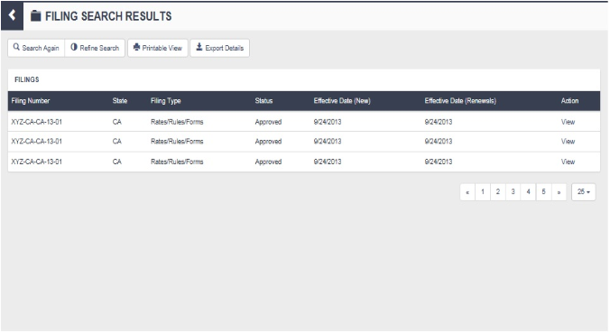

##### SearchFilingResult

## Home Dashboard

### UC-2-1 - Home Dashboard

The use case encompasses functionality of Home Dashboard View for logged in users.

|  |  |
| --- | --- |
| Preconditions Admin, Authenticated Client, Authenticated Client Admin should be logged in. | Success Guarantee System will display Dashboard View to the Admin, Authenticated Client, Authenticated Client Admin with their preferences set. |

#### Main Success Scenario

1. System authenticates Admin, Authenticated Client, Authenticated Client Admin, Authenticated User and redirects them to the Home Dashboard View.
2. When System redirects user on Home Dashboard for the first time, it will display Home Starter Dashboard. [Refer Use Case - Starter Dashboards (UC-23-1)].
3. Admin, Authenticated Client, Authenticated Client Admin, Authenticated User can see Home Dashboard view (as shown in DGM-Dashboard.ndx) once their authentication is validated, System will redirect the user to Home Dashboard. Also user can click on "Dashboard" menu.
4. Home Dashboard will have a "Dashboard Name" list which will have all the dashboards created by the user and also the public dashboards of other users of the same account. If Admin, Authenticated Client, Authenticated Client Admin, Authenticated User selects a Name from the list of Dashboard Names, System will display the Dashboard for selected name and all the preferences set under selected dashboard.
5. System will display Last Refreshed Date for the selected dashboard.
6. Home Dashboard View will display all the preferences set by the user.
   1. General Widgets Functionality Widgets
      1. User can only add widgets with data specific to the filters selected while creating the dashboard.
      2. Add Widget - User can add widgets to current Home Dashboard by clicking "Edit Dashboard" button, System will redirect user to "Edit Dashboard" screen and user can add the widgets on the current dashboard.
         1. Refer Use Case - Add Widget (UC-2-5) which will describe the general functionality of adding the widget.
      3. Reorder Widgets - Admin, Authenticated Client, Authenticated Client Admin, Authenticated User can reorder the widgets added to the dashboard.
      4. Remove Widgets - Admin, Authenticated Client, Authenticated Client Admin, Authenticated User can delete the widgets added to the dashboard and it will no longer be displayed on that dashboard.
      5. Edit Widget - Admin, Authenticated Client, Authenticated Client Admin, Authenticated User can edit the widgets added to the dashboard. If user clicks on Edit Widget button in the header section of the widget, System will redirect users to Edit Widget Screen.
         1. Refer Use Case - Edit Widget (UC-2-6) which will describe the general functionality of editing the widget.
         2. User cannot edit a widget placed on public dashboard created by other users of same account.
      6. View Records - IF Admin, Authenticated Client, Authenticated Client Admin, Authenticated User clicks on View Record link, System will display results for the respective widget (i.e. - result for criteria mentioned in the widgets).
   2. Home Dashboard specific Widgets [Please Refer Requirement - REQ-SF-8 (REQ-12-8)]
      1. Metric & Filters/Dimensions
         1. Metric
            1. Average Interrogatory Response Time

"Average Interrogatory Response Time" provides the average number of days that lapse between "Correspondence Date" and "Response Date" for all correspondence with the "Correspondence Type" of "Objection Letter" (It will consider all correspondence which logged in user has added and not the correspondence belonging to other users).

* + - * 1. Average Time to Filing Approval

"Average Time to Filing Approval" provides the average number of days that lapse between "Submission Date" and "Disposition Date" for all filings where Filing Status = "Filed/Approved" for logged in user (It will consider all filings which logged in user has added and not the filings belonging to other users).

* + - * 1. Average Time to Project Completion

"Average Time to Project Completion" provides the average number of days that lapse between "Start Date" and "End Date" for all projects of the logged in user (It will consider all projects which logged in user has created and not the projects belonging to other users).

* + - * 1. Count of Activities
        2. Count of Adoptions
        3. Count of Circulars
        4. Count of Company Forms
        5. Count of Correspondence
        6. Count of Filings
        7. Count of Projects
        8. Count of Tasks
        9. Percent Project Complete

System will consider the projects of user account where project status is "closed".

* + - * 1. Sum of Filing Fees
      1. Filters/Dimensions
         1. Activity Type
         2. Adoption Method
         3. Affiliate
         4. Bureau
         5. Bureau Action
         6. Bureau LOB
         7. Bureau Filing Type
         8. Circular Type
         9. Company Action
         10. Correspondence Type
         11. Countrywide Circular
         12. Filing Fee Type
         13. Filing Fee Amount
         14. Filing Owner
         15. Filing Status
         16. Filing Type
         17. Forms Issuing Status
         18. Forms Purpose
         19. Forms Status
         20. Forms Type
         21. Forms Contact
         22. Insurance Company
         23. Insurance Group
         24. New/Revised
         25. Product
         26. Product Type
         27. Project Name
         28. Project Owner
         29. Project Status
         30. Rate/Rule Contact
         31. Response Required
         32. SERFF Status
         33. Special Topic
         34. State
         35. State Status
         36. Sub-TOI
         37. Task Type
         38. Task Status
         39. Third Party Filer
         40. TOI
    1. Home Dashboard Widget Examples by Widget Types
       1. Metric
          1. Example 1 - If user selects filters as Product = 'Commercial Auto' (Only Show) & Project = "2013 Comm Auto" (Only Show) along with the metric "Count of Filings". Suppose there are total 50 filings belonging to the same account out of which 20 filings belongs to product 'Commercial Auto' and project '2013 Comm Auto' then System will display the Metric Widget with Filing Count as '20' & '% of Total' as "40.00%" (20/50*100).
          2. Example 2 - If user selects filters as State = 'Florida' (Only Show), Task Status = 'Open' (Don't Show) along with the metric "Count of Tasks". Suppose there are total 30 Task belonging to the same account out of which 22 tasks belongs to state Florida and has task status other than 'Open' then System will display the Metric Widget with Task Count as '22' & '% of Total' as "73.33%" (22/30*100) .
       2. Timeline
          1. If user selects 'All Time' in the date range field on the widget sub header section, System will display count of the Activities added till date.
          2. If user selects 'This Week' in the date range field on the widget sub header section, System will display count of the Activities added in the current week.
          3. If user selects 'This Month' in the date range field on the widget sub header section, System will display count of the Activities added in the current month.
          4. If user selects 'This Year' in the date range field on the widget sub header section, System will display count of the Activities added in the current year.
          5. The "Compare With Metric" drop down will have list of all the metrics available for Home Page Dashboard. If user selects "Compare With Metric"from the drop down list, System will add an additional metric on Timeline widget along with main metric
          6. Example 1 - If user selects filters as Product = "Commercial Auto" (Only Show) & Insurance Group = "Allstate Insurance Group" (Only Show) along with the metric "Count of Activities", System will display the Timeline Widget with Activities Count which are created for filings belonging to Group "Allstate Insurance Group" and product "Commercial Auto".
          7. Example 2 - If user selects filters as Product = "Commercial Auto" (Only Show) & Insurance Group = "Allstate Insurance Group" (Only Show) along with the metric "Count of Activities" & compare with metric as "Count of Tasks", System will display the Timeline Widget with Activities Count & Task Counts which are created for filings belonging to Group "Allstate Insurance Group" and product "Commercial Auto".
       3. Geomap
          1. It will display selected metric with selected filters applied.
          2. Example - If user selects filters as Filing Type = 'Rates' (Don't Show), Project = '2013 Commercial Auto Revision' (Only Show) along with the metric "Count of Correspondence", System will display the Geomap Widget with Correspondence Count across different states which are associated with project '2013 Commercial Auto Revision' and has Filing type other than 'Rate'.
       4. Table
          1. It will display count of selected metric by the dimension selected.
          2. User can select any metric 1 (required) & metric 2 (optional) from given list and user can select one dimension (required).
          3. The dimension drop down will have all the filter names for Home Page Dashboard listed. Unlike filters user can only select the dimension and not their values.
          4. Example 1 (Dimension, Metric 1) - If user selects dimension as "Filing Type" along with the metric 1 "Count of Filings", System will display the Table Widget with first column as Filing Type & it will have filing type values like 'Forms', 'Rates', 'Rules' & 'Loss Cost'. The second column of the table widget will be named as "Filings" and it will have count of filings against the filings types mentioned in column 1.
          5. Example 2 (Dimension, Metric 1, Metric 2) - If user selects dimension as "Filing Type" along with the metric 1 as "Count of Filings" & metric 2 as "Average Time to Filing Approval", System will display the Table Widget with first column as Filing Type & it will have filing type values like 'Forms', 'Rates', 'Rules' & 'Loss Cost'. The second column of the table widget will be named as "Filings" and it will have count of filings against the filings types mentioned in column 1. The third column of the table widget will be named as "Average Filing Approval Time" and it will have average time taken for filing approval of the types mentioned in column 1.
       5. Pie
          1. It will display count of selected metric by grouping it with another specified field in Grouped By drop down.
          2. If user select Pie widget type, System will not allow user to select filters. Instead it will display a Grouped By option from where user can select value with which selected metric will be grouped.
          3. "Grouped By" will be mandatory for users to select.
          4. Grouped By drop down will have list of all the filters available for Home Page Dashboard.
          5. Example - If user selects Grouped By = 'Task Status' along with the metric "Count of Task", System will display the Pie Widget with Task Count grouped across Open & Closed task status. That means Pie widget will have two slices, one slice will have Task Count for 'Open' & second slice will have Task Count for 'Closed', both slices with different colors.
          6. The System will limit the number of slices displayed in pie chart widgets to 10 maximum slices.

The Example - if user looks for count of activities grouped by product and the no of product under user account is greater than 10, then System will get only those 10 products which will have highest count of activities.

* + - 1. Bar
         1. It will display count of selected metric by grouping it with another specified field in Grouped By drop down.
         2. If user select Bar widget type, System will not allow user to select filters. Instead it will display a Grouped By option from where user can select value with which selected metric will be grouped.
         3. "Grouped By" will be mandatory for users to select.
         4. Grouped By drop down will have list of all the filters available for Home Page Dashboard.
         5. Example - If user selects Grouped By = 'Project Status' along with the metric "Count of Projects", System will display the Bar Widget with Project Count grouped across their status. That means Bar widget will have bars equal to the no of Project Status and the no. of projects per status.
         6. The System will limit the number of bars displayed in bar chart widget to 10 maximum bars.

The Example - if user looks for count of adoptions grouped by special topic and the no of special topics is greater than 10, then System will get only those 10 special topics which will have highest count of adoptions.

* + 1. All the records to be shown in the widgets will be account level records

1. Home Dashboards will not have any static widgets.
2. Add Dashboard - System will redirect user to "Add Dashboard" screen. Once the Admin, Authenticated Client, Authenticated Client Admin, Authenticated User adds new dashboard it will be available in "Dashboard Name" list and user can view newly added dashboard by clicking the name of the dashboard.
   1. Refer Use Case - Home Dashboard - Add (UC-2-2)] for general functionality of Adding a Dashboard.
   2. Home Dashboard will have following filters
      1. Bureau
      2. Bureau LOB
      3. Bureau Filing Type
      4. Circular Type
      5. Filing Owner
      6. Insurance Company
      7. Insurance Group
      8. Product
      9. Project
      10. Project Owner
      11. State
      12. Third Party Filer
      13. TOI
      14. Sub-TOI
   3. If a user select Project = "2013 Comm Auto Revision" then the user can only add widgets with data specific to the above selected project name.
3. Edit Dashboard - System will redirect user to "Edit Dashboard" screen. Once the Admin, Authenticated Client, Authenticated Client Admin, Authenticated User edits the existing dashboard, user can view changes applied to dashboard by clicking the name of the dashboard.
   1. Admin, Authenticated Client, Authenticated Client Admin, Authenticated User cannot edit public dashboards created by other users of same account.
   2. Refer Use Case - Home Dashboard - Edit (UC-2-3) for general functionality of Editing a Dashboard.
4. Clone Dashboard - System will create a copy of selected dashboard with additional changes made by Admin, Authenticated Client, Authenticated Client Admin, Authenticated User (if they make changes to selected dashboard). A new record will be created by the System when user clones existing dashboard.
   1. Refer Use Case - Home Dashboard - Clone (UC-2-4) for general functionality of Cloning a Dashboard.
5. Delete Dashboard - System will confirm from Admin, Authenticated Client, Authenticated Client Admin, Authenticated User if they want to delete the selected dashboard. If Admin, Authenticated Client, Authenticated Client Admin, Authenticated User click 'yes', System will remove the selected dashboard and it will not be available for user to view the dashboard
   1. Admin, Authenticated Client, Authenticated Client Admin, Authenticated User cannot delete public dashboards created by other users.
6. Refresh Dashboard - If Admin, Authenticated Client, Authenticated Client Admin, Authenticated User clicks on Refresh Dashboard button, all the record counts under widgets on dashboard will be updated as of today.
7. Email Dashboard - System will email the selected dashboard to the logged in user. [Refer Point 3.1 from Use Case - E-Mail Notification Manager (UC-4-5)]
   1. Admin, Authenticated Client, Authenticated Client Admin, Authenticated User click on "Email Dashboard" button, System will display a list of frequencies mentioned below.
      1. Daily - If user selects "Daily", System will add the selected dashboard to "Scheduled Dashboards" section of tool "Email Notification Manager" with "Daily" & "Active" options selected.
         1. System will send the email to the logged in user from Monday through Friday between 12 am and 4 am PST.
         2. System will send the dashboard in PDF Format.
      2. Weekly - If user selects "Weekly", System will add the selected report to "Scheduled Dashboards" section of tool "Email Notification Manager" with "Weekly" & "Active" options selected.
         1. System will send the email to the logged in user on every Monday between 12 am and 4 am PST.
         2. System will send the dashboard in PDF Format.
      3. Monthly - If user selects "Monthly", System will add the selected report to "Scheduled Dashboards" section of tool "Email Notification Manager" with "Monthly" & "Active" options selected.
         1. System will send the email to the logged in user on the first day of every month between 12 am and 4 am PST.
         2. System will send the dashboard in PDF Format.
   2. System stop sending mails for dashboards when user un-checks the active option for dashboards from Email Notification Manager - Scheduled Dashboards.
8. Printable View - System will display a view of the dashboard selected and a "Print" button in a new browser window. When Admin, Authenticated Client, Authenticated Client Admin, Authenticated User click on "Print", a Print dialog box will be opened and user can print the dashboard.

#### Extensions

1.a If the authentication fails, System will redirect user to the login screen.

6.2.2.2.5.a If user selects same metric in "compare with metric" option as main metric

1. System will display an error "Please select a different metric for comparison."

6.2.2.2.5.b If user doesn't select "compare with metric", System will display only one line for Timeline widget indicating the main metric selected.

6.2.2.4.2.a If user selects same metric in "metric 2" option as "metric 1"

1. System will display an error "Please select two different metrics."

6.2.2.5.3.a If user doesn't select "Grouped By"

1. System will display an error "Please select a data group."

6.2.2.6.3.a If user doesn't select "Grouped By"

1. System will display an error "Please select a data group."

11.a If Admin, Authenticated Client, Authenticated Client Admin click 'no', system will do nothing.

13.a If System doesn't have logged in user's email id

1. System will display an error "Please add a valid e-mail address to your user profile."

13.b If no frequency is set for selected Dashboard, System will not email the dashboard to the logged in user.

|  |  |  |
| --- | --- | --- |
| Related Requirements |  |  |
| REQ-12-8 | REQ-SF-8 | Non-functional |

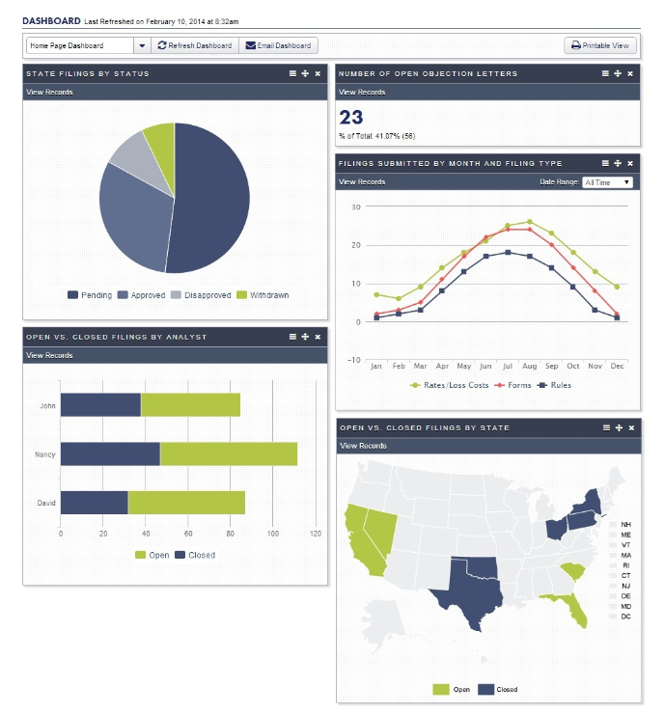

##### Dashboard

### UC-2-7 - Home Dashboard With Welcome & My Apps widgets

The use case encompasses functionality of Home Dashboard View for logged in users.

|  |  |
| --- | --- |
| Preconditions Admin, Authenticated Client, Authenticated Client Admin should be logged in. | Success Guarantee System will display Dashboard View to the Admin, Authenticated Client, Authenticated Client Admin with their preferences set. |

#### Main Success Scenario

1. System authenticates Admin, Authenticated Client, Authenticated Client Admin, Authenticated User and redirects them to the Home Dashboard View.
2. When System redirects user on Home Dashboard for the first time, it will display Home Starter Dashboard. [Refer Use Case - Starter Dashboards (UC-23-1)].
3. Admin, Authenticated Client, Authenticated Client Admin, Authenticated User can see Home Dashboard view (as shown in DGM-Dashboard.ndx) once their authentication is validated, System will redirect the user to Home Dashboard. Also user can click on "Dashboard" menu.
4. Home Dashboard will have a "Dashboard Name" list which will have all the dashboards created by the user and also the public dashboards of other users of the same account. If Admin, Authenticated Client, Authenticated Client Admin, Authenticated User selects a Name from the list of Dashboard Names, System will display the Dashboard for selected name and all the preferences set under selected dashboard.
5. System will display Last Refreshed Date for the selected dashboard.
6. Home Dashboard View will display all the preferences set by the user.
   1. General Widgets Functionality Widgets
      1. User can only add widgets with data specific to the filters selected while creating the dashboard.
      2. Add Widget - User can add widgets to current Home Dashboard by clicking "Edit Dashboard" button, System will redirect user to "Edit Dashboard" screen and user can add the widgets on the current dashboard.
         1. Refer Use Case - Add Widget (UC-2-5) which will describe the general functionality of adding the widget.
      3. Reorder Widgets - Admin, Authenticated Client, Authenticated Client Admin, Authenticated User can reorder the widgets added to the dashboard.
      4. Remove Widgets - Admin, Authenticated Client, Authenticated Client Admin, Authenticated User can delete the widgets added to the dashboard and it will no longer be displayed on that dashboard.
      5. Edit Widget - Admin, Authenticated Client, Authenticated Client Admin, Authenticated User can edit the widgets added to the dashboard. If user clicks on Edit Widget button in the header section of the widget, System will redirect users to Edit Widget Screen.
         1. Refer Use Case - Edit Widget (UC-2-6) which will describe the general functionality of editing the widget.
         2. User cannot edit a widget placed on public dashboard created by other users of same account.
      6. View Records - IF Admin, Authenticated Client, Authenticated Client Admin, Authenticated User clicks on View Record link, System will display results for the respective widget (i.e. - result for criteria mentioned in the widgets).
   2. Home Dashboard specific Widgets [Please Refer Requirement - REQ-SF-8 (REQ-12-8)]
      1. Metric & Filters/Dimensions
         1. Metric
            1. Average Interrogatory Response Time

"Average Interrogatory Response Time" provides the average number of days that lapse between "Correspondence Date" and "Response Date" for all correspondence with the "Correspondence Type" of "Objection Letter" (It will consider all correspondence which logged in user has added and not the correspondence belonging to other users).

* + - * 1. Average Time to Filing Approval

"Average Time to Filing Approval" provides the average number of days that lapse between "Submission Date" and "Disposition Date" for all filings where Filing Status = "Filed/Approved" for logged in user (It will consider all filings which logged in user has added and not the filings belonging to other users).

* + - * 1. Average Time to Project Completion

"Average Time to Project Completion" provides the average number of days that lapse between "Start Date" and "End Date" for all projects of the logged in user (It will consider all projects which logged in user has created and not the projects belonging to other users).

* + - * 1. Count of Activities
        2. Count of Adoptions
        3. Count of Circulars
        4. Count of Company Forms
        5. Count of Correspondence
        6. Count of Filings
        7. Count of Projects
        8. Count of Tasks
        9. Percent Project Complete

System will consider the projects of user account where project status is "closed".

* + - * 1. Sum of Filing Fees
      1. Filters/Dimensions
         1. Activity Type
         2. Adoption Method
         3. Affiliate
         4. Bureau
         5. Bureau Action
         6. Bureau LOB
         7. Bureau Filing Type
         8. Circular Type
         9. Company Action
         10. Correspondence Type
         11. Countrywide Circular
         12. Filing Fee Type
         13. Filing Fee Amount
         14. Filing Owner
         15. Filing Status
         16. Filing Type
         17. Forms Issuing Status
         18. Forms Purpose
         19. Forms Status
         20. Forms Type
         21. Forms Contact
         22. Insurance Company
         23. Insurance Group
         24. New/Revised
         25. Product
         26. Product Type
         27. Project Name
         28. Project Owner
         29. Project Status
         30. Rate/Rule Contact
         31. Response Required
         32. SERFF Status
         33. Special Topic
         34. State
         35. State Status
         36. Sub-TOI
         37. Task Type
         38. Task Status
         39. Third Party Filer
         40. TOI
    1. Home Dashboard Widget Examples by Widget Types
       1. Metric
          1. Example 1 - If user selects filters as Product = 'Commercial Auto' (Only Show) & Project = "2013 Comm Auto" (Only Show) along with the metric "Count of Filings". Suppose there are total 50 filings belonging to the same account out of which 20 filings belongs to product 'Commercial Auto' and project '2013 Comm Auto' then System will display the Metric Widget with Filing Count as '20' & '% of Total' as "40.00%" (20/50*100).
          2. Example 2 - If user selects filters as State = 'Florida' (Only Show), Task Status = 'Open' (Don't Show) along with the metric "Count of Tasks". Suppose there are total 30 Task belonging to the same account out of which 22 tasks belongs to state Florida and has task status other than 'Open' then System will display the Metric Widget with Task Count as '22' & '% of Total' as "73.33%" (22/30*100) .
       2. Timeline
          1. If user selects 'All Time' in the date range field on the widget sub header section, System will display count of the Activities added till date.
          2. If user selects 'This Week' in the date range field on the widget sub header section, System will display count of the Activities added in the current week.
          3. If user selects 'This Month' in the date range field on the widget sub header section, System will display count of the Activities added in the current month.
          4. If user selects 'This Year' in the date range field on the widget sub header section, System will display count of the Activities added in the current year.
          5. The "Compare With Metric" drop down will have list of all the metrics available for Home Page Dashboard. If user selects "Compare With Metric"from the drop down list, System will add an additional metric on Timeline widget along with main metric
          6. Example 1 - If user selects filters as Product = "Commercial Auto" (Only Show) & Insurance Group = "Allstate Insurance Group" (Only Show) along with the metric "Count of Activities", System will display the Timeline Widget with Activities Count which are created for filings belonging to Group "Allstate Insurance Group" and product "Commercial Auto".
          7. Example 2 - If user selects filters as Product = "Commercial Auto" (Only Show) & Insurance Group = "Allstate Insurance Group" (Only Show) along with the metric "Count of Activities" & compare with metric as "Count of Tasks", System will display the Timeline Widget with Activities Count & Task Counts which are created for filings belonging to Group "Allstate Insurance Group" and product "Commercial Auto".
       3. Geomap
          1. It will display selected metric with selected filters applied.
          2. Example - If user selects filters as Filing Type = 'Rates' (Don't Show), Project = '2013 Commercial Auto Revision' (Only Show) along with the metric "Count of Correspondence", System will display the Geomap Widget with Correspondence Count across different states which are associated with project '2013 Commercial Auto Revision' and has Filing type other than 'Rate'.
       4. Table
          1. It will display count of selected metric by the dimension selected.
          2. User can select any metric 1 (required) & metric 2 (optional) from given list and user can select one dimension (required).
          3. The dimension drop down will have all the filter names for Home Page Dashboard listed. Unlike filters user can only select the dimension and not their values.
          4. Example 1 (Dimension, Metric 1) - If user selects dimension as "Filing Type" along with the metric 1 "Count of Filings", System will display the Table Widget with first column as Filing Type & it will have filing type values like 'Forms', 'Rates', 'Rules' & 'Loss Cost'. The second column of the table widget will be named as "Filings" and it will have count of filings against the filings types mentioned in column 1.
          5. Example 2 (Dimension, Metric 1, Metric 2) - If user selects dimension as "Filing Type" along with the metric 1 as "Count of Filings" & metric 2 as "Average Time to Filing Approval", System will display the Table Widget with first column as Filing Type & it will have filing type values like 'Forms', 'Rates', 'Rules' & 'Loss Cost'. The second column of the table widget will be named as "Filings" and it will have count of filings against the filings types mentioned in column 1. The third column of the table widget will be named as "Average Filing Approval Time" and it will have average time taken for filing approval of the types mentioned in column 1.
       5. Pie
          1. It will display count of selected metric by grouping it with another specified field in Grouped By drop down.
          2. If user select Pie widget type, System will not allow user to select filters. Instead it will display a Grouped By option from where user can select value with which selected metric will be grouped.
          3. "Grouped By" will be mandatory for users to select.
          4. Grouped By drop down will have list of all the filters available for Home Page Dashboard.
          5. Example - If user selects Grouped By = 'Task Status' along with the metric "Count of Task", System will display the Pie Widget with Task Count grouped across Open & Closed task status. That means Pie widget will have two slices, one slice will have Task Count for 'Open' & second slice will have Task Count for 'Closed', both slices with different colors.
          6. The System will limit the number of slices displayed in pie chart widgets to 10 maximum slices.

The Example - if user looks for count of activities grouped by product and the no of product under user account is greater than 10, then System will get only those 10 products which will have highest count of activities.

* + - 1. Bar
         1. It will display count of selected metric by grouping it with another specified field in Grouped By drop down.
         2. If user select Bar widget type, System will not allow user to select filters. Instead it will display a Grouped By option from where user can select value with which selected metric will be grouped.
         3. "Grouped By" will be mandatory for users to select.
         4. Grouped By drop down will have list of all the filters available for Home Page Dashboard.
         5. Example - If user selects Grouped By = 'Project Status' along with the metric "Count of Projects", System will display the Bar Widget with Project Count grouped across their status. That means Bar widget will have bars equal to the no of Project Status and the no. of projects per status.
         6. The System will limit the number of bars displayed in bar chart widget to 10 maximum bars.

The Example - if user looks for count of adoptions grouped by special topic and the no of special topics is greater than 10, then System will get only those 10 special topics which will have highest count of adoptions.

* + 1. All the records to be shown in the widgets will be account level records

1. Welcome Widget
   1. System will display Name of the user who has logged in and also Company Name of the Admin, Authenticated Client, Authenticated Client Admin, Authenticated User under Welcome Widget.
   2. Other links under Welcome Widget
      1. Edit Profile - System will redirect the user to Edit User screen where Admin, Authenticated Client, Authenticated Client Admin, Authenticated User can edit their info and save into the system.
      2. Change Password - System will redirect user to Change Password screen where Admin, Authenticated Client, Authenticated Client Admin, Authenticated User can change their existing password.
      3. Download the User Manual - Admin, Authenticated Client, Authenticated Client Admin, Authenticated User can download the user manual by clicking on this link
      4. Contact Support - System will redirect the user to support screen.
      5. Admin, Authenticated Client, Authenticated Client Admin, Authenticated User
   3. Admin, Authenticated Client, Authenticated Client Admin, Authenticated User can move Welcome widget but can not edit or delete this widget.
2. My Apps Widget
   1. All the applications for which user has a valid subscription are listed under My Apps widget by the System.
   2. If Admin, Authenticated Client, Authenticated Client Admin, Authenticated User clicks on "View All Apps" link, System will redirect user to apps screen where all the apps under StateFilings.com are listed.
   3. Admin, Authenticated Client, Authenticated Client Admin, Authenticated User can move My Apps widget but can not edit or delete this widget.
3. Add Dashboard - System will redirect user to "Add Dashboard" screen. Once the Admin, Authenticated Client, Authenticated Client Admin, Authenticated User adds new dashboard it will be available in "Dashboard Name" list and user can view newly added dashboard by clicking the name of the dashboard.
   1. Refer Use Case - Home Dashboard - Add (UC-2-2)] for general functionality of Adding a Dashboard.
   2. Home Dashboard will have following filters
      1. Bureau
      2. Bureau LOB
      3. Bureau Filing Type
      4. Circular Type
      5. Filing Owner
      6. Insurance Company
      7. Insurance Group
      8. Product
      9. Project
      10. Project Owner
      11. State
      12. Third Party Filer
      13. TOI
      14. Sub-TOI
   3. If a user select Project = "2013 Comm Auto Revision" then the user can only add widgets with data specific to the above selected project name.
4. Edit Dashboard - System will redirect user to "Edit Dashboard" screen. Once the Admin, Authenticated Client, Authenticated Client Admin, Authenticated User edits the existing dashboard, user can view changes applied to dashboard by clicking the name of the dashboard.
   1. Admin, Authenticated Client, Authenticated Client Admin, Authenticated User cannot edit public dashboards created by other users of same account.
   2. Refer Use Case - Home Dashboard - Edit (UC-2-3) for general functionality of Editing a Dashboard.
5. Clone Dashboard - System will create a copy of selected dashboard with additional changes made by Admin, Authenticated Client, Authenticated Client Admin, Authenticated User (if they make changes to selected dashboard). A new record will be created by the System when user clones existing dashboard.
   1. Refer Use Case - Home Dashboard - Clone (UC-2-4) for general functionality of Cloning a Dashboard.
6. Delete Dashboard - System will confirm from Admin, Authenticated Client, Authenticated Client Admin, Authenticated User if they want to delete the selected dashboard. If Admin, Authenticated Client, Authenticated Client Admin, Authenticated User click 'yes', System will remove the selected dashboard and it will not be available for user to view the dashboard
   1. Admin, Authenticated Client, Authenticated Client Admin, Authenticated User cannot delete public dashboards created by other users.
7. Refresh Dashboard - If Admin, Authenticated Client, Authenticated Client Admin, Authenticated User clicks on Refresh Dashboard button, all the record counts under widgets on dashboard will be updated as of today.
8. Email Dashboard - System will email the selected dashboard to the logged in user. [Refer Point 3.1 from Use Case - E-Mail Notification Manager (UC-4-5)]
   1. Admin, Authenticated Client, Authenticated Client Admin, Authenticated User click on "Email Dashboard" button, System will display a list of frequencies mentioned below.
      1. Daily - If user selects "Daily", System will add the selected dashboard to "Scheduled Dashboards" section of tool "Email Notification Manager" with "Daily" & "Active" options selected.
         1. System will send the email to the logged in user from Monday through Friday between 12 am and 4 am PST.
         2. System will send the dashboard in PDF Format.
      2. Weekly - If user selects "Weekly", System will add the selected report to "Scheduled Dashboards" section of tool "Email Notification Manager" with "Weekly" & "Active" options selected.
         1. System will send the email to the logged in user on every Monday between 12 am and 4 am PST.
         2. System will send the dashboard in PDF Format.
      3. Monthly - If user selects "Monthly", System will add the selected report to "Scheduled Dashboards" section of tool "Email Notification Manager" with "Monthly" & "Active" options selected.
         1. System will send the email to the logged in user on the first day of every month between 12 am and 4 am PST.
         2. System will send the dashboard in PDF Format.
   2. System stop sending mails for dashboards when user un-checks the active option for dashboards from Email Notification Manager - Scheduled Dashboards.
9. Printable View - System will display a view of the dashboard selected and a "Print" button in a new browser window. When Admin, Authenticated Client, Authenticated Client Admin, Authenticated User click on "Print", a Print dialog box will be opened and user can print the dashboard.

#### Extensions

1.a If the authentication fails, System will redirect user to the login screen.

6.2.2.2.5.a If user selects same metric in "compare with metric" option as main metric

1. System will display an error "Please select a different metric for comparison."

6.2.2.2.5.b If user doesn't select "compare with metric", System will display only one line for Timeline widget indicating the main metric selected.

6.2.2.4.2.a If user selects same metric in "metric 2" option as "metric 1"

1. System will display an error "Please select two different metrics."

6.2.2.5.3.a If user doesn't select "Grouped By"

1. System will display an error "Please select a data group."

6.2.2.6.3.a If user doesn't select "Grouped By"

1. System will display an error "Please select a data group."

12.a If Admin, Authenticated Client, Authenticated Client Admin click 'no', system will do nothing.

14.a If System doesn't have logged in user's email id

1. System will display an error "Please add a valid e-mail address to your user profile."

14.b If no frequency is set for selected Dashboard, System will not email the dashboard to the logged in user.

|  |  |  |
| --- | --- | --- |
| Related Requirements |  |  |
| REQ-12-8 | REQ-SF-8 | Non-functional |

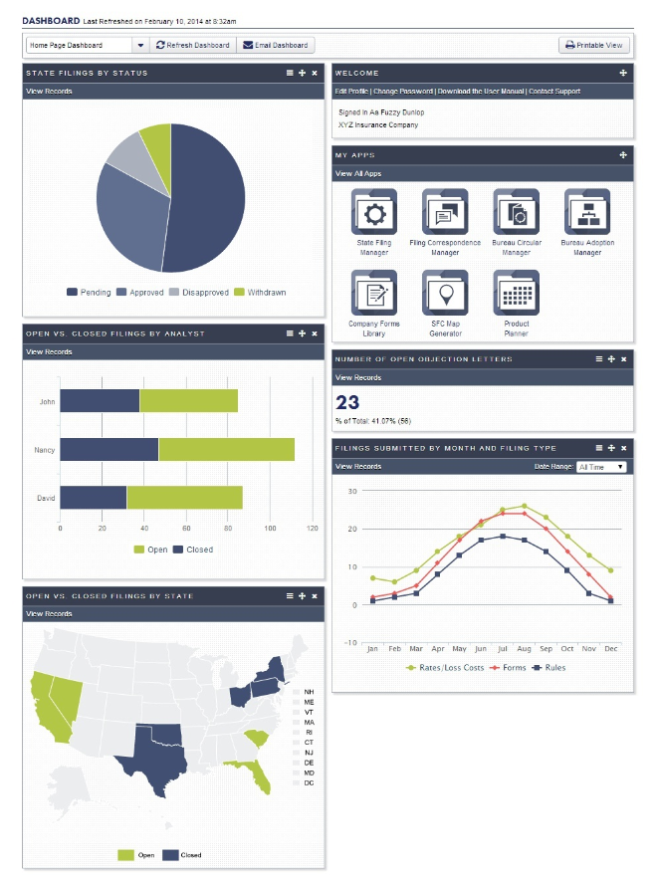

##### Dashboard

## Common

$Description $DeleteEmptyLine

$repeatDiagrams

$Picture

##### $Name

$Description

$endRepeatDiagrams

$repeatUseCases

### $ID - $Name

$Description

$if PreConditions <> ‘’ or PostConditions <> ‘’

|  |  |
| --- | --- |
| Preconditions $PreConditions | Success Guarantee $PostConditions |

$endif

#### Main Success Scenario

1. $listSteps $Description

#### Extensions

$listExtensions $NumberedDescription

|  |  |  |
| --- | --- | --- |
| Related Requirements |  |  |
| $tableRequirements $ID | $Name | $Type |

|  |
| --- |
| Related Documents |
| $tableRelatedDocuments $Name |

* $listNotes $DateAdded $Description

$repeatDiagrams

$Picture

##### $Name

$Description

$Break

$endRepeatDiagrams

$Break

$endrepeatUseCases

## Tools

$Description $DeleteEmptyLine

$repeatDiagrams

$Picture

##### $Name

$Description

$endRepeatDiagrams

$repeatUseCases

### $ID - $Name

$Description

$if PreConditions <> ‘’ or PostConditions <> ‘’

|  |  |
| --- | --- |
| Preconditions $PreConditions | Success Guarantee $PostConditions |

$endif

#### Main Success Scenario

1. $listSteps $Description

#### Extensions

$listExtensions $NumberedDescription

|  |  |  |
| --- | --- | --- |
| Related Requirements |  |  |
| $tableRequirements $ID | $Name | $Type |

|  |
| --- |
| Related Documents |
| $tableRelatedDocuments $Name |

* $listNotes $DateAdded $Description

$repeatDiagrams

$Picture

##### $Name

$Description

$Break

$endRepeatDiagrams

$Break

$endrepeatUseCases

## Reports

$Description $DeleteEmptyLine

$repeatDiagrams

$Picture

##### $Name

$Description

$endRepeatDiagrams

$repeatUseCases

### $ID - $Name

$Description

$if PreConditions <> ‘’ or PostConditions <> ‘’

|  |  |
| --- | --- |
| Preconditions $PreConditions | Success Guarantee $PostConditions |

$endif

#### Main Success Scenario

1. $listSteps $Description

#### Extensions

$listExtensions $NumberedDescription

|  |  |  |
| --- | --- | --- |
| Related Requirements |  |  |
| $tableRequirements $ID | $Name | $Type |

|  |
| --- |
| Related Documents |
| $tableRelatedDocuments $Name |

* $listNotes $DateAdded $Description

$repeatDiagrams

$Picture

##### $Name

$Description

$Break

$endRepeatDiagrams

$Break

$endrepeatUseCases

## Profile

$Description $DeleteEmptyLine

$repeatDiagrams

$Picture

##### $Name

$Description

$endRepeatDiagrams

$repeatUseCases

### $ID - $Name

$Description

$if PreConditions <> ‘’ or PostConditions <> ‘’

|  |  |
| --- | --- |
| Preconditions $PreConditions | Success Guarantee $PostConditions |

$endif

#### Main Success Scenario

1. $listSteps $Description

#### Extensions

$listExtensions $NumberedDescription

|  |  |  |
| --- | --- | --- |
| Related Requirements |  |  |
| $tableRequirements $ID | $Name | $Type |

|  |
| --- |
| Related Documents |
| $tableRelatedDocuments $Name |

* $listNotes $DateAdded $Description

$repeatDiagrams

$Picture

##### $Name

$Description

$Break

$endRepeatDiagrams

$Break

$endrepeatUseCases

## Admin

$Description $DeleteEmptyLine

$repeatDiagrams

$Picture

##### $Name

$Description

$endRepeatDiagrams

$repeatUseCases

### $ID - $Name

$Description

$if PreConditions <> ‘’ or PostConditions <> ‘’

|  |  |
| --- | --- |
| Preconditions $PreConditions | Success Guarantee $PostConditions |

$endif

#### Main Success Scenario

1. $listSteps $Description

#### Extensions

$listExtensions $NumberedDescription

|  |  |  |
| --- | --- | --- |
| Related Requirements |  |  |
| $tableRequirements $ID | $Name | $Type |

|  |
| --- |
| Related Documents |
| $tableRelatedDocuments $Name |

* $listNotes $DateAdded $Description

$repeatDiagrams

$Picture

##### $Name

$Description

$Break

$endRepeatDiagrams

$Break

$endrepeatUseCases

## Accounts

$Description $DeleteEmptyLine

$repeatDiagrams

$Picture

##### $Name

$Description

$endRepeatDiagrams

$repeatUseCases

### $ID - $Name

$Description

$if PreConditions <> ‘’ or PostConditions <> ‘’

|  |  |
| --- | --- |
| Preconditions $PreConditions | Success Guarantee $PostConditions |

$endif

#### Main Success Scenario

1. $listSteps $Description

#### Extensions

$listExtensions $NumberedDescription

|  |  |  |
| --- | --- | --- |
| Related Requirements |  |  |
| $tableRequirements $ID | $Name | $Type |

|  |
| --- |
| Related Documents |
| $tableRelatedDocuments $Name |

* $listNotes $DateAdded $Description

$repeatDiagrams

$Picture

##### $Name

$Description

$Break

$endRepeatDiagrams

$Break

$endrepeatUseCases

## Users

$Description $DeleteEmptyLine

$repeatDiagrams

$Picture

##### $Name

$Description

$endRepeatDiagrams

$repeatUseCases

### $ID - $Name

$Description

$if PreConditions <> ‘’ or PostConditions <> ‘’

|  |  |
| --- | --- |
| Preconditions $PreConditions | Success Guarantee $PostConditions |

$endif

#### Main Success Scenario

1. $listSteps $Description

#### Extensions

$listExtensions $NumberedDescription

|  |  |  |
| --- | --- | --- |
| Related Requirements |  |  |
| $tableRequirements $ID | $Name | $Type |

|  |
| --- |
| Related Documents |
| $tableRelatedDocuments $Name |

* $listNotes $DateAdded $Description

$repeatDiagrams

$Picture

##### $Name

$Description

$Break

$endRepeatDiagrams

$Break

$endrepeatUseCases

## Special Topics

$Description $DeleteEmptyLine

$repeatDiagrams

$Picture

##### $Name

$Description

$endRepeatDiagrams

$repeatUseCases

### $ID - $Name

$Description

$if PreConditions <> ‘’ or PostConditions <> ‘’

|  |  |
| --- | --- |
| Preconditions $PreConditions | Success Guarantee $PostConditions |

$endif

#### Main Success Scenario

1. $listSteps $Description

#### Extensions

$listExtensions $NumberedDescription

|  |  |  |
| --- | --- | --- |
| Related Requirements |  |  |
| $tableRequirements $ID | $Name | $Type |

|  |
| --- |
| Related Documents |
| $tableRelatedDocuments $Name |

* $listNotes $DateAdded $Description

$repeatDiagrams

$Picture

##### $Name

$Description

$Break

$endRepeatDiagrams

$Break

$endrepeatUseCases

## Bureau Adoption Matrix

$Description $DeleteEmptyLine

$repeatDiagrams

$Picture

##### $Name

$Description

$endRepeatDiagrams

$repeatUseCases

### $ID - $Name

$Description

$if PreConditions <> ‘’ or PostConditions <> ‘’

|  |  |
| --- | --- |
| Preconditions $PreConditions | Success Guarantee $PostConditions |

$endif

#### Main Success Scenario

1. $listSteps $Description

#### Extensions

$listExtensions $NumberedDescription

|  |  |  |
| --- | --- | --- |
| Related Requirements |  |  |
| $tableRequirements $ID | $Name | $Type |

|  |
| --- |
| Related Documents |
| $tableRelatedDocuments $Name |

* $listNotes $DateAdded $Description

$repeatDiagrams

$Picture

##### $Name

$Description

$Break

$endRepeatDiagrams

$Break

$endrepeatUseCases

## Bureaus

$Description $DeleteEmptyLine

$repeatDiagrams

$Picture

##### $Name

$Description

$endRepeatDiagrams

$repeatUseCases

### $ID - $Name

$Description

$if PreConditions <> ‘’ or PostConditions <> ‘’

|  |  |
| --- | --- |
| Preconditions $PreConditions | Success Guarantee $PostConditions |

$endif

#### Main Success Scenario

1. $listSteps $Description

#### Extensions

$listExtensions $NumberedDescription

|  |  |  |
| --- | --- | --- |
| Related Requirements |  |  |
| $tableRequirements $ID | $Name | $Type |

|  |
| --- |
| Related Documents |
| $tableRelatedDocuments $Name |

* $listNotes $DateAdded $Description

$repeatDiagrams

$Picture

##### $Name

$Description

$Break

$endRepeatDiagrams

$Break

$endrepeatUseCases

## User Role Management

$Description $DeleteEmptyLine

$repeatDiagrams

$Picture

##### $Name

$Description

$endRepeatDiagrams

$repeatUseCases

### $ID - $Name

$Description

$if PreConditions <> ‘’ or PostConditions <> ‘’

|  |  |
| --- | --- |
| Preconditions $PreConditions | Success Guarantee $PostConditions |

$endif

#### Main Success Scenario

1. $listSteps $Description

#### Extensions

$listExtensions $NumberedDescription

|  |  |  |
| --- | --- | --- |
| Related Requirements |  |  |
| $tableRequirements $ID | $Name | $Type |

|  |
| --- |
| Related Documents |
| $tableRelatedDocuments $Name |

* $listNotes $DateAdded $Description

$repeatDiagrams

$Picture

##### $Name

$Description

$Break

$endRepeatDiagrams

$Break

$endrepeatUseCases

## Manual Site Update

$Description $DeleteEmptyLine

$repeatDiagrams

$Picture

##### $Name

$Description

$endRepeatDiagrams

$repeatUseCases

### $ID - $Name

$Description

$if PreConditions <> ‘’ or PostConditions <> ‘’

|  |  |
| --- | --- |
| Preconditions $PreConditions | Success Guarantee $PostConditions |

$endif

#### Main Success Scenario

1. $listSteps $Description

#### Extensions

$listExtensions $NumberedDescription

|  |  |  |
| --- | --- | --- |
| Related Requirements |  |  |
| $tableRequirements $ID | $Name | $Type |

|  |
| --- |
| Related Documents |
| $tableRelatedDocuments $Name |

* $listNotes $DateAdded $Description

$repeatDiagrams

$Picture

##### $Name

$Description

$Break

$endRepeatDiagrams

$Break

$endrepeatUseCases

## Products

$Description $DeleteEmptyLine

$repeatDiagrams

$Picture

##### $Name

$Description

$endRepeatDiagrams

$repeatUseCases

### $ID - $Name

$Description

$if PreConditions <> ‘’ or PostConditions <> ‘’

|  |  |
| --- | --- |
| Preconditions $PreConditions | Success Guarantee $PostConditions |

$endif

#### Main Success Scenario

1. $listSteps $Description

#### Extensions

$listExtensions $NumberedDescription

|  |  |  |
| --- | --- | --- |
| Related Requirements |  |  |
| $tableRequirements $ID | $Name | $Type |

|  |
| --- |
| Related Documents |
| $tableRelatedDocuments $Name |

* $listNotes $DateAdded $Description

$repeatDiagrams

$Picture

##### $Name

$Description

$Break

$endRepeatDiagrams

$Break

$endrepeatUseCases

## Product Planner

$Description $DeleteEmptyLine

$repeatDiagrams

$Picture

##### $Name

$Description

$endRepeatDiagrams

$repeatUseCases

### $ID - $Name

$Description

$if PreConditions <> ‘’ or PostConditions <> ‘’

|  |  |
| --- | --- |
| Preconditions $PreConditions | Success Guarantee $PostConditions |

$endif

#### Main Success Scenario

1. $listSteps $Description

#### Extensions

$listExtensions $NumberedDescription

|  |  |  |
| --- | --- | --- |
| Related Requirements |  |  |
| $tableRequirements $ID | $Name | $Type |

|  |
| --- |
| Related Documents |
| $tableRelatedDocuments $Name |

* $listNotes $DateAdded $Description

$repeatDiagrams

$Picture

##### $Name

$Description

$Break

$endRepeatDiagrams

$Break

$endrepeatUseCases

## Filing Correspondence Manager

$Description $DeleteEmptyLine

$repeatDiagrams

$Picture

##### $Name

$Description

$endRepeatDiagrams

$repeatUseCases

### $ID - $Name

$Description

$if PreConditions <> ‘’ or PostConditions <> ‘’

|  |  |
| --- | --- |
| Preconditions $PreConditions | Success Guarantee $PostConditions |

$endif

#### Main Success Scenario

1. $listSteps $Description

#### Extensions

$listExtensions $NumberedDescription

|  |  |  |
| --- | --- | --- |
| Related Requirements |  |  |
| $tableRequirements $ID | $Name | $Type |

|  |
| --- |
| Related Documents |
| $tableRelatedDocuments $Name |

* $listNotes $DateAdded $Description

$repeatDiagrams

$Picture

##### $Name

$Description

$Break

$endRepeatDiagrams

$Break

$endrepeatUseCases

## SFC Map Generator

$Description $DeleteEmptyLine

$repeatDiagrams

$Picture

##### $Name

$Description

$endRepeatDiagrams

$repeatUseCases

### $ID - $Name

$Description

$if PreConditions <> ‘’ or PostConditions <> ‘’

|  |  |
| --- | --- |
| Preconditions $PreConditions | Success Guarantee $PostConditions |

$endif

#### Main Success Scenario

1. $listSteps $Description

#### Extensions

$listExtensions $NumberedDescription

|  |  |  |
| --- | --- | --- |
| Related Requirements |  |  |
| $tableRequirements $ID | $Name | $Type |

|  |
| --- |
| Related Documents |
| $tableRelatedDocuments $Name |

* $listNotes $DateAdded $Description

$repeatDiagrams

$Picture

##### $Name

$Description

$Break

$endRepeatDiagrams

$Break

$endrepeatUseCases

## Requirement

$Description $DeleteEmptyLine

$repeatDiagrams

$Picture

##### $Name

$Description

$endRepeatDiagrams

$repeatUseCases

### $ID - $Name

$Description

$if PreConditions <> ‘’ or PostConditions <> ‘’

|  |  |
| --- | --- |
| Preconditions $PreConditions | Success Guarantee $PostConditions |

$endif

#### Main Success Scenario

1. $listSteps $Description

#### Extensions

$listExtensions $NumberedDescription

|  |  |  |
| --- | --- | --- |
| Related Requirements |  |  |
| $tableRequirements $ID | $Name | $Type |

|  |
| --- |
| Related Documents |
| $tableRelatedDocuments $Name |

* $listNotes $DateAdded $Description

$repeatDiagrams

$Picture

##### $Name

$Description

$Break

$endRepeatDiagrams

$Break

$endrepeatUseCases

## Bureau Adoption Manager

$Description $DeleteEmptyLine

$repeatDiagrams

$Picture

##### $Name

$Description

$endRepeatDiagrams

$repeatUseCases

### $ID - $Name

$Description

$if PreConditions <> ‘’ or PostConditions <> ‘’

|  |  |
| --- | --- |
| Preconditions $PreConditions | Success Guarantee $PostConditions |

$endif

#### Main Success Scenario

1. $listSteps $Description

#### Extensions

$listExtensions $NumberedDescription

|  |  |  |
| --- | --- | --- |
| Related Requirements |  |  |
| $tableRequirements $ID | $Name | $Type |

|  |
| --- |
| Related Documents |
| $tableRelatedDocuments $Name |

* $listNotes $DateAdded $Description

$repeatDiagrams

$Picture

##### $Name

$Description

$Break

$endRepeatDiagrams

$Break

$endrepeatUseCases

## Bureau Circular Manager

$Description $DeleteEmptyLine

$repeatDiagrams

$Picture

##### $Name

$Description

$endRepeatDiagrams

$repeatUseCases

### $ID - $Name

$Description

$if PreConditions <> ‘’ or PostConditions <> ‘’

|  |  |
| --- | --- |
| Preconditions $PreConditions | Success Guarantee $PostConditions |

$endif

#### Main Success Scenario

1. $listSteps $Description

#### Extensions

$listExtensions $NumberedDescription

|  |  |  |
| --- | --- | --- |
| Related Requirements |  |  |
| $tableRequirements $ID | $Name | $Type |

|  |
| --- |
| Related Documents |
| $tableRelatedDocuments $Name |

* $listNotes $DateAdded $Description

$repeatDiagrams

$Picture

##### $Name

$Description

$Break

$endRepeatDiagrams

$Break

$endrepeatUseCases

## Company Forms Library

$Description $DeleteEmptyLine

$repeatDiagrams

$Picture

##### $Name

$Description

$endRepeatDiagrams

$repeatUseCases

### $ID - $Name

$Description

$if PreConditions <> ‘’ or PostConditions <> ‘’

|  |  |
| --- | --- |
| Preconditions $PreConditions | Success Guarantee $PostConditions |

$endif

#### Main Success Scenario

1. $listSteps $Description

#### Extensions

$listExtensions $NumberedDescription

|  |  |  |
| --- | --- | --- |
| Related Requirements |  |  |
| $tableRequirements $ID | $Name | $Type |

|  |
| --- |
| Related Documents |
| $tableRelatedDocuments $Name |

* $listNotes $DateAdded $Description

$repeatDiagrams

$Picture

##### $Name

$Description

$Break

$endRepeatDiagrams

$Break

$endrepeatUseCases

## Starter Dashboard

$Description $DeleteEmptyLine

$repeatDiagrams

$Picture

##### $Name

$Description

$endRepeatDiagrams

$repeatUseCases

### $ID - $Name

$Description

$if PreConditions <> ‘’ or PostConditions <> ‘’

|  |  |
| --- | --- |
| Preconditions $PreConditions | Success Guarantee $PostConditions |

$endif

#### Main Success Scenario

1. $listSteps $Description

#### Extensions

$listExtensions $NumberedDescription

|  |  |  |
| --- | --- | --- |
| Related Requirements |  |  |
| $tableRequirements $ID | $Name | $Type |

|  |
| --- |
| Related Documents |
| $tableRelatedDocuments $Name |

* $listNotes $DateAdded $Description

$repeatDiagrams

$Picture

##### $Name

$Description

$Break

$endRepeatDiagrams

$Break

$endrepeatUseCases

## User Role & Data Access

$Description $DeleteEmptyLine

$repeatDiagrams

$Picture

##### $Name

$Description

$endRepeatDiagrams

$repeatUseCases

### $ID - $Name

$Description

$if PreConditions <> ‘’ or PostConditions <> ‘’

|  |  |
| --- | --- |
| Preconditions $PreConditions | Success Guarantee $PostConditions |

$endif

#### Main Success Scenario

1. $listSteps $Description

#### Extensions

$listExtensions $NumberedDescription

|  |  |  |
| --- | --- | --- |
| Related Requirements |  |  |
| $tableRequirements $ID | $Name | $Type |

|  |
| --- |
| Related Documents |
| $tableRelatedDocuments $Name |

* $listNotes $DateAdded $Description

$repeatDiagrams

$Picture

##### $Name

$Description

$Break

$endRepeatDiagrams

$Break

$endrepeatUseCases

## Activity Manager

$Description $DeleteEmptyLine

$repeatDiagrams

$Picture

##### $Name

$Description

$endRepeatDiagrams

$repeatUseCases

### $ID - $Name

$Description

$if PreConditions <> ‘’ or PostConditions <> ‘’

|  |  |
| --- | --- |
| Preconditions $PreConditions | Success Guarantee $PostConditions |

$endif

#### Main Success Scenario

1. $listSteps $Description

#### Extensions

$listExtensions $NumberedDescription

|  |  |  |
| --- | --- | --- |
| Related Requirements |  |  |
| $tableRequirements $ID | $Name | $Type |

|  |
| --- |
| Related Documents |
| $tableRelatedDocuments $Name |

* $listNotes $DateAdded $Description

$repeatDiagrams

$Picture

##### $Name

$Description

$Break

$endRepeatDiagrams

$Break

$endrepeatUseCases

# Actors



|  |  |  |
| --- | --- | --- |
| Name | Description | Participates in |
| $tableActorsSortName $Name ($ID) | $Description | $listUseCases $ID $Name |

# Requirements

|  |  |  |
| --- | --- | --- |
| Requirement | Description | Type |
| $tableRequirementsSortID $ID  $Name | $Description | $Type |

# Glossary

|  |  |
| --- | --- |
|  |  |
| $tableGlossary $Name | $Description  $if [Aliases <> ‘’]aka $Aliases $endif |

# Open Issues

|  |  |  |
| --- | --- | --- |
|  |  |  |
| $tableOpenIssuesSortParentID $if [ParentID <> ‘’]**$ParentID:**$endif$if [ParentID = ‘’]**$ParentTypeName:**$endif $ParentName | $Description | **$Status**  $AssignedTo $if [ResolveBy <> ‘’]to resolve by $ResolveBy $endif |